09_modelling_cont.

Jake Cavaiani

3/24/2022

# Read in data #   
antecedent_HI_FI_1_0 <- read_csv("~/Documents/Storms/Output_from_analysis/06_HI_fire_permafrost_script/antecedent_HI_FI_1.0.csv") # read in data

## Warning: Missing column names filled in: 'X1' [1]

##   
## ── Column specification ────────────────────────────────────────────────────────  
## cols(  
## .default = col_double(),  
## site.ID = col_character(),  
## storm.ID = col_character(),  
## response_var = col_character(),  
## burn = col_character(),  
## pf = col_character(),  
## date = col_date(format = "")  
## )  
## ℹ Use `spec()` for the full column specifications.

antecedent_HI_FI_1_0 <- antecedent_HI_FI_1_0[,-c(1:2,14:15,17,19)] # cleaning up columns that are unnecessary   
  
colNames <- c("Hyst_index", "HI_ymin", "HI_ymax", "site.ID", "storm.ID", "month", "day", "response_var", "Flush_index", "FI_ymin", "FI_ymax", "year", "beta", "StormPrecip", "StormTemp", "PrecipWeek", "PrecipMonth", "ThreeMonth", "TempWeek", "Duration", "Intensity", "doy", "burn", "pf", "date", "TimeSinceChena")  
  
names(antecedent_HI_FI_1_0)<- colNames # renaming columns   
  
# filling in holes that the automated script did not do correctly   
antecedent_HI_FI_1_0[c(306:310), 20] <- 68.75  
antecedent_HI_FI_1_0[c(306:310), 21] <- 0.01454545  
  
antecedent_HI_FI_1_0[c(313:315), 20] <- 68.75  
antecedent_HI_FI_1_0[c(313:315), 21] <- 0.01454545  
  
antecedent_HI_FI_1_0[c(327:330), 20] <- 61.25  
antecedent_HI_FI_1_0[c(327:330), 21] <- 0.07183673  
  
antecedent_HI_FI_1_0[c(628:631), 20] <- 21.25  
antecedent_HI_FI_1_0[c(628:631), 21] <- 0.09411765  
  
antecedent_HI_FI_1_0[c(650:652), 20] <- 30.25  
antecedent_HI_FI_1_0[c(650:652), 21] <- 0.2181818  
  
antecedent_HI_FI_1_0[c(656:657), 20] <- 23.5  
antecedent_HI_FI_1_0[c(656:657), 21] <- 0.03404255  
  
antecedent_HI_FI_1_0[c(810:813), 20] <- 30.5  
antecedent_HI_FI_1_0[c(810:813), 21] <- 0.1901639  
  
antecedent_HI_FI_1_0[c(848:850), 20] <- 58.5  
antecedent_HI_FI_1_0[c(848:850), 21] <- 0.1628205  
  
antecedent_HI_FI_1_0[c(885:888), 20] <- 31.5  
antecedent_HI_FI_1_0[c(885:888), 21] <- 0.1777778  
  
antecedent_HI_FI_1_0[c(86), 14] <- 6.604  
antecedent_HI_FI_1_0[c(86), 15] <- 13.560411  
antecedent_HI_FI_1_0[c(86), 16] <- 9.779  
antecedent_HI_FI_1_0[c(86), 17] <- 79.756  
antecedent_HI_FI_1_0[c(86), 18] <- 79.756  
antecedent_HI_FI_1_0[c(86), 19] <- 6.389494  
antecedent_HI_FI_1_0[c(86), 20] <- 32.46667  
antecedent_HI_FI_1_0[c(86), 21] <- 0.203408624  
antecedent_HI_FI_1_0[c(86), 22] <- 179.2299  
antecedent_HI_FI_1_0[c(86), 23] <- "burned"  
antecedent_HI_FI_1_0[c(86), 24] <- "medium"  
  
antecedent_HI_FI_1_0[c(86), 26] <- 38.22986  
  
antecedent_HI_FI_1_0[c(110), 14] <- 2.667  
antecedent_HI_FI_1_0[c(110), 15] <- 7.809827  
antecedent_HI_FI_1_0[c(110), 16] <- 8.255  
antecedent_HI_FI_1_0[c(110), 17] <- 109.474000  
antecedent_HI_FI_1_0[c(110), 18] <- 175.641000  
antecedent_HI_FI_1_0[c(110), 19] <- 9.680474  
antecedent_HI_FI_1_0[c(110), 20] <- 47.96667  
antecedent_HI_FI_1_0[c(110), 21] <- 0.055601112  
antecedent_HI_FI_1_0[c(110), 22] <- 235.4590  
antecedent_HI_FI_1_0[c(110), 23] <- "burned"  
antecedent_HI_FI_1_0[c(110), 24] <- "medium"  
#antecedent_HI_FI_1_0[c(110), 25] <- "2018-06-29"  
antecedent_HI_FI_1_0[c(110), 26] <- 94.45903  
  
antecedent_HI_FI_1_0[c(126:127), 14] <- 40.640  
antecedent_HI_FI_1_0[c(126:127), 15] <- 4.928689  
antecedent_HI_FI_1_0[c(126:127), 16] <- 21.082  
antecedent_HI_FI_1_0[c(126:127), 17] <- 26.543  
antecedent_HI_FI_1_0[c(126:127), 18] <- 26.543  
antecedent_HI_FI_1_0[c(126:127), 19] <- 5.977116  
antecedent_HI_FI_1_0[c(126:127), 20] <- 104.96667  
antecedent_HI_FI_1_0[c(126:127), 21] <- 0.387170530  
antecedent_HI_FI_1_0[c(126:127), 22] <- 262.9174  
antecedent_HI_FI_1_0[c(126:127), 23] <- "burned"  
antecedent_HI_FI_1_0[c(126:127), 24] <- "medium"  
#antecedent_HI_FI_1_0[c(126:127), 25] <- "2018-06-29"  
antecedent_HI_FI_1_0[c(126:127), 26] <- 121.91736  
  
antecedent_HI_FI_1_0[c(130), 14] <- 4.572  
antecedent_HI_FI_1_0[c(130), 15] <- 4.103419  
antecedent_HI_FI_1_0[c(130), 16] <- 48.133  
antecedent_HI_FI_1_0[c(130), 17] <- 67.183  
antecedent_HI_FI_1_0[c(130), 18] <- 67.183  
antecedent_HI_FI_1_0[c(130), 19] <- 5.676306  
antecedent_HI_FI_1_0[c(130), 20] <- 130.96667  
antecedent_HI_FI_1_0[c(130), 21] <- 0.034909646  
antecedent_HI_FI_1_0[c(130), 22] <- 267.3340  
antecedent_HI_FI_1_0[c(130), 23] <- "burned"  
antecedent_HI_FI_1_0[c(130), 24] <- "medium"  
#antecedent_HI_FI_1_0[c(130), 25] <- "2018-06-29"  
antecedent_HI_FI_1_0[c(130), 26] <- 126.33403  
  
antecedent_HI_FI_1_0[c(305), 23] <- "burned"  
antecedent_HI_FI_1_0[c(305), 24] <- "high"  
  
antecedent_HI_FI_1_0[c(313), 14] <- 37.600  
antecedent_HI_FI_1_0[c(313), 15] <- 12.7643333  
antecedent_HI_FI_1_0[c(313), 16] <- 54.800  
antecedent_HI_FI_1_0[c(313), 17] <- 106.600  
antecedent_HI_FI_1_0[c(313), 18] <- 229.000  
antecedent_HI_FI_1_0[c(313), 19] <- 12.263147  
antecedent_HI_FI_1_0[c(313), 20] <- 68.75  
antecedent_HI_FI_1_0[c(313), 21] <- 0.014545450  
antecedent_HI_FI_1_0[c(313), 22] <- 216.6042  
antecedent_HI_FI_1_0[c(313), 23] <- "burned"  
antecedent_HI_FI_1_0[c(313), 24] <- "high"  
#antecedent_HI_FI_1_0[c(313), 25] <- "2018-06-29"  
#antecedent_HI_FI_1_0[c(313), 26] <- 79.60417  
  
antecedent_HI_FI_1_0[c(339:342), 23] <- "burned"  
antecedent_HI_FI_1_0[c(339:342), 24] <- "high"  
  
antecedent_HI_FI_1_0 <- antecedent_HI_FI_1_0[-658,]  
  
antecedent_HI_FI_1_0[c(750), 23] <- "burned"  
antecedent_HI_FI_1_0[c(750), 24] <- "medium"  
  
which(antecedent_HI_FI_1_0$site.ID == "MOOS")

## [1] 38 39 40 41 42 43 44 45 46 47 48 49 50 51 52 53 54 55  
## [19] 56 57 58 59 60 61 62 63 64 65 66 67 68 69 70 71 72 73  
## [37] 74 75 76 77 78 79 80 81 216 217 218 219 220 221 222 223 224 225  
## [55] 226 227 228 229 230 231 232 233 234 235 236 237 238 239 240 241 242 243  
## [73] 244 245 246 247 248 249 250 251 252 253 254 255 256 257 258 259 260 261  
## [91] 262 263 264 503 504 505 506 507 508 509 510 511 512 513 514 515 516 517  
## [109] 518 519 520 521 522 523 524 525 526 527 528 529 530 531 532 817 818 819  
## [127] 820 821 822 823 824 825 826 827 828 829 830 831 832 833 834 835 836 837  
## [145] 838 839 840 841 842 843 844 845 846

# i have a discrepency with is MOOS is burned or not....2018/2019 are listed as burned and 2020/2021 are listed as unburned....MOOS is catergorized as BURNED  
  
antecedent_HI_FI_1_0[c(503:532, 817:846), 23] <- "burned"  
  
antecedent_HI_FI_1_0 <- antecedent_HI_FI_1_0[-c(1:4,9,35:41,43,82:85,106:109,   
 153:156, 158:160,162:164,166:168,170:172,221:226,265:279,298:301,343:354,370:373,387:402,  
 459:462,530,533:540,561:564,574:575,593:596,674:677,695:698,711:718,  
 786,850,893:896,918:921,946:949), ] # removing storms that do not have a Q respond  
  
##subsetting by solute   
# NO3 #  
HI_FI_NO3 = subset(antecedent_HI_FI_1_0, response_var == "NO3")  
# fDOM #  
HI_FI_fDOM = subset(antecedent_HI_FI_1_0, response_var == "fDOM")  
# SPC #  
HI_FI_SPC = subset(antecedent_HI_FI_1_0, response_var == "SPC")  
# turb #  
HI_FI_turb = subset(antecedent_HI_FI_1_0, response_var == "turb")

HI vs. FI

HI_FI_NO3.p =   
 ggplot(HI_FI_NO3, aes(Flush_index, Hyst_index)) + geom_point(aes(colour=factor(site.ID), shape = pf), size = 4)+  
 geom_errorbar(aes(ymin=HI_ymin, ymax=HI_ymax), colour="black", alpha=0.5, size=.5, width = 0.1)+   
 geom_hline(yintercept = 0) + geom_vline(xintercept = 0)+  
 geom_errorbarh(aes(xmin=FI_ymin, xmax=FI_ymax), colour="black", alpha=0.5, size=.5, height = 0.1) +  
 scale_color_manual(values = c("orange red", viridis::viridis(6)), "Catchment")+theme_bw() +  
 ylim(-1.5, 1.5) + xlim(-1.5, 1.5)+  
 ggtitle("a) NO3-")+   
 ylab("HI") +  
 xlab("") +  
 theme(panel.border = element_blank(), panel.grid.major = element_blank(),panel.grid.minor = element_blank(), axis.line = element_line(colour = "black"), text = element_text(size = 20))   
HI_FI_NO3.p

## Warning: Removed 73 rows containing missing values (geom_point).

## Warning: Removed 79 rows containing missing values (geom_errorbarh).

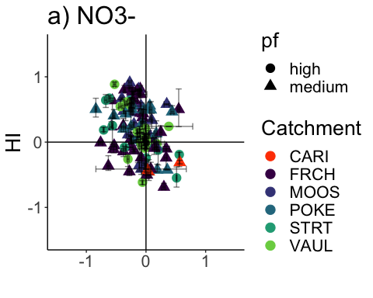 Doesnt look like there is too much of a pattern here….slightly more (+) HI and slightly more (-) FI

### HI vs. FI ### PF

HI_FI_fDOM$site.ID <- factor(HI_FI_fDOM$site.ID, levels = c('FRCH','MOOS','CARI','POKE','STRT', 'VAUL'))  
  
HI_FI_fDOM.p =   
 ggplot(HI_FI_fDOM, aes(Flush_index, Hyst_index)) + geom_point(aes(colour=factor(site.ID), shape = pf), size = 4)+  
 geom_errorbar(aes(ymin=HI_ymin, ymax=HI_ymax), colour="black", alpha=0.5, size=.5, width = 0.1)+   
 geom_hline(yintercept = 0) + geom_vline(xintercept = 0)+  
 geom_errorbarh(aes(xmin=FI_ymin, xmax=FI_ymax), colour="black", alpha=0.5, size=.5, height = 0.1) +  
 scale_color_manual(values = c("orange red", viridis::viridis(6)), "Catchment")+theme_bw() +  
 ylim(-1.5, 1.5) + xlim(-1.5, 1.5)+  
 ggtitle("b) fDOM")+   
 xlab("") +  
 ylab("") +  
 theme(panel.border = element_blank(), panel.grid.major = element_blank(),panel.grid.minor = element_blank(), axis.line = element_line(colour = "black"), text = element_text(size = 20))   
HI_FI_fDOM.p

## Warning: Removed 57 rows containing missing values (geom_point).

## Warning: Removed 80 rows containing missing values (geom_errorbarh).

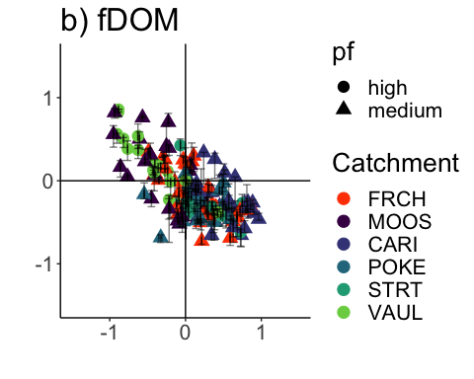 Looks like there is a clear pattern with VAUL and MOOS as it usually dilutes during a storm meanwhile CARI and the other sites flush more frequently

### HI vs. FI

HI_FI_SPC$site.ID <- factor(HI_FI_SPC$site.ID, levels = c('FRCH','MOOS','CARI','POKE','STRT', 'VAUL'))  
  
HI_FI_SPC.p =   
 ggplot(HI_FI_SPC, aes(Flush_index, Hyst_index)) + geom_point(aes(colour=factor(site.ID), shape = pf), size = 4)+  
 geom_errorbar(aes(ymin=HI_ymin, ymax=HI_ymax), colour="black", alpha=0.5, size=.5, width = 0.1)+   
 geom_hline(yintercept = 0) + geom_vline(xintercept = 0)+  
 geom_errorbarh(aes(xmin=FI_ymin, xmax=FI_ymax), colour="black", alpha=0.5, size=.5, height = 0.1) +  
 scale_color_manual(values = c("orange red", viridis::viridis(6)), "Catchment")+theme_bw() +  
 ylim(-1.5, 1.5) + xlim(-1.5, 1.5)+  
 ggtitle("c) SPC")+  
 xlab("FI") +   
 ylab("HI") +  
 theme(panel.border = element_blank(), panel.grid.major = element_blank(),panel.grid.minor = element_blank(), axis.line = element_line(colour = "black"), text = element_text(size = 20))   
HI_FI_SPC.p

## Warning: Removed 96 rows containing missing values (geom_point).

## Warning: Removed 99 rows containing missing values (geom_errorbarh).

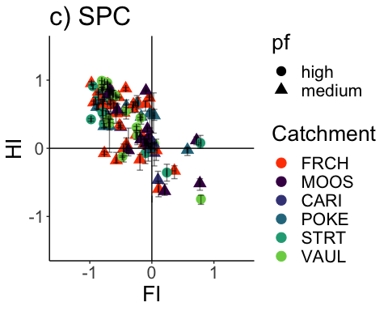 Mostly a dilution and clockwise effect for SPC

### HI vs. FI

HI_FI_turb$site.ID <- factor(HI_FI_turb$site.ID, levels = c('FRCH','MOOS','POKE','STRT','VAUL', 'CARI'))  
  
HI_FI_turb.p =   
 ggplot(HI_FI_turb, aes(Flush_index, Hyst_index)) + geom_point(aes(colour=factor(site.ID), shape = pf), size = 4)+  
 geom_errorbar(aes(ymin=HI_ymin, ymax=HI_ymax), colour="black", alpha=0.5, size=.5, width = 0.1)+   
 geom_hline(yintercept = 0) + geom_vline(xintercept = 0)+  
 geom_errorbarh(aes(xmin=FI_ymin, xmax=FI_ymax), colour="black", alpha=0.5, size=.5, height = 0.1) +  
 scale_color_manual(values = c("orange red", viridis::viridis(6)), "Catchment")+theme_bw() +  
 ylim(-1.5, 1.5) + xlim(-1.5, 1.5)+  
 ggtitle("d) Turb")+   
 xlab("FI") +  
 ylab("") +  
 theme(panel.border = element_blank(), panel.grid.major = element_blank(),panel.grid.minor = element_blank(), axis.line = element_line(colour = "black"), text = element_text(size = 20))   
HI_FI_turb.p

## Warning: Removed 61 rows containing missing values (geom_point).

## Warning: Removed 94 rows containing missing values (geom_errorbarh).

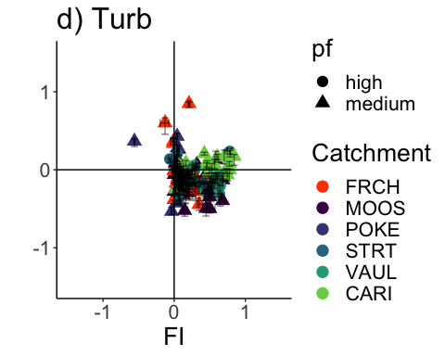 This seems like we would expect…a mostly flushing effect during storms

library(ggpubr)  
ggarrange(HI_FI_NO3.p, HI_FI_fDOM.p, HI_FI_SPC.p, HI_FI_turb.p, ncol=2, nrow=2, common.legend = TRUE, legend="right")

## Warning: Removed 73 rows containing missing values (geom_point).

## Warning: Removed 79 rows containing missing values (geom_errorbarh).

## Warning: Removed 73 rows containing missing values (geom_point).

## Warning: Removed 79 rows containing missing values (geom_errorbarh).

## Warning: Removed 57 rows containing missing values (geom_point).

## Warning: Removed 80 rows containing missing values (geom_errorbarh).

## Warning: Removed 96 rows containing missing values (geom_point).

## Warning: Removed 99 rows containing missing values (geom_errorbarh).

## Warning: Removed 61 rows containing missing values (geom_point).

## Warning: Removed 94 rows containing missing values (geom_errorbarh).

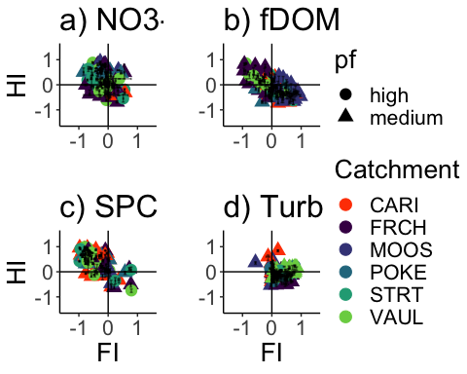

ggsave("~/Documents/Storms/Output_from_analysis/From_07_Modelling/HI_FI_permafrost.pdf", width = 10, height = 10, device = "pdf")

### HI vs. FI ### FIRE

HI_FI_NO3.p.fire =   
 ggplot(HI_FI_NO3, aes(Flush_index, Hyst_index)) + geom_point(aes(colour=factor(site.ID), shape = burn), size = 4)+  
 geom_errorbar(aes(ymin=HI_ymin, ymax=HI_ymax), colour="black", alpha=0.5, size=.5, width = 0.1)+   
 geom_hline(yintercept = 0) + geom_vline(xintercept = 0)+  
 geom_errorbarh(aes(xmin=FI_ymin, xmax=FI_ymax), colour="black", alpha=0.5, size=.5, height = 0.1) +  
 scale_color_manual(values = c("orange red", viridis::viridis(6)), "Catchment")+theme_bw() +  
 ylim(-1.5, 1.5) + xlim(-1.5, 1.5)+  
 ggtitle("a) NO3-")+   
 theme(panel.border = element_blank(), panel.grid.major = element_blank(),panel.grid.minor = element_blank(), axis.line = element_line(colour = "black"), text = element_text(size = 20))   
HI_FI_NO3.p.fire

## Warning: Removed 73 rows containing missing values (geom_point).

## Warning: Removed 79 rows containing missing values (geom_errorbarh).

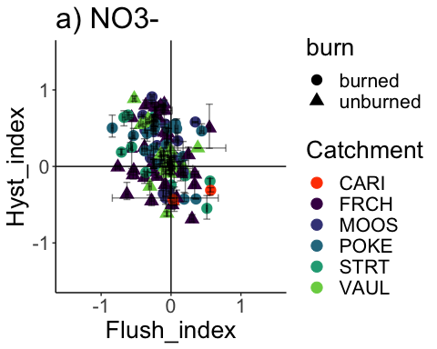

HI_FI_fDOM.p.fire =   
 ggplot(HI_FI_fDOM, aes(Flush_index, Hyst_index)) + geom_point(aes(colour=factor(site.ID), shape = burn), size = 4)+  
 geom_errorbar(aes(ymin=HI_ymin, ymax=HI_ymax), colour="black", alpha=0.5, size=.5, width = 0.1)+   
 geom_hline(yintercept = 0) + geom_vline(xintercept = 0)+  
 geom_errorbarh(aes(xmin=FI_ymin, xmax=FI_ymax), colour="black", alpha=0.5, size=.5, height = 0.1) +  
 scale_color_manual(values = c("orange red", viridis::viridis(6)), "Catchment")+theme_bw() +  
 ylim(-1.5, 1.5) + xlim(-1.5, 1.5)+  
 ggtitle("b) fDOM")+   
 theme(panel.border = element_blank(), panel.grid.major = element_blank(),panel.grid.minor = element_blank(), axis.line = element_line(colour = "black"), text = element_text(size = 20))   
HI_FI_fDOM.p.fire

## Warning: Removed 57 rows containing missing values (geom_point).

## Warning: Removed 80 rows containing missing values (geom_errorbarh).

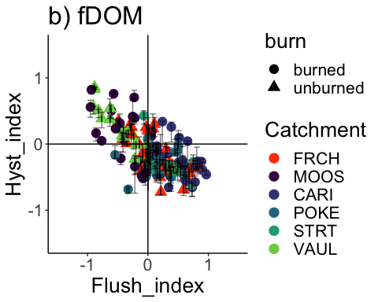

HI_FI_SPC.p.fire =   
 ggplot(HI_FI_SPC, aes(Flush_index, Hyst_index)) + geom_point(aes(colour=factor(site.ID), shape = burn), size = 4)+  
 geom_errorbar(aes(ymin=HI_ymin, ymax=HI_ymax), colour="black", alpha=0.5, size=.5, width = 0.1)+   
 geom_hline(yintercept = 0) + geom_vline(xintercept = 0)+  
 geom_errorbarh(aes(xmin=FI_ymin, xmax=FI_ymax), colour="black", alpha=0.5, size=.5, height = 0.1) +  
 scale_color_manual(values = c("orange red", viridis::viridis(6)), "Catchment")+theme_bw() +  
 ylim(-1.5, 1.5) + xlim(-1.5, 1.5)+  
 ggtitle("c) SPC")+   
 theme(panel.border = element_blank(), panel.grid.major = element_blank(),panel.grid.minor = element_blank(), axis.line = element_line(colour = "black"), text = element_text(size = 20))   
HI_FI_SPC.p.fire

## Warning: Removed 96 rows containing missing values (geom_point).

## Warning: Removed 99 rows containing missing values (geom_errorbarh).

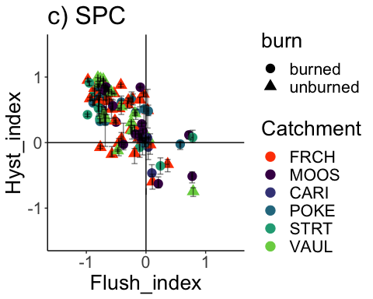

HI_FI_turb.p.fire =   
 ggplot(HI_FI_turb, aes(Flush_index, Hyst_index)) + geom_point(aes(colour=factor(site.ID), shape = burn), size = 4)+  
 geom_errorbar(aes(ymin=HI_ymin, ymax=HI_ymax), colour="black", alpha=0.5, size=.5, width = 0.1)+   
 geom_hline(yintercept = 0) + geom_vline(xintercept = 0)+  
 geom_errorbarh(aes(xmin=FI_ymin, xmax=FI_ymax), colour="black", alpha=0.5, size=.5, height = 0.1) +  
 scale_color_manual(values = c("orange red", viridis::viridis(6)), "Catchment")+theme_bw() +  
 ylim(-1.5, 1.5) + xlim(-1.5, 1.5)+  
 ggtitle("d) Turb")+   
 theme(panel.border = element_blank(), panel.grid.major = element_blank(),panel.grid.minor = element_blank(), axis.line = element_line(colour = "black"), text = element_text(size = 20))   
HI_FI_turb.p.fire

## Warning: Removed 61 rows containing missing values (geom_point).

## Warning: Removed 94 rows containing missing values (geom_errorbarh).

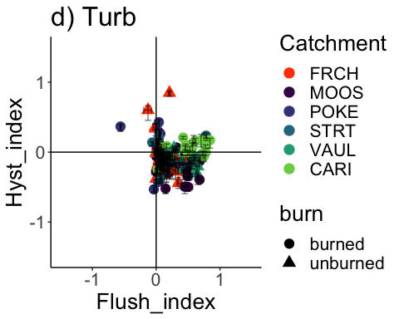

ggarrange(HI_FI_NO3.p.fire, HI_FI_fDOM.p.fire, HI_FI_SPC.p.fire, HI_FI_turb.p.fire, ncol=2, nrow=2, common.legend = TRUE, legend="right")

## Warning: Removed 73 rows containing missing values (geom_point).

## Warning: Removed 79 rows containing missing values (geom_errorbarh).

## Warning: Removed 73 rows containing missing values (geom_point).

## Warning: Removed 79 rows containing missing values (geom_errorbarh).

## Warning: Removed 57 rows containing missing values (geom_point).

## Warning: Removed 80 rows containing missing values (geom_errorbarh).

## Warning: Removed 96 rows containing missing values (geom_point).

## Warning: Removed 99 rows containing missing values (geom_errorbarh).

## Warning: Removed 61 rows containing missing values (geom_point).

## Warning: Removed 94 rows containing missing values (geom_errorbarh).

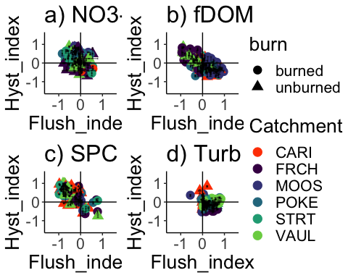

ggsave("~/Documents/Storms/Output_from_analysis/From_07_Modelling/HI_FI_fire.pdf", width = 10, height = 10, device = "pdf")

ggplot() +   
 geom_density(data=HI_FI_NO3[HI_FI_NO3$site.ID == "MOOS",],   
 aes(x=Hyst_index), fill="#6A3D9A",alpha=0.5) +  
 geom_density(data=HI_FI_NO3[HI_FI_NO3$site.ID == "FRCH",],   
 aes(x=Hyst_index), fill="#2D004B", alpha=0.5) +  
 geom_density(data=HI_FI_NO3[HI_FI_NO3$site.ID == "CARI",],   
 aes(x=Hyst_index), fill="#FF7F00", alpha=0.5) +  
 geom_density(data=HI_FI_NO3[HI_FI_NO3$site.ID == "POKE",],   
 aes(x=Hyst_index), fill="#3288BD", alpha=0.5) +  
 geom_density(data=HI_FI_NO3[HI_FI_NO3$site.ID == "VAUL",],   
 aes(x=Hyst_index), fill="#ABDDA4", alpha=0.5) +  
 geom_density(data=HI_FI_NO3[HI_FI_NO3$site.ID == "STRT",],   
 aes(x=Hyst_index), fill="#66C2A5", alpha=0.5) +  
 ylab("Density") +  
 theme_bw() +  
 theme(legend.position = "none",  
 plot.title = element_text(face = "bold", hjust = 0.5, size =18),  
 panel.grid = element_blank(),  
 panel.border = element_rect(color = "black", size = 2),  
 axis.text = element_text(size = 18),  
 axis.title.x = element_text(size = 18),  
 axis.title.y = element_text(size = 18),  
 plot.margin = margin(.5,2,.5,.5, "cm"))

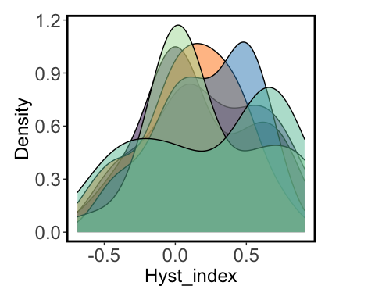

ggplot() +   
 geom_density(data=HI_FI_fDOM[HI_FI_fDOM$site.ID == "MOOS",],   
 aes(x=Hyst_index), fill="#6A3D9A",alpha=0.5) +  
 geom_density(data=HI_FI_fDOM[HI_FI_fDOM$site.ID == "FRCH",],   
 aes(x=Hyst_index), fill="#2D004B", alpha=0.5) +  
 geom_density(data=HI_FI_fDOM[HI_FI_fDOM$site.ID == "CARI",],   
 aes(x=Hyst_index), fill="#FF7F00", alpha=0.5) +  
 geom_density(data=HI_FI_fDOM[HI_FI_fDOM$site.ID == "POKE",],   
 aes(x=Hyst_index), fill="#3288BD", alpha=0.5) +  
 geom_density(data=HI_FI_fDOM[HI_FI_fDOM$site.ID == "VAUL",],   
 aes(x=Hyst_index), fill="#ABDDA4", alpha=0.5) +  
 geom_density(data=HI_FI_fDOM[HI_FI_fDOM$site.ID == "STRT",],   
 aes(x=Hyst_index), fill="#66C2A5", alpha=0.5) +  
 ylab("Density") +  
 theme_bw() +  
 theme(legend.position = "none",  
 plot.title = element_text(face = "bold", hjust = 0.5, size =18),  
 panel.grid = element_blank(),  
 panel.border = element_rect(color = "black", size = 2),  
 axis.text = element_text(size = 18),  
 axis.title.x = element_text(size = 18),  
 axis.title.y = element_text(size = 18),  
 plot.margin = margin(.5,2,.5,.5, "cm"))

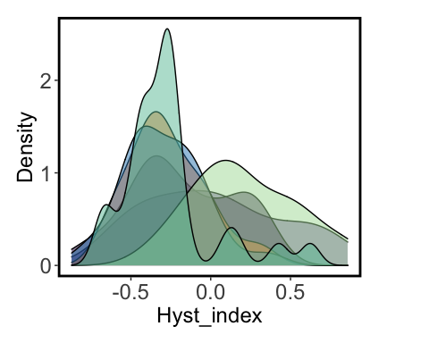

ggplot() +   
 geom_density(data=HI_FI_fDOM[HI_FI_fDOM$site.ID == "MOOS",],   
 aes(x=Hyst_index), fill="#6A3D9A",alpha=0.5) +  
 xlim(-1,1) +  
 theme_classic()

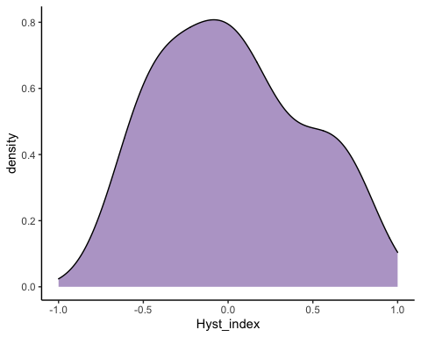

HI_FI_fDOM %>% filter(site.ID == "MOOS") %>%  
 ggplot(aes(beta, Hyst_index)) +  
 geom_point(aes(color = factor(site.ID), shape = pf), size = 4) +  
 geom_errorbar(aes(ymin=HI_ymin, ymax=HI_ymax), colour="black", alpha=0.5, size=.5, width = 0.1)+   
 geom_hline(yintercept = 0) + geom_vline(xintercept = 0)+  
 geom_errorbarh(aes(xmin=FI_ymin, xmax=FI_ymax), colour="black", alpha=0.5, size=.5, height = 0.1) +  
 scale_color_manual(values = "#6A3D9A", "Catchment")+theme_bw() +  
 ylim(-1.5, 1.5) + xlim(-1.5, 1.5)+  
 ggtitle("b) fDOM")+   
 xlab("") +  
 ylab("") +  
 theme(panel.border = element_blank(), panel.grid.major = element_blank(),panel.grid.minor = element_blank(), axis.line = element_line(colour = "black"), text = element_text(size = 20))

## Warning: Removed 5 rows containing missing values (geom_point).

## Warning: Removed 16 rows containing missing values (geom_errorbarh).

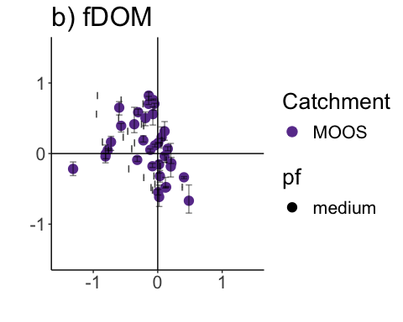

ggplot()+  
 geom_density(data=HI_FI_fDOM[HI_FI_fDOM$site.ID == "VAUL",],   
 aes(x=Hyst_index), fill="#ABDDA4", alpha=0.5) +   
 xlim(-1,1) +   
 theme_classic()

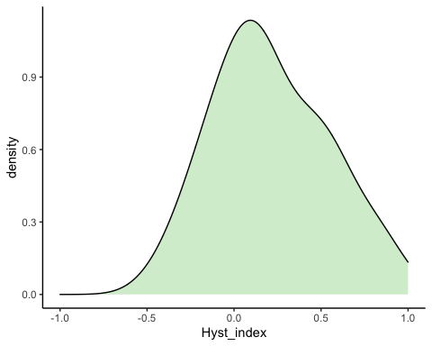

HI_FI_fDOM %>% filter(site.ID == "VAUL") %>%  
 ggplot(aes(beta, Hyst_index)) +  
 geom_point(aes(color = factor(site.ID), shape = pf), size = 4) +  
 geom_errorbar(aes(ymin=HI_ymin, ymax=HI_ymax), colour="black", alpha=0.5, size=.5, width = 0.1)+   
 geom_hline(yintercept = 0) + geom_vline(xintercept = 0)+  
 geom_errorbarh(aes(xmin=FI_ymin, xmax=FI_ymax), colour="black", alpha=0.5, size=.5, height = 0.1) +  
 scale_color_manual(values = "#ABDDA4", "Catchment")+theme_bw() +  
 ylim(-1.5, 1.5) + xlim(-1.5, 1.5)+  
 ggtitle("b) fDOM")+   
 xlab("") +  
 ylab("") +  
 theme(panel.border = element_blank(), panel.grid.major = element_blank(),panel.grid.minor = element_blank(), axis.line = element_line(colour = "black"), text = element_text(size = 20))

## Warning: Removed 9 rows containing missing values (geom_point).

## Warning: Removed 8 rows containing missing values (geom_errorbarh).

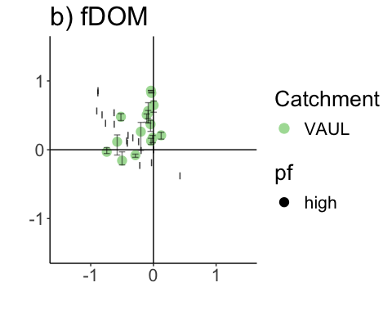

ggplot() +  
 geom_density(data=HI_FI_fDOM[HI_FI_fDOM$site.ID == "POKE",],   
 aes(x=Hyst_index), fill="#3288BD", alpha=0.5) +  
 xlim(-1,1) +  
 theme_classic()

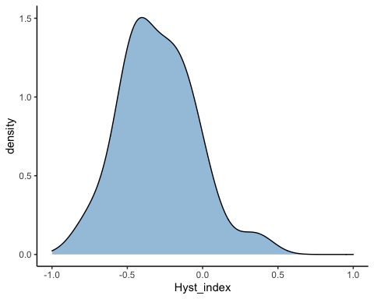

HI_FI_fDOM %>% filter(site.ID == "POKE") %>%  
 ggplot(aes(beta, Hyst_index)) +  
 geom_point(aes(color = factor(site.ID), shape = pf), size = 4) +  
 geom_errorbar(aes(ymin=HI_ymin, ymax=HI_ymax), colour="black", alpha=0.5, size=.5, width = 0.1)+   
 geom_hline(yintercept = 0) + geom_vline(xintercept = 0)+  
 geom_errorbarh(aes(xmin=FI_ymin, xmax=FI_ymax), colour="black", alpha=0.5, size=.5, height = 0.1) +  
 scale_color_manual(values = "#3288BD", "Catchment")+theme_bw() +  
 ylim(-1.5, 1.5) + xlim(-1.5, 1.5)+  
 ggtitle("b) fDOM")+   
 xlab("") +  
 ylab("") +  
 theme(panel.border = element_blank(), panel.grid.major = element_blank(),panel.grid.minor = element_blank(), axis.line = element_line(colour = "black"), text = element_text(size = 20))

## Warning: Removed 4 rows containing missing values (geom_point).

## Warning: Removed 9 rows containing missing values (geom_errorbarh).

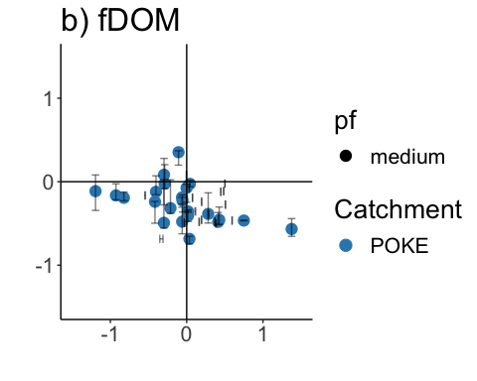

ggplot() +  
geom_density(data=HI_FI_fDOM[HI_FI_fDOM$site.ID == "CARI",],   
 aes(x=Hyst_index), fill="#FF7F00", alpha=0.5) +  
 xlim(-1,1) +  
 theme_classic()

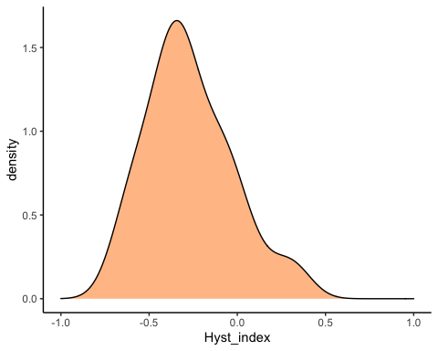

HI_FI_fDOM %>% filter(site.ID == "CARI") %>%  
 ggplot(aes(beta, Hyst_index)) +  
 geom_point(aes(color = factor(site.ID), shape = pf), size = 4) +  
 geom_errorbar(aes(ymin=HI_ymin, ymax=HI_ymax), colour="black", alpha=0.5, size=.5, width = 0.1)+   
 geom_hline(yintercept = 0) + geom_vline(xintercept = 0)+  
 geom_errorbarh(aes(xmin=FI_ymin, xmax=FI_ymax), colour="black", alpha=0.5, size=.5, height = 0.1) +  
 scale_color_manual(values = "#FF7F00", "Catchment")+theme_bw() +  
 ylim(-1.5, 1.5) + xlim(-1.5, 1.5)+  
 ggtitle("b) fDOM")+   
 xlab("") +  
 ylab("") +  
 theme(panel.border = element_blank(), panel.grid.major = element_blank(),panel.grid.minor = element_blank(), axis.line = element_line(colour = "black"), text = element_text(size = 20))

## Warning: Removed 4 rows containing missing values (geom_point).

## Warning: Removed 21 rows containing missing values (geom_errorbarh).

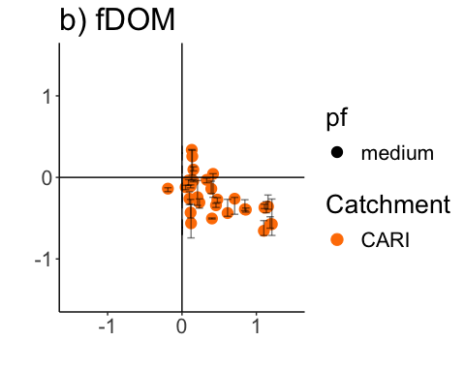

ggplot() +  
 geom_density(data=HI_FI_fDOM[HI_FI_fDOM$site.ID == "STRT",],   
 aes(x=Hyst_index), fill="#66C2A5", alpha=0.5) +  
 xlim(-1,1) +  
 theme_classic()

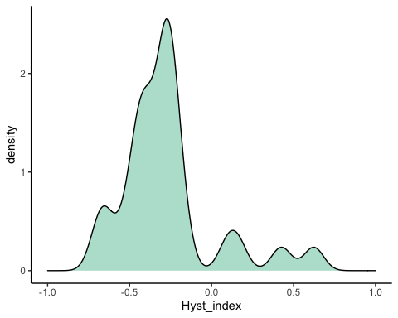

HI_FI_fDOM %>% filter(site.ID == "STRT") %>%  
 ggplot(aes(beta, Hyst_index)) +  
 geom_point(aes(color = factor(site.ID), shape = as.factor(year)), size = 4) +  
 geom_errorbar(aes(ymin=HI_ymin, ymax=HI_ymax), colour="black", alpha=0.5, size=.5, width = 0.1)+   
 geom_hline(yintercept = 0) + geom_vline(xintercept = 0)+  
 geom_errorbarh(aes(xmin=FI_ymin, xmax=FI_ymax), colour="black", alpha=0.5, size=.5, height = 0.1) +  
 scale_color_manual(values = "#66C2A5", "Catchment")+theme_bw() +  
 ylim(-1.5, 1.5) + xlim(-1.5, 1.5)+  
 ggtitle("b) fDOM")+   
 xlab("") +  
 ylab("") +  
 theme(panel.border = element_blank(), panel.grid.major = element_blank(),panel.grid.minor = element_blank(), axis.line = element_line(colour = "black"), text = element_text(size = 20))

## Warning: Removed 4 rows containing missing values (geom_point).

## Warning: Removed 17 rows containing missing values (geom_errorbarh).

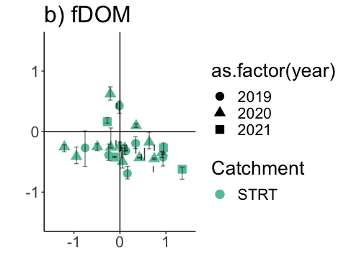

ggplot() +  
 geom_density(data=HI_FI_fDOM[HI_FI_fDOM$site.ID == "FRCH",],   
 aes(x=Hyst_index), fill="#2D004B", alpha=0.5) +  
 xlim(-1,1) +  
 theme_classic()

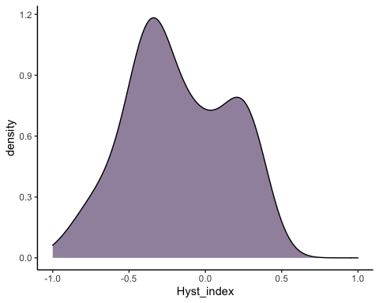

HI_FI_fDOM %>% filter(site.ID == "FRCH") %>%  
 ggplot(aes(beta, Hyst_index)) +  
 geom_point(aes(color = factor(site.ID), shape = as.factor(year)), size = 4) +  
 geom_errorbar(aes(ymin=HI_ymin, ymax=HI_ymax), colour="black", alpha=0.5, size=.5, width = 0.1)+   
 geom_hline(yintercept = 0) + geom_vline(xintercept = 0)+  
 geom_errorbarh(aes(xmin=FI_ymin, xmax=FI_ymax), colour="black", alpha=0.5, size=.5, height = 0.1) +  
 scale_color_manual(values = "#2D004B", "Catchment")+theme_bw() +  
 ylim(-1.5, 1.5) + xlim(-1.5, 1.5)+  
 ggtitle("b) fDOM")+   
 xlab("") +  
 ylab("") +  
 theme(panel.border = element_blank(), panel.grid.major = element_blank(),panel.grid.minor = element_blank(), axis.line = element_line(colour = "black"), text = element_text(size = 20))

## Warning: Removed 3 rows containing missing values (geom_point).

## Warning: Removed 9 rows containing missing values (geom_errorbarh).

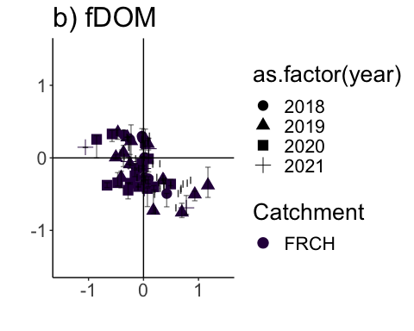

### SCALING

### Scatter plot matrix

NO3_data.1 <- HI_FI_NO3[,c("Hyst_index","StormPrecip")]  
  
pairs(NO3_data.1)

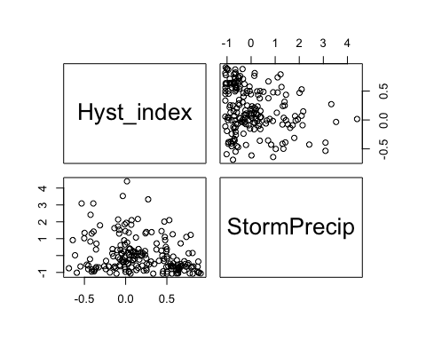

HI_FI_NO3 %>% ggplot(aes(x = StormPrecip, y = Hyst_index)) +   
 geom_hline(yintercept = 0, linetype = "dotted", size = 1) +  
 geom_errorbar(aes(ymin=HI_ymin, ymax=HI_ymax), colour="black", alpha=0.5, size=.5, width = 0.1)+   
 geom_point(aes(color = site.ID), size = 2) +  
 scale_color_manual(values = c("orange red", viridis::viridis(6)), "Catchment")+  
 geom_smooth(method = "lm", na.rm = TRUE, fullrange = TRUE, aes(group = 1)) +   
 stat_poly_eq(formula = y~x,  
 label.y = "top", label.x = "right",  
 aes(label = paste(..eq.label.., ..rr.label.., sep = "~~~")),   
 parse = TRUE) +   
 ylab("Hysteresis Index") +  
 ggtitle("HI vs. StormPrecip")

## `geom_smooth()` using formula 'y ~ x'

## Warning: Removed 5 rows containing non-finite values (stat_poly_eq).

## Warning: Removed 5 rows containing missing values (geom_point).

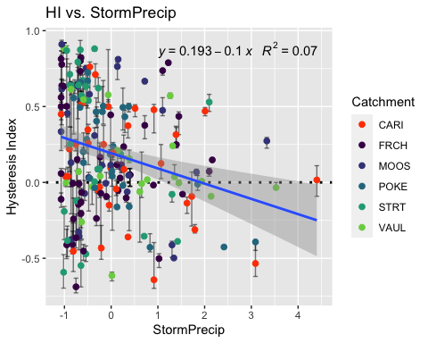

NO3_data.2 <- HI_FI_NO3[,c("Hyst_index","PrecipWeek")]  
  
pairs(NO3_data.2)

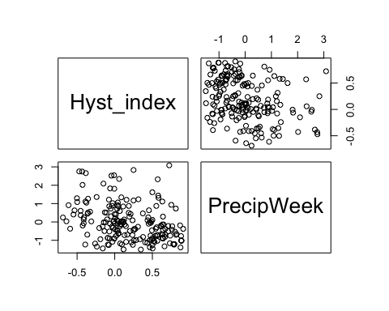

HI_FI_NO3 %>% ggplot(aes(x = PrecipWeek, y = Hyst_index)) +   
 geom_hline(yintercept = 0, linetype = "dotted", size = 1) +  
 geom_errorbar(aes(ymin=HI_ymin, ymax=HI_ymax), colour="black", alpha=0.5, size=.5, width = 0.1)+   
 geom_point(aes(color = site.ID), size = 2) +  
 scale_color_manual(values = c("orange red", viridis::viridis(6)), "Catchment")+  
 geom_smooth(method = "lm", na.rm = TRUE, fullrange = TRUE, aes(group = 1)) +   
 stat_poly_eq(formula = y~x,  
 label.y = "top", label.x = "right",  
 aes(label = paste(..eq.label.., ..rr.label.., sep = "~~~")),   
 parse = TRUE) +   
 ylab("Hysteresis Index") +  
 ggtitle("HI vs. PrecipWeek")

## `geom_smooth()` using formula 'y ~ x'

## Warning: Removed 5 rows containing non-finite values (stat_poly_eq).

## Warning: Removed 5 rows containing missing values (geom_point).

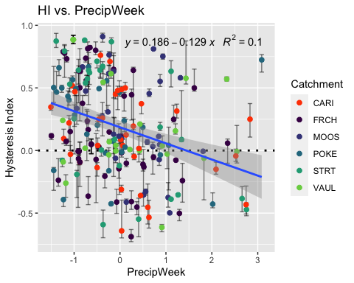

NO3_data.3 <- HI_FI_NO3[,c("Hyst_index","PrecipMonth")]  
  
pairs(NO3_data.3)

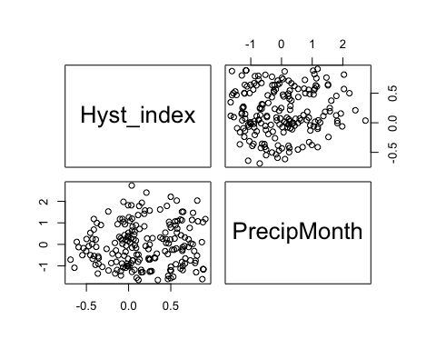

HI_FI_NO3 %>% ggplot(aes(x = PrecipMonth, y = Hyst_index)) +   
 geom_hline(yintercept = 0, linetype = "dotted", size = 1) +  
 geom_errorbar(aes(ymin=HI_ymin, ymax=HI_ymax), colour="black", alpha=0.5, size=.5, width = 0.1)+   
 geom_point(aes(color = site.ID), size = 2) +  
 scale_color_manual(values = c("orange red", viridis::viridis(6)), "Catchment")+  
 geom_smooth(method = "lm", na.rm = TRUE, fullrange = TRUE, aes(group = 1)) +   
 stat_poly_eq(formula = y~x,  
 label.y = "top", label.x = "right",  
 aes(label = paste(..eq.label.., ..rr.label.., sep = "~~~")),   
 parse = TRUE) +   
 ylab("Hysteresis Index") +  
 ggtitle("HI vs. PrecipMonth")

## `geom_smooth()` using formula 'y ~ x'

## Warning: Removed 5 rows containing non-finite values (stat_poly_eq).

## Warning: Removed 5 rows containing missing values (geom_point).

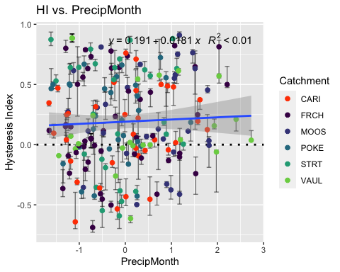

NO3_data.4 <- HI_FI_NO3[,c("Hyst_index","ThreeMonth")]  
  
pairs(NO3_data.4)

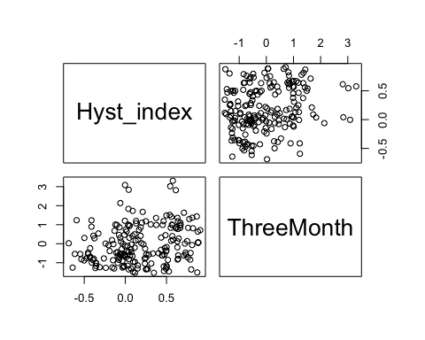

HI_FI_NO3_CARI <- filter(HI_FI_NO3, site.ID == "CARI")  
HI_FI_NO3_FRCH <- filter(HI_FI_NO3, site.ID == "FRCH")  
HI_FI_NO3_MOOS <- filter(HI_FI_NO3, site.ID == "MOOS")  
HI_FI_NO3_POKE <- filter(HI_FI_NO3, site.ID == "POKE")  
HI_FI_NO3_VAUL <- filter(HI_FI_NO3, site.ID == "VAUL")  
HI_FI_NO3_STRT <- filter(HI_FI_NO3, site.ID == "STRT")  
  
HI_FI_NO3_CARI %>% ggplot(aes(x = ThreeMonth, y = Hyst_index)) +  
 geom_hline(yintercept = 0, linetype = "dotted", size = 1) +  
 geom_errorbar(aes(ymin=HI_ymin, ymax=HI_ymax), colour="black", alpha=0.5, size=.5, width = 0.1)+   
 geom_point(aes(color = year), size = 2)

## Warning: Removed 1 rows containing missing values (geom_point).

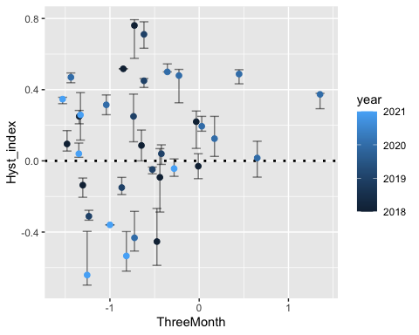

HI_FI_NO3_FRCH %>% ggplot(aes(x = ThreeMonth, y = Hyst_index)) +  
 geom_hline(yintercept = 0, linetype = "dotted", size = 1) +  
 geom_errorbar(aes(ymin=HI_ymin, ymax=HI_ymax), colour="black", alpha=0.5, size=.5, width = 0.1)+   
 geom_point(aes(color = year), size = 2)

## Warning: Removed 2 rows containing missing values (geom_point).

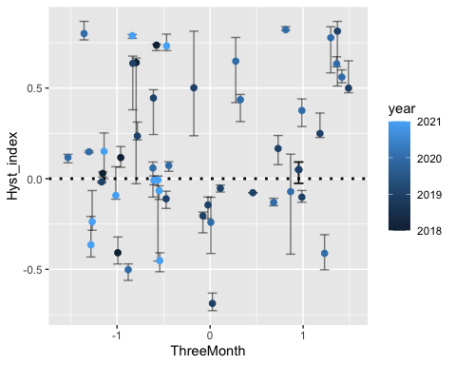

HI_FI_NO3_MOOS %>% ggplot(aes(x = ThreeMonth, y = Hyst_index)) +  
 geom_hline(yintercept = 0, linetype = "dotted", size = 1) +  
 geom_errorbar(aes(ymin=HI_ymin, ymax=HI_ymax), colour="black", alpha=0.5, size=.5, width = 0.1)+   
 geom_point(aes(color = year), size = 2)

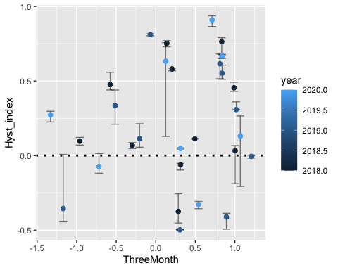

HI_FI_NO3_POKE %>% ggplot(aes(x = ThreeMonth, y = Hyst_index)) +  
 geom_hline(yintercept = 0, linetype = "dotted", size = 1) +  
 geom_errorbar(aes(ymin=HI_ymin, ymax=HI_ymax), colour="black", alpha=0.5, size=.5, width = 0.1)+   
 geom_point(aes(color = year), size = 2)

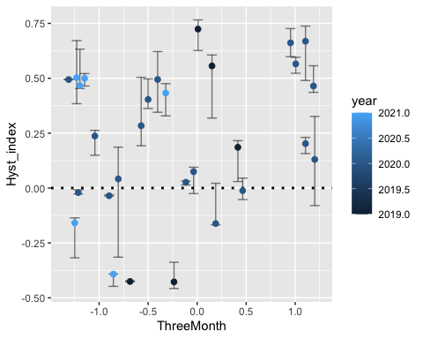

HI_FI_NO3_VAUL %>% ggplot(aes(x = ThreeMonth, y = Hyst_index)) +  
 geom_hline(yintercept = 0, linetype = "dotted", size = 1) +  
 geom_errorbar(aes(ymin=HI_ymin, ymax=HI_ymax), colour="black", alpha=0.5, size=.5, width = 0.1)+   
 geom_point(aes(color = year), size = 2)

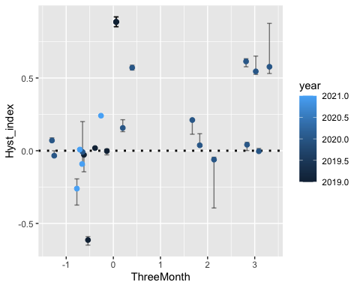

HI_FI_NO3_STRT %>% ggplot(aes(x = ThreeMonth, y = Hyst_index)) +  
 geom_hline(yintercept = 0, linetype = "dotted", size = 1) +  
 geom_errorbar(aes(ymin=HI_ymin, ymax=HI_ymax), colour="black", alpha=0.5, size=.5, width = 0.1)+   
 geom_point(aes(color = year), size = 2)

## Warning: Removed 2 rows containing missing values (geom_point).

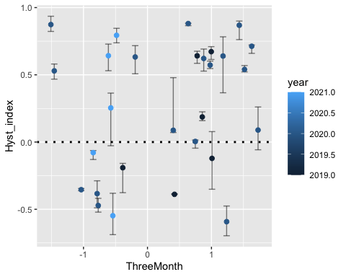

HI_FI_NO3 %>% ggplot(aes(x = ThreeMonth, y = Hyst_index)) +   
 geom_hline(yintercept = 0, linetype = "dotted", size = 1) +  
 geom_errorbar(aes(ymin=HI_ymin, ymax=HI_ymax), colour="black", alpha=0.5, size=.5, width = 0.1)+   
 geom_point(aes(color = site.ID), size = 2) +  
 scale_color_manual(values = c("orange red", viridis::viridis(6)), "Catchment")+  
 geom_smooth(method = "lm", na.rm = TRUE, fullrange = TRUE, aes(group = 1)) +   
 stat_poly_eq(formula = y~x,  
 label.y = "top", label.x = "right",  
 aes(label = paste(..eq.label.., ..rr.label.., sep = "~~~")),   
 parse = TRUE) +   
 ylab("Hysteresis Index") +  
 ggtitle("HI vs. ThreeMonth")

## `geom_smooth()` using formula 'y ~ x'

## Warning: Removed 5 rows containing non-finite values (stat_poly_eq).

## Warning: Removed 5 rows containing missing values (geom_point).

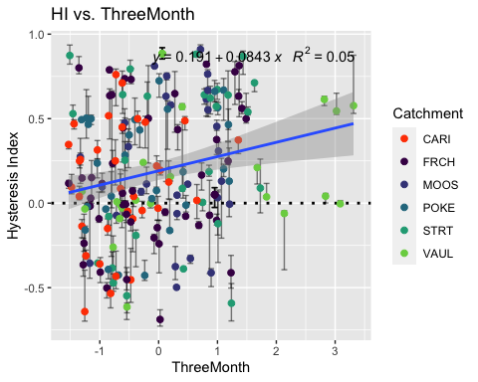 Caribou potentially not right

NO3_data.5 <- HI_FI_NO3[,c("Hyst_index","Intensity")]  
  
HI_FI_NO3 %>% ggplot(aes(x = Intensity, y = Hyst_index)) +   
 geom_hline(yintercept = 0, linetype = "dotted", size = 1) +  
 geom_errorbar(aes(ymin=HI_ymin, ymax=HI_ymax), colour="black", alpha=0.5, size=.5, width = 0.1)+   
 geom_point(aes(color = site.ID), size = 2) +  
 scale_color_manual(values = c("orange red", viridis::viridis(6)), "Catchment")+  
 ylab("Hysteresis Index") +  
 ggtitle("HI vs. Intensity")

## Warning: Removed 11 rows containing missing values (geom_point).

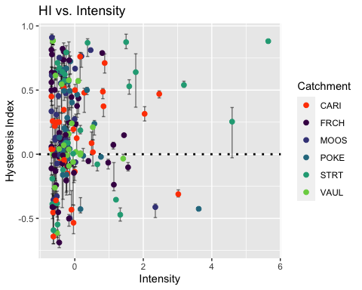

pairs(NO3_data.5)

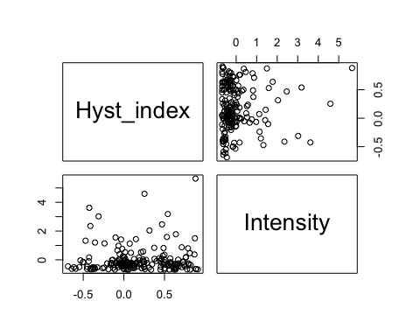

which(HI_FI_NO3$Intensity > 1.5)

## [1] 38 53 57 78 129 135 139 142 158 159 190

HI_FI_NO3.low <- HI_FI_NO3[-c(45,60,67,97,106,154,155,161,165,168,173,188,189,221), ]  
which(HI_FI_NO3.low$Intensity > 1.0)

## [1] 38 52 56 75 84 87 123 124 125 127 130 134 137 141 151 152 160 177

#HI_FI_NO3.low <- HI_FI_NO3.low[-c(42, 71, 89, 92, 137, 138, 139, 140, 145, 147, 152, 176), ]  
  
NO3_data.5 <- HI_FI_NO3.low[,c("Hyst_index","Intensity")]  
  
pairs(NO3_data.5)

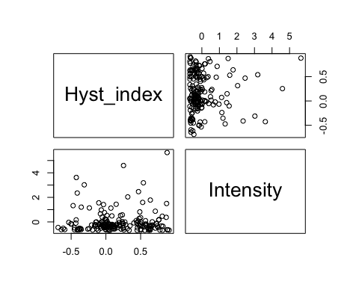 I removed some storms that were way higher in intensity then any other storm

NO3_data.6 <- HI_FI_NO3[,c("Hyst_index","StormTemp")]  
  
pairs(NO3_data.6)

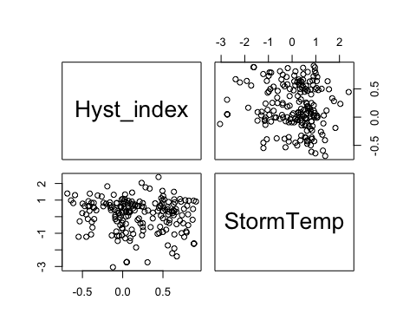

HI_FI_NO3 %>% ggplot(aes(x = StormTemp, y = Hyst_index)) +   
 geom_hline(yintercept = 0, linetype = "dotted", size = 1) +  
 geom_errorbar(aes(ymin=HI_ymin, ymax=HI_ymax), colour="black", alpha=0.5, size=.5, width = 0.1)+   
 geom_point(aes(color = site.ID), size = 2) +  
 scale_color_manual(values = c("orange red", viridis::viridis(6)), "Catchment")+  
 geom_smooth(method = "lm", na.rm = TRUE, fullrange = TRUE, aes(group = 1)) +   
 stat_poly_eq(formula = y~x,  
 label.y = "top", label.x = "right",  
 aes(label = paste(..eq.label.., ..rr.label.., sep = "~~~")),   
 parse = TRUE) +   
 ylab("Hysteresis Index") +  
 ggtitle("HI vs. StormTemp")

## `geom_smooth()` using formula 'y ~ x'

## Warning: Removed 5 rows containing non-finite values (stat_poly_eq).

## Warning: Removed 5 rows containing missing values (geom_point).

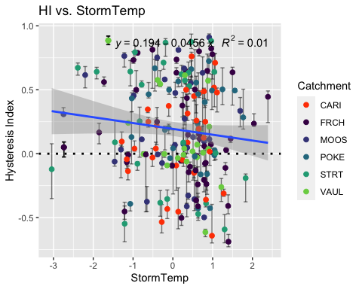

NO3_data.7 <- HI_FI_NO3[,c("Hyst_index","TempWeek")]  
  
pairs(NO3_data.7)

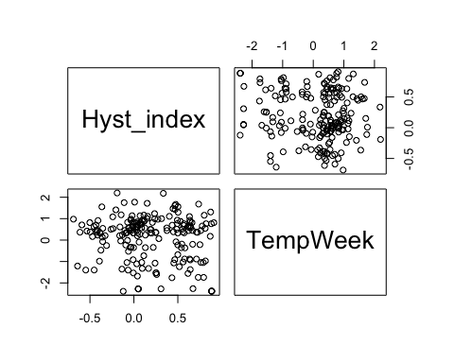

HI_FI_NO3 %>% ggplot(aes(x = TempWeek, y = Hyst_index)) +   
 geom_hline(yintercept = 0, linetype = "dotted", size = 1) +  
 geom_errorbar(aes(ymin=HI_ymin, ymax=HI_ymax), colour="black", alpha=0.5, size=.5, width = 0.1)+   
 geom_point(aes(color = site.ID), size = 2) +  
 scale_color_manual(values = c("orange red", viridis::viridis(6)), "Catchment")+  
 geom_smooth(method = "lm", na.rm = TRUE, fullrange = TRUE, aes(group = 1)) +   
 stat_poly_eq(formula = y~x,  
 label.y = "top", label.x = "right",  
 aes(label = paste(..eq.label.., ..rr.label.., sep = "~~~")),   
 parse = TRUE) +   
 ylab("Hysteresis Index") +  
 ggtitle("HI vs. StormTemp")

## `geom_smooth()` using formula 'y ~ x'

## Warning: Removed 6 rows containing non-finite values (stat_poly_eq).

## Warning: Removed 6 rows containing missing values (geom_point).

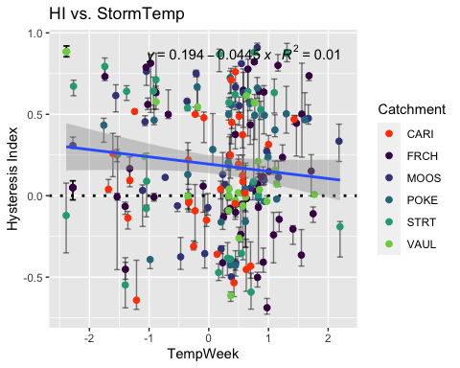

NO3_data.8 <- HI_FI_NO3[,c("Hyst_index","TimeSinceChena")]  
  
pairs(NO3_data.8)

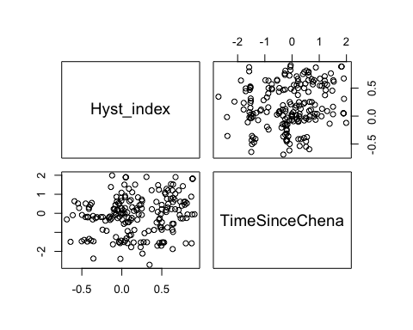

HI_FI_NO3 %>% ggplot(aes(x = TimeSinceChena, y = Hyst_index)) +   
 geom_hline(yintercept = 0, linetype = "dotted", size = 1) +  
 geom_errorbar(aes(ymin=HI_ymin, ymax=HI_ymax), colour="black", alpha = 0.5, size=.5, width = 0.1)+   
 geom_point(aes(color = site.ID, shape = as.factor(year)), size = 2) +  
 scale_color_manual(values = c("orange red", viridis::viridis(6)), "Catchment")+  
 geom_smooth(method = "lm", na.rm = TRUE, fullrange = TRUE, aes(group = 1)) +   
 stat_poly_eq(formula = y~x,  
 label.y = "top", label.x = "right",  
 aes(label = paste(..eq.label.., ..rr.label.., sep = "~~~")),   
 parse = TRUE) +   
 ylab("Hysteresis Index") +  
 ggtitle("HI vs. StormTemp")

## `geom_smooth()` using formula 'y ~ x'

## Warning: Removed 6 rows containing non-finite values (stat_poly_eq).

## Warning: Removed 6 rows containing missing values (geom_point).

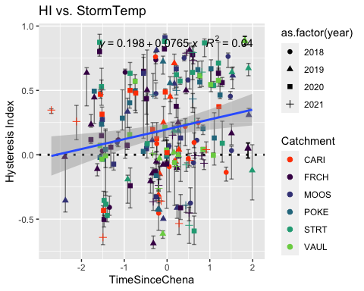

#### Correlation

NO3_data <- HI_FI_NO3[,c("Hyst_index", "site.ID", "StormPrecip", "StormTemp", "PrecipWeek", "PrecipMonth", "ThreeMonth", "TempWeek", "Intensity", "TimeSinceChena", "pf", "burn", "year")]  
NO3_data <- na.omit(NO3_data) # 236 to 223 rows   
cor(NO3_data[,c(1,3:10)])

## Hyst_index StormPrecip StormTemp PrecipWeek PrecipMonth  
## Hyst_index 1.00000000 -0.24042294 -0.1238678 -0.33691158 0.04035006  
## StormPrecip -0.24042294 1.00000000 0.1135049 0.06085225 -0.02477302  
## StormTemp -0.12386779 0.11350494 1.0000000 0.10597095 0.18246869  
## PrecipWeek -0.33691158 0.06085225 0.1059709 1.00000000 0.45622474  
## PrecipMonth 0.04035006 -0.02477302 0.1824687 0.45622474 1.00000000  
## ThreeMonth 0.22688269 -0.17814146 -0.2686345 0.07235675 0.54149608  
## TempWeek -0.12883414 0.20133904 0.8190297 0.16056772 0.19521076  
## Intensity 0.03038876 0.36008823 0.1337550 -0.08369641 -0.06759824  
## TimeSinceChena 0.22394402 -0.20371559 -0.7308023 -0.21662669 0.07193664  
## ThreeMonth TempWeek Intensity TimeSinceChena  
## Hyst_index 0.22688269 -0.1288341 0.03038876 0.22394402  
## StormPrecip -0.17814146 0.2013390 0.36008823 -0.20371559  
## StormTemp -0.26863452 0.8190297 0.13375502 -0.73080228  
## PrecipWeek 0.07235675 0.1605677 -0.08369641 -0.21662669  
## PrecipMonth 0.54149608 0.1952108 -0.06759824 0.07193664  
## ThreeMonth 1.00000000 -0.2012805 -0.10813357 0.61013405  
## TempWeek -0.20128047 1.0000000 0.13542234 -0.68172203  
## Intensity -0.10813357 0.1354223 1.00000000 -0.11425698  
## TimeSinceChena 0.61013405 -0.6817220 -0.11425698 1.00000000

1. Storm temperature is heavily correlated with temperature a week leading up to a storm (0.794) but storm temperature is slightly more correlated with HI (-0.173 vs. -0.164)
2. Storm temperature is also correlated with time since chena (-0.735) but time since chena is more correlated with HI (0.251 vs. -0.173) so this makes me want to keep Time since Chena and temperature a week before considering that is a more marginal comparison with HI and the temperature predictors.

3)Precip week is correlated with precip month (0.511) but precip week is more correlated with HI than precip month (-0.242 vs. 0.048)

4)Precip month is correlated with three month precip (0.591) but three month precip is more correlated with HI (0.220 vs. 0.048)

1. Three month is correlated with Time since Chena (0.619) but time since chena is more correlated with HI (0.251 vs. 0.220)

* to sum up this makes me want to drop storm temperature and three month precipitation…..but lets run the model with all of the candidate predictors first and go from there

## boundary (singular) fit: see ?isSingular

## Linear mixed model fit by REML ['lmerMod']  
## Formula: Hyst_index ~ StormPrecip + PrecipWeek + PrecipMonth + ThreeMonth +   
## Intensity + StormTemp + TempWeek + TimeSinceChena + (1 | site.ID)  
## Data: NO3_data  
##   
## REML criterion at convergence: 178  
##   
## Scaled residuals:   
## Min 1Q Median 3Q Max   
## -2.48986 -0.74644 -0.02836 0.76637 2.84280   
##   
## Random effects:  
## Groups Name Variance Std.Dev.  
## site.ID (Intercept) 0.0000 0.0000   
## Residual 0.1238 0.3518   
## Number of obs: 189, groups: site.ID, 6  
##   
## Fixed effects:  
## Estimate Std. Error t value  
## (Intercept) 0.192972 0.025780 7.485  
## StormPrecip -0.090266 0.028261 -3.194  
## PrecipWeek -0.166993 0.032128 -5.198  
## PrecipMonth 0.071605 0.039508 1.812  
## ThreeMonth 0.064478 0.042638 1.512  
## Intensity 0.049438 0.030756 1.607  
## StormTemp -0.059469 0.051407 -1.157  
## TempWeek 0.005457 0.046436 0.118  
## TimeSinceChena -0.045355 0.053463 -0.848  
##   
## Correlation of Fixed Effects:  
## (Intr) StrmPr PrcpWk PrcpMn ThrMnt Intnst StrmTm TempWk  
## StormPrecip -0.013   
## PrecipWeek -0.003 -0.035   
## PrecipMonth 0.054 -0.045 -0.470   
## ThreeMonth -0.047 0.094 0.016 -0.508   
## Intensity 0.028 -0.349 0.077 0.034 0.006   
## StormTemp -0.035 0.149 0.236 -0.234 -0.009 -0.080   
## TempWeek -0.048 -0.162 -0.006 -0.022 -0.175 -0.001 -0.574   
## TimeSincChn -0.017 0.047 0.307 -0.045 -0.561 -0.031 0.418 0.266  
## optimizer (nloptwrap) convergence code: 0 (OK)  
## boundary (singular) fit: see ?isSingular

1. Scaled residulas look pretty good as our median is close to 0 and our quartiles are roughly the same
2. This shows us that the site explains 0 of our variance which doesn’t make complete sence
3. This makes it seem that precip week and storm precip are the most significant in HI which doesnt make sense when we have time since chena as the highest cor factor with HI

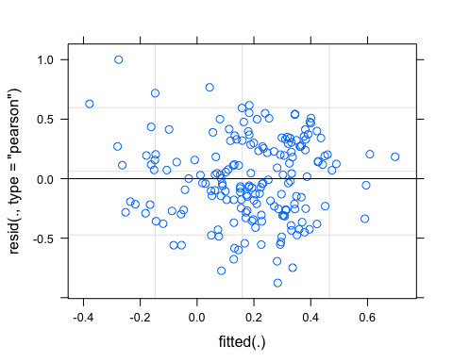 1) Ideally the residual plot will show no fitted pattern. The red line should be horizontal at 0.

This residual are spread equally along the ranges of predictors. It is good to see a horizontal line with equal spread points

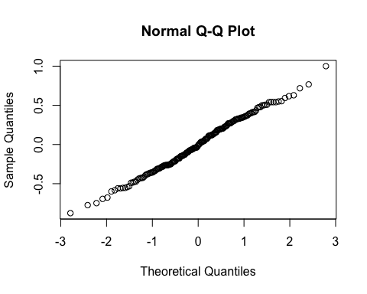 1) Ideally the QQ plot should be a straight line to visually check the normality assumptions. If it is not a straight line we can try log transforming the response variable but this looks pretty good.

vif(M0)

## StormPrecip PrecipWeek PrecipMonth ThreeMonth Intensity   
## 1.235705 1.515648 2.238218 2.803415 1.181512   
## StormTemp TempWeek TimeSinceChena   
## 4.119784 3.452655 4.407246

Anything above a 2 indicates a high correlation and should be removed….lets take StormTemp out and ThreeMonth

f1 <- formula(Hyst_index ~ StormPrecip + PrecipWeek + PrecipMonth + Intensity + TempWeek + TimeSinceChena + (1|site.ID))  
  
M1 <- lmer(f1, data = NO3_data)

## boundary (singular) fit: see ?isSingular

summary(M1)

## Linear mixed model fit by REML ['lmerMod']  
## Formula: Hyst_index ~ StormPrecip + PrecipWeek + PrecipMonth + Intensity +   
## TempWeek + TimeSinceChena + (1 | site.ID)  
## Data: NO3_data  
##   
## REML criterion at convergence: 173  
##   
## Scaled residuals:   
## Min 1Q Median 3Q Max   
## -2.55204 -0.69000 0.04951 0.75490 2.60348   
##   
## Random effects:  
## Groups Name Variance Std.Dev.  
## site.ID (Intercept) 0.0000 0.0000   
## Residual 0.1249 0.3534   
## Number of obs: 189, groups: site.ID, 6  
##   
## Fixed effects:  
## Estimate Std. Error t value  
## (Intercept) 0.19378 0.02585 7.497  
## StormPrecip -0.08943 0.02794 -3.201  
## PrecipWeek -0.15911 0.03135 -5.075  
## PrecipMonth 0.09118 0.03282 2.778  
## Intensity 0.04635 0.03079 1.506  
## TempWeek -0.01278 0.03724 -0.343  
## TimeSinceChena 0.02518 0.03855 0.653  
##   
## Correlation of Fixed Effects:  
## (Intr) StrmPr PrcpWk PrcpMn Intnst TempWk  
## StormPrecip -0.004   
## PrecipWeek 0.007 -0.075   
## PrecipMonth 0.026 0.047 -0.504   
## Intensity 0.025 -0.344 0.099 0.021   
## TempWeek -0.095 -0.076 0.171 -0.377 -0.059   
## TimeSincChn -0.041 0.053 0.314 -0.390 0.007 0.707  
## optimizer (nloptwrap) convergence code: 0 (OK)  
## boundary (singular) fit: see ?isSingular

vif(M1)

## StormPrecip PrecipWeek PrecipMonth Intensity TempWeek   
## 1.197135 1.431016 1.531418 1.173831 2.200955   
## TimeSinceChena   
## 2.271331

1. Our scaled residuals look good
2. Site still not accounting for any variance
3. This makes it seem like precip week leading up to the storm affects HI the most with precip month also significant
4. all VIFs are below 2 which is good!
5. TimeSinceChena and TempWeek are correlated with each other at 0.61 which breaks our rule of not including anything >0.5. Should I keep it as is or get rid of TempWeek

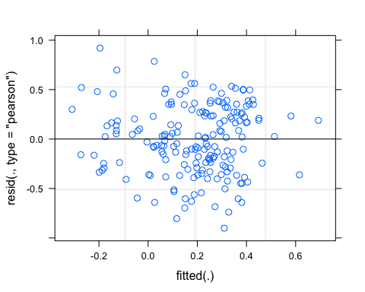

### Partial residuals

Plot partial residual for the interesting predictor – PrecipWeek

pr <- ggpredict(M1, terms = c("PrecipWeek"))  
plot(pr, add.data = TRUE)

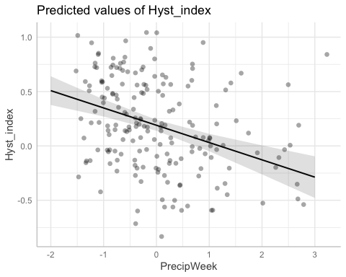

ggsave("~/Documents/Storms/Output_from_analysis/From_07_Modelling/HI/NO3/partial.residuals.pdf")

## Saving 5 x 4 in image

Visually look at the effect of PrecipWeek on HI and we would expect these to look like a nice regression model 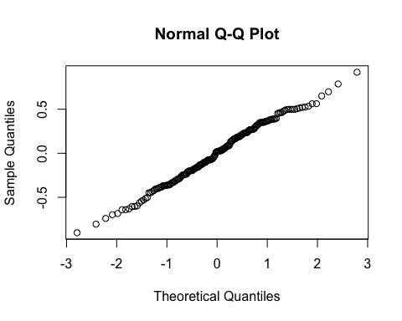

vif(M1)

## StormPrecip PrecipWeek PrecipMonth Intensity TempWeek   
## 1.197135 1.431016 1.531418 1.173831 2.200955   
## TimeSinceChena   
## 2.271331

TimeSinceChena and TempWeek are correlated (0.61) so lets try and remove TempWeek

f2 <- formula(Hyst_index ~ StormPrecip + PrecipWeek + PrecipMonth + Intensity + TimeSinceChena + (1|site.ID))  
  
M2 <- lmer(f2, REML = TRUE, data = NO3_data)

## boundary (singular) fit: see ?isSingular

summary(M2)

## Linear mixed model fit by REML ['lmerMod']  
## Formula: Hyst_index ~ StormPrecip + PrecipWeek + PrecipMonth + Intensity +   
## TimeSinceChena + (1 | site.ID)  
## Data: NO3_data  
##   
## REML criterion at convergence: 168.4  
##   
## Scaled residuals:   
## Min 1Q Median 3Q Max   
## -2.60111 -0.70603 0.05386 0.76389 2.59349   
##   
## Random effects:  
## Groups Name Variance Std.Dev.  
## site.ID (Intercept) 0.0000 0.0000   
## Residual 0.1243 0.3525   
## Number of obs: 189, groups: site.ID, 6  
##   
## Fixed effects:  
## Estimate Std. Error t value  
## (Intercept) 0.19294 0.02567 7.517  
## StormPrecip -0.09016 0.02779 -3.244  
## PrecipWeek -0.15727 0.03082 -5.103  
## PrecipMonth 0.08694 0.03033 2.866  
## Intensity 0.04573 0.03066 1.492  
## TimeSinceChena 0.03453 0.02721 1.269  
##   
## Correlation of Fixed Effects:  
## (Intr) StrmPr PrcpWk PrcpMn Intnst  
## StormPrecip -0.011   
## PrecipWeek 0.023 -0.063   
## PrecipMonth -0.011 0.021 -0.482   
## Intensity 0.020 -0.350 0.111 -0.001   
## TimeSincChn 0.038 0.151 0.276 -0.189 0.069  
## optimizer (nloptwrap) convergence code: 0 (OK)  
## boundary (singular) fit: see ?isSingular

pr <- ggpredict(M2, terms = c("PrecipWeek"))  
plot(pr, add.data = TRUE)

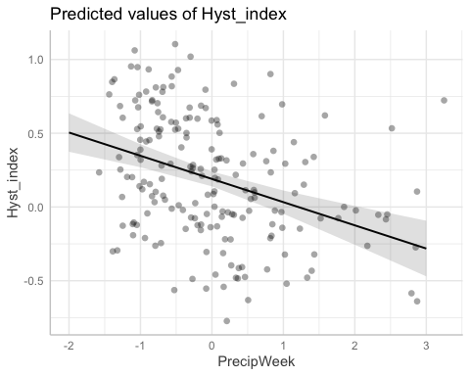

vif(M2)

## StormPrecip PrecipWeek PrecipMonth Intensity TimeSinceChena   
## 1.190285 1.389054 1.314220 1.169765 1.136827

f3 <- formula(Hyst_index ~ StormPrecip + PrecipWeek + PrecipMonth + Intensity + TempWeek + TimeSinceChena + (PrecipWeek|site.ID))  
  
M3 <- lmer(f3, REML = TRUE, data = NO3_data)

## boundary (singular) fit: see ?isSingular

summary(M3)

## Linear mixed model fit by REML ['lmerMod']  
## Formula: Hyst_index ~ StormPrecip + PrecipWeek + PrecipMonth + Intensity +   
## TempWeek + TimeSinceChena + (PrecipWeek | site.ID)  
## Data: NO3_data  
##   
## REML criterion at convergence: 173  
##   
## Scaled residuals:   
## Min 1Q Median 3Q Max   
## -2.56175 -0.69133 0.04755 0.75681 2.56392   
##   
## Random effects:  
## Groups Name Variance Std.Dev. Corr  
## site.ID (Intercept) 0.0000000 0.00000   
## PrecipWeek 0.0003526 0.01878 NaN  
## Residual 0.1245955 0.35298   
## Number of obs: 189, groups: site.ID, 6  
##   
## Fixed effects:  
## Estimate Std. Error t value  
## (Intercept) 0.19359 0.02587 7.482  
## StormPrecip -0.08944 0.02791 -3.205  
## PrecipWeek -0.15956 0.03234 -4.934  
## PrecipMonth 0.09143 0.03289 2.780  
## Intensity 0.04562 0.03078 1.482  
## TempWeek -0.01343 0.03726 -0.360  
## TimeSinceChena 0.02436 0.03857 0.631  
##   
## Correlation of Fixed Effects:  
## (Intr) StrmPr PrcpWk PrcpMn Intnst TempWk  
## StormPrecip -0.004   
## PrecipWeek 0.005 -0.072   
## PrecipMonth 0.026 0.047 -0.492   
## Intensity 0.026 -0.344 0.096 0.022   
## TempWeek -0.094 -0.075 0.169 -0.377 -0.058   
## TimeSincChn -0.039 0.053 0.306 -0.391 0.008 0.707  
## optimizer (nloptwrap) convergence code: 0 (OK)  
## boundary (singular) fit: see ?isSingular

alter structure between random slopes and random intercepts

pr.no3 <- ggpredict(M3, terms = c("PrecipWeek"))  
plot(pr.no3, add.data = TRUE)

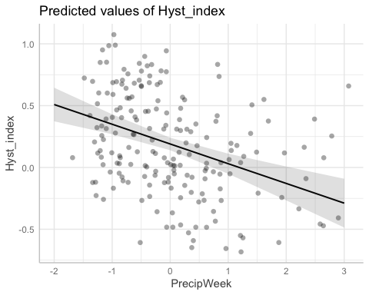

ggsave("~/Documents/Storms/Output_from_analysis/From_07_Modelling/HI/NO3/partial.residuals.png", device = "png")

## Saving 5 x 4 in image

f10 <- formula(Hyst_index ~ StormPrecip + PrecipWeek + PrecipMonth + Intensity + TempWeek + TimeSinceChena + (0+PrecipWeek|site.ID) + (1|site.ID))  
  
M10 <- lmer(f10, REML = TRUE, data = NO3_data)

## boundary (singular) fit: see ?isSingular

summary(M10)

## Linear mixed model fit by REML ['lmerMod']  
## Formula: Hyst_index ~ StormPrecip + PrecipWeek + PrecipMonth + Intensity +   
## TempWeek + TimeSinceChena + (0 + PrecipWeek | site.ID) + (1 | site.ID)  
## Data: NO3_data  
##   
## REML criterion at convergence: 173  
##   
## Scaled residuals:   
## Min 1Q Median 3Q Max   
## -2.56175 -0.69133 0.04755 0.75681 2.56391   
##   
## Random effects:  
## Groups Name Variance Std.Dev.  
## site.ID PrecipWeek 0.0003527 0.01878   
## site.ID.1 (Intercept) 0.0000000 0.00000   
## Residual 0.1245955 0.35298   
## Number of obs: 189, groups: site.ID, 6  
##   
## Fixed effects:  
## Estimate Std. Error t value  
## (Intercept) 0.19359 0.02587 7.482  
## StormPrecip -0.08944 0.02791 -3.205  
## PrecipWeek -0.15956 0.03234 -4.934  
## PrecipMonth 0.09143 0.03289 2.780  
## Intensity 0.04562 0.03078 1.482  
## TempWeek -0.01343 0.03726 -0.360  
## TimeSinceChena 0.02436 0.03857 0.631  
##   
## Correlation of Fixed Effects:  
## (Intr) StrmPr PrcpWk PrcpMn Intnst TempWk  
## StormPrecip -0.004   
## PrecipWeek 0.005 -0.072   
## PrecipMonth 0.026 0.047 -0.492   
## Intensity 0.026 -0.344 0.096 0.022   
## TempWeek -0.094 -0.075 0.169 -0.377 -0.058   
## TimeSincChn -0.039 0.053 0.306 -0.391 0.008 0.707  
## optimizer (nloptwrap) convergence code: 0 (OK)  
## boundary (singular) fit: see ?isSingular

f11 <- formula(Hyst_index ~ StormPrecip + PrecipWeek + PrecipMonth + Intensity + TempWeek + TimeSinceChena + (1|site.ID) + (1|year))  
  
M11 <- lmer(f11, data = NO3_data)

## boundary (singular) fit: see ?isSingular

summary(M11)

## Linear mixed model fit by REML ['lmerMod']  
## Formula: Hyst_index ~ StormPrecip + PrecipWeek + PrecipMonth + Intensity +   
## TempWeek + TimeSinceChena + (1 | site.ID) + (1 | year)  
## Data: NO3_data  
##   
## REML criterion at convergence: 168.5  
##   
## Scaled residuals:   
## Min 1Q Median 3Q Max   
## -2.77865 -0.68385 -0.00999 0.76489 2.79039   
##   
## Random effects:  
## Groups Name Variance Std.Dev.  
## site.ID (Intercept) 0.00000 0.0000   
## year (Intercept) 0.01176 0.1084   
## Residual 0.11882 0.3447   
## Number of obs: 189, groups: site.ID, 6; year, 4  
##   
## Fixed effects:  
## Estimate Std. Error t value  
## (Intercept) 0.16352 0.06096 2.682  
## StormPrecip -0.08369 0.02741 -3.053  
## PrecipWeek -0.16112 0.03130 -5.148  
## PrecipMonth 0.06793 0.03350 2.028  
## Intensity 0.04058 0.03034 1.337  
## TempWeek -0.03161 0.03697 -0.855  
## TimeSinceChena 0.02768 0.03814 0.726  
##   
## Correlation of Fixed Effects:  
## (Intr) StrmPr PrcpWk PrcpMn Intnst TempWk  
## StormPrecip -0.019   
## PrecipWeek 0.017 -0.091   
## PrecipMonth 0.032 0.045 -0.503   
## Intensity 0.032 -0.345 0.095 0.027   
## TempWeek -0.003 -0.091 0.181 -0.330 -0.041   
## TimeSincChn -0.013 0.041 0.337 -0.400 0.003 0.691  
## optimizer (nloptwrap) convergence code: 0 (OK)  
## boundary (singular) fit: see ?isSingular

f12 <- formula(Hyst_index ~ StormPrecip + PrecipWeek + PrecipMonth + Intensity + TempWeek + TimeSinceChena + (0+PrecipWeek|site.ID) + (1|site.ID) + (1|year))  
  
M12 <- lmer(f12, data = NO3_data)

## boundary (singular) fit: see ?isSingular

aictab(list(M0,M1,M2,M3,M10,M11,M12))

## Warning in aictab.AIClmerMod(list(M0, M1, M2, M3, M10, M11, M12)):   
## Model names have been supplied automatically in the table

## Warning in aictab.AIClmerMod(list(M0, M1, M2, M3, M10, M11, M12)):   
## Model selection for fixed effects is only appropriate with ML estimation:  
## REML (default) should only be used to select random effects for a constant set of fixed effects

##   
## Model selection based on AICc:  
##   
## K AICc Delta_AICc AICcWt Cum.Wt Res.LL  
## Mod3 8 185.17 0.00 0.84 0.84 -84.19  
## Mod6 10 189.74 4.57 0.09 0.93 -84.25  
## Mod7 11 191.58 6.40 0.03 0.96 -84.04  
## Mod2 9 192.00 6.83 0.03 0.99 -86.50  
## Mod5 10 194.22 9.05 0.01 1.00 -86.49  
## Mod4 11 196.48 11.30 0.00 1.00 -86.49  
## Mod1 11 201.48 16.30 0.00 1.00 -88.99

Mod3: Model without TempWeek, ThreeMonth, or StormTemp with a random intercept structure Mod2: Model without ThreeMonth or StormTemp with a random intercept structure Mod5: Reduced model with random slopes and intercepts uncorrelated Mod6: Reduced model with random effect of year and site Mod7: Reduced model with random effect of year with uncorrelated structure Mod4: Model without ThreeMonth or StormTemp with a random slope structure with (PrecipWeek|site.ID) Mod1: full model with all candidate predictors and random intercept structure

This shows us that the random intercept structure is a better fit model

### Dot and Whisker plot

m1 <- lm(Hyst_index ~ StormPrecip + PrecipWeek + PrecipMonth + Intensity + TempWeek + TimeSinceChena, data = NO3_data)  
dwplot(m1,  
 dot_args = list(color = "black"), # color for the dot  
 whisker_args = list(color = "red"), # color for the whisker  
 vline = geom_vline(xintercept = 0, colour = "grey50", linetype = 2)) +  
 xlab("Coefficient") +   
 ggtitle("") +  
 theme_classic()

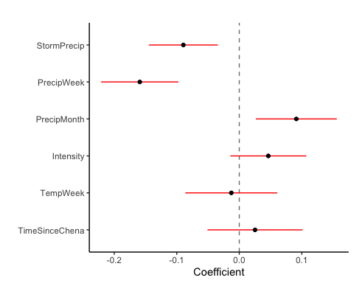

#ggsave("~/Documents/Storms/Output_from_analysis/From_07_Modelling/HI/NO3/coefficient.png")

CI overlapping 0 are nonsignificant

summary(M1)

## Linear mixed model fit by REML ['lmerMod']  
## Formula: Hyst_index ~ StormPrecip + PrecipWeek + PrecipMonth + Intensity +   
## TempWeek + TimeSinceChena + (1 | site.ID)  
## Data: NO3_data  
##   
## REML criterion at convergence: 173  
##   
## Scaled residuals:   
## Min 1Q Median 3Q Max   
## -2.55204 -0.69000 0.04951 0.75490 2.60348   
##   
## Random effects:  
## Groups Name Variance Std.Dev.  
## site.ID (Intercept) 0.0000 0.0000   
## Residual 0.1249 0.3534   
## Number of obs: 189, groups: site.ID, 6  
##   
## Fixed effects:  
## Estimate Std. Error t value  
## (Intercept) 0.19378 0.02585 7.497  
## StormPrecip -0.08943 0.02794 -3.201  
## PrecipWeek -0.15911 0.03135 -5.075  
## PrecipMonth 0.09118 0.03282 2.778  
## Intensity 0.04635 0.03079 1.506  
## TempWeek -0.01278 0.03724 -0.343  
## TimeSinceChena 0.02518 0.03855 0.653  
##   
## Correlation of Fixed Effects:  
## (Intr) StrmPr PrcpWk PrcpMn Intnst TempWk  
## StormPrecip -0.004   
## PrecipWeek 0.007 -0.075   
## PrecipMonth 0.026 0.047 -0.504   
## Intensity 0.025 -0.344 0.099 0.021   
## TempWeek -0.095 -0.076 0.171 -0.377 -0.059   
## TimeSincChn -0.041 0.053 0.314 -0.390 0.007 0.707  
## optimizer (nloptwrap) convergence code: 0 (OK)  
## boundary (singular) fit: see ?isSingular

anova(M0, M1, test = "Chi")

## refitting model(s) with ML (instead of REML)

## Warning in optwrap(optimizer, devfun, x@theta, lower = x@lower, calc.derivs =  
## TRUE, : convergence code 3 from bobyqa: bobyqa -- a trust region step failed to  
## reduce q

## Data: NO3_data  
## Models:  
## M1: Hyst_index ~ StormPrecip + PrecipWeek + PrecipMonth + Intensity +   
## M1: TempWeek + TimeSinceChena + (1 | site.ID)  
## M0: Hyst_index ~ StormPrecip + PrecipWeek + PrecipMonth + ThreeMonth +   
## M0: Intensity + StormTemp + TempWeek + TimeSinceChena + (1 |   
## M0: site.ID)  
## npar AIC BIC logLik deviance Chisq Df Pr(>Chisq)  
## M1 9 154.02 183.19 -68.009 136.02   
## M0 11 154.28 189.94 -66.141 132.28 3.7346 2 0.1545

plot(M1, site.ID ~ resid(.), abline = 0 ) # generate diagnostic plots

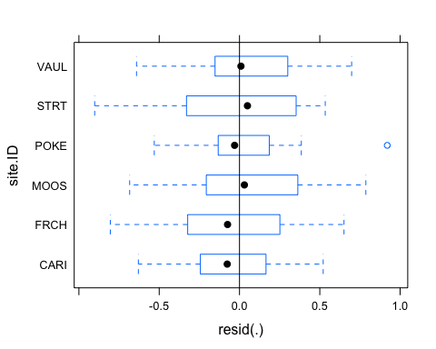 Looking for equal variance -testing assumptions of the model

This plot shows us that there are some outliers in POKE and that the variability within FRCH is greater than in other sites we therefore examine the sites in isolation standardized residuals versus fitted values

plot(M1, resid(., type = "pearson") ~ fitted(.) | site.ID, id = 0.05,   
 adj = -0.3, pch = 20, col = "gray40")

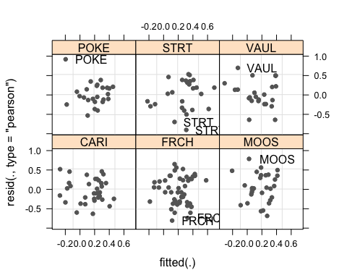 The plot shows the standardized residuals (or Pearson’s residuals) versus fitted values and suggests that there are outliers in the data (the names elements in the plots). To check if these outliers are a cause for concern, we will now use a Levene’s test to check if the variance is distributed homogeneously (homoscedasticity) or whether the assumption of variance homogeneity is violated (due to the outliers).

### Mixed effect model is a pseudo r^2

sjPlot::tab_model(M1)

## Warning: Argument 'df_method' is deprecated. Please use 'ci_method' instead.

Hyst_index

Predictors

Estimates

CI

p

(Intercept)

0.19

0.14 – 0.24

<0.001

StormPrecip

-0.09

-0.14 – -0.03

0.002

PrecipWeek

-0.16

-0.22 – -0.10

<0.001

PrecipMonth

0.09

0.03 – 0.16

0.006

Intensity

0.05

-0.01 – 0.11

0.134

TempWeek

-0.01

-0.09 – 0.06

0.732

TimeSinceChena

0.03

-0.05 – 0.10

0.514

Random Effects

σ2

0.12

τ00 site.ID

0.00

N site.ID

6

Observations

189

Marginal R2 / Conditional R2

0.215 / NA

The R2 values of the summary table are incorrect (as indicated by the missing conditional R2 value). The more appropriate conditional and marginal coefficient of determination for generalized mixed-effect models can be extracted using the r.squaredGLMM function from the MuMIn package

The marginal R2 (marginal coefficient of determination) represents the variance explained by the fixed effects while the conditional R2 is interpreted as a variance explained by the entire model, including both fixed and random effects

r.squaredGLMM(M1)

## Warning: 'r.squaredGLMM' now calculates a revised statistic. See the help page.

## R2m R2c  
## [1,] 0.2145427 0.2145427

random effect isnt explaining only explaining 15 % of the model….maybe dont need a random effect in the model at all if it is 0

sjPlot::plot_model(M1, type = "pred", terms = c("PrecipWeek")) +  
 # show uncentered date rather than centered date  
 scale_x_continuous(name = "PrecipWeek",   
 breaks = seq(-500, 300, 100),   
 labels = seq(1150, 1950, 100))

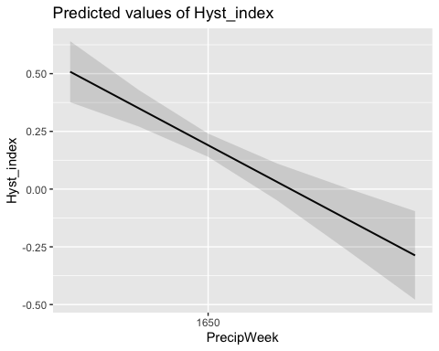 While we have already shown that the effect of PrecipWeek is significant, it is small which means that the HI does not correlate very strongly with PrecipWeek. This suggests that other factors that are not included in the model also influence HI (and probably more meaningfully, too).

Before turning to the diagnostics, we will use the fitted (or predicted) and the observed values with a regression line for the predicted values. This will not only show how good the model fit the data but also the direction and magnitude of the effect.

### Interactions

### Permafrost

f4 <- formula(Hyst_index ~ StormPrecip*pf + PrecipWeek*pf + PrecipMonth*pf + Intensity*pf + TempWeek*pf + TimeSinceChena*pf + (1|site.ID))  
  
M4 <- lmer(f4, data = NO3_data)

## boundary (singular) fit: see ?isSingular

summary(M4)

## Linear mixed model fit by REML ['lmerMod']  
## Formula: Hyst_index ~ StormPrecip * pf + PrecipWeek * pf + PrecipMonth *   
## pf + Intensity * pf + TempWeek * pf + TimeSinceChena * pf +   
## (1 | site.ID)  
## Data: NO3_data  
##   
## REML criterion at convergence: 191.2  
##   
## Scaled residuals:   
## Min 1Q Median 3Q Max   
## -2.33793 -0.72041 -0.01313 0.77034 2.53801   
##   
## Random effects:  
## Groups Name Variance Std.Dev.  
## site.ID (Intercept) 0.000 0.0000   
## Residual 0.125 0.3535   
## Number of obs: 189, groups: site.ID, 6  
##   
## Fixed effects:  
## Estimate Std. Error t value  
## (Intercept) 0.208924 0.055052 3.795  
## StormPrecip -0.055603 0.052696 -1.055  
## pfmedium -0.034619 0.063268 -0.547  
## PrecipWeek -0.157801 0.067577 -2.335  
## PrecipMonth 0.077617 0.073130 1.061  
## Intensity 0.061764 0.042023 1.470  
## TempWeek -0.090535 0.086971 -1.041  
## TimeSinceChena 0.033154 0.106722 0.311  
## StormPrecip:pfmedium -0.028006 0.064172 -0.436  
## pfmedium:PrecipWeek 0.003522 0.077032 0.046  
## pfmedium:PrecipMonth 0.028208 0.082422 0.342  
## pfmedium:Intensity -0.042815 0.066712 -0.642  
## pfmedium:TempWeek 0.119841 0.096970 1.236  
## pfmedium:TimeSinceChena -0.013238 0.114902 -0.115

##   
## Correlation matrix not shown by default, as p = 14 > 12.  
## Use print(x, correlation=TRUE) or  
## vcov(x) if you need it

## optimizer (nloptwrap) convergence code: 0 (OK)  
## boundary (singular) fit: see ?isSingular

This shows us if there is an interaction with any of our candidate predictors and permafrost extent and it doesnt seem like there is any

### burn

f5 <- formula(Hyst_index ~ StormPrecip*burn + PrecipWeek*burn + PrecipMonth*burn + Intensity*burn + TempWeek*burn + TimeSinceChena*pf + (1|site.ID))  
  
M5 <- lmer(f5, data = NO3_data)

## boundary (singular) fit: see ?isSingular

summary(M5)

## Linear mixed model fit by REML ['lmerMod']  
## Formula: Hyst_index ~ StormPrecip * burn + PrecipWeek * burn + PrecipMonth *   
## burn + Intensity * burn + TempWeek * burn + TimeSinceChena *   
## pf + (1 | site.ID)  
## Data: NO3_data  
##   
## REML criterion at convergence: 195  
##   
## Scaled residuals:   
## Min 1Q Median 3Q Max   
## -2.8478 -0.6932 -0.1052 0.7620 2.5091   
##   
## Random effects:  
## Groups Name Variance Std.Dev.  
## site.ID (Intercept) 0.000 0.0000   
## Residual 0.125 0.3535   
## Number of obs: 189, groups: site.ID, 6  
##   
## Fixed effects:  
## Estimate Std. Error t value  
## (Intercept) 0.188722 0.061940 3.047  
## StormPrecip -0.114623 0.036519 -3.139  
## burnunburned -0.032353 0.057914 -0.559  
## PrecipWeek -0.154308 0.037627 -4.101  
## PrecipMonth 0.075565 0.044518 1.697  
## Intensity 0.053817 0.034390 1.565  
## TempWeek 0.041050 0.045950 0.893  
## TimeSinceChena 0.104991 0.062330 1.684  
## pfmedium 0.001821 0.065580 0.028  
## StormPrecip:burnunburned 0.098873 0.065838 1.502  
## burnunburned:PrecipWeek 0.002337 0.065225 0.036  
## burnunburned:PrecipMonth 0.030552 0.062916 0.486  
## burnunburned:Intensity -0.109115 0.107666 -1.013  
## burnunburned:TempWeek -0.086913 0.053542 -1.623  
## TimeSinceChena:pfmedium -0.106308 0.059913 -1.774

##   
## Correlation matrix not shown by default, as p = 15 > 12.  
## Use print(x, correlation=TRUE) or  
## vcov(x) if you need it

## optimizer (nloptwrap) convergence code: 0 (OK)  
## boundary (singular) fit: see ?isSingular

This shows us if there is an interaction with any of our candidate predictors and burn vs. unburned catchments and it doesnt seem like there are any

fDOM

#### Scatter plot matrix

HI_FI_fDOM_CARI <- filter(HI_FI_fDOM, site.ID == "CARI")  
HI_FI_fDOM_FRCH <- filter(HI_FI_fDOM, site.ID == "FRCH")  
HI_FI_fDOM_MOOS <- filter(HI_FI_fDOM, site.ID == "MOOS")  
HI_FI_fDOM_POKE <- filter(HI_FI_fDOM, site.ID == "POKE")  
HI_FI_fDOM_VAUL <- filter(HI_FI_fDOM, site.ID == "VAUL")  
HI_FI_fDOM_STRT <- filter(HI_FI_fDOM, site.ID == "STRT")  
  
fDOM_data.1 <- HI_FI_fDOM[,c("Hyst_index","StormPrecip")]  
  
pairs(fDOM_data.1)

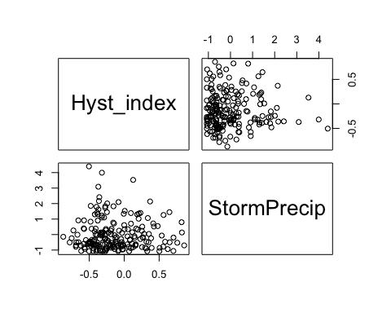

HI_FI_fDOM %>% ggplot(aes(x = StormPrecip, y = Hyst_index)) +   
 geom_hline(yintercept = 0, linetype = "dotted", size = 1) +  
 geom_errorbar(aes(ymin=HI_ymin, ymax=HI_ymax), colour="black", alpha=0.5, size=.5, width = 0.1)+   
 geom_point(aes(color = site.ID), size = 2) +  
 scale_color_manual(values = c("orange red", viridis::viridis(6)), "Catchment")+theme_bw() +  
 geom_smooth(method = "lm", na.rm = TRUE, fullrange = TRUE, aes(group = 1)) +   
 stat_poly_eq(formula = y~x,  
 label.y = "top", label.x = "right",  
 aes(label = paste(..eq.label.., ..rr.label.., sep = "~~~")),   
 parse = TRUE) +   
 ylab("Hysteresis Index") +  
 ggtitle("HI vs. StormPrecip")

## `geom_smooth()` using formula 'y ~ x'

## Warning: Removed 1 rows containing non-finite values (stat_poly_eq).

## Warning: Removed 1 rows containing missing values (geom_point).

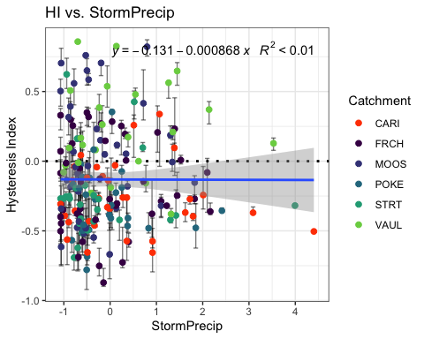 Big storms in FRCH but why not every where else

fDOM_data.2 <- HI_FI_fDOM[,c("Hyst_index","PrecipWeek")]  
  
pairs(fDOM_data.2)

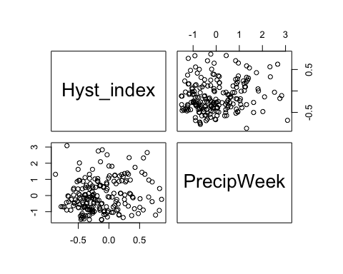

HI_FI_fDOM %>% ggplot(aes(x = PrecipWeek, y = Hyst_index)) +   
 geom_hline(yintercept = 0, linetype = "dotted", size = 1) +  
 geom_errorbar(aes(ymin=HI_ymin, ymax=HI_ymax), colour="black", alpha=0.5, size=.5, width = 0.1)+   
 geom_point(aes(color = site.ID), size = 2) +  
 scale_color_manual(values = c("orange red", viridis::viridis(6)), "Catchment")+theme_bw() +  
 geom_smooth(method = "lm", na.rm = TRUE, fullrange = TRUE, aes(group = 1)) +   
 stat_poly_eq(formula = y~x,  
 label.y = "top", label.x = "right",  
 aes(label = paste(..eq.label.., ..rr.label.., sep = "~~~")),   
 parse = TRUE) +   
 ylab("Hysteresis Index") +  
 ggtitle("HI vs. PrecipWeek")

## `geom_smooth()` using formula 'y ~ x'

## Warning: Removed 1 rows containing non-finite values (stat_poly_eq).

## Warning: Removed 1 rows containing missing values (geom_point).

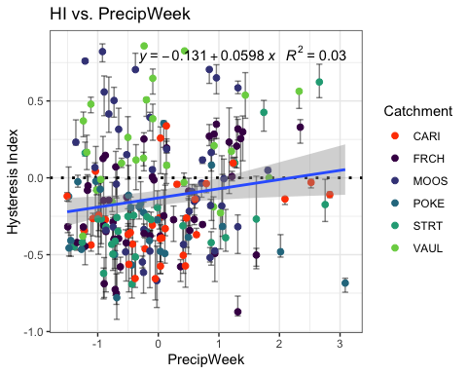

fDOM_data.3 <- HI_FI_fDOM[,c("Hyst_index","PrecipMonth")]  
  
pairs(fDOM_data.3)

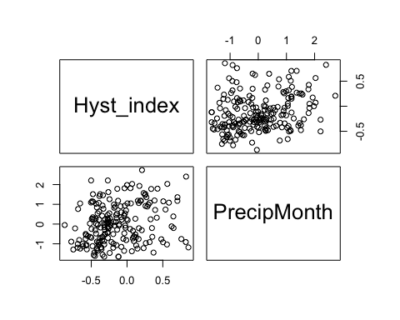

HI_FI_fDOM %>% ggplot(aes(x = PrecipMonth, y = Hyst_index)) +   
 geom_hline(yintercept = 0, linetype = "dotted", size = 1) +  
 geom_errorbar(aes(ymin=HI_ymin, ymax=HI_ymax), colour="black", alpha=0.5, size=.5, width = 0.1)+   
 geom_point(aes(color = site.ID), size = 2) +  
 scale_color_manual(values = c("orange red", viridis::viridis(6)), "Catchment")+theme_bw() +  
 geom_smooth(method = "lm", na.rm = TRUE, fullrange = TRUE, aes(group = 1)) +   
 stat_poly_eq(formula = y~x,  
 label.y = "top", label.x = "right",  
 aes(label = paste(..eq.label.., ..rr.label.., sep = "~~~")),   
 parse = TRUE) +   
 ylab("Hysteresis Index") +  
 ggtitle("HI vs. PrecipMonth")

## `geom_smooth()` using formula 'y ~ x'

## Warning: Removed 1 rows containing non-finite values (stat_poly_eq).

## Warning: Removed 1 rows containing missing values (geom_point).

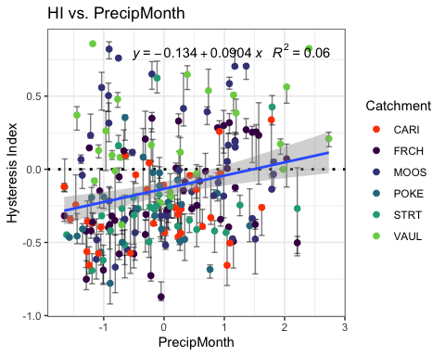

fDOM_data.4 <- HI_FI_fDOM[,c("Hyst_index","ThreeMonth")]  
  
pairs(fDOM_data.4)

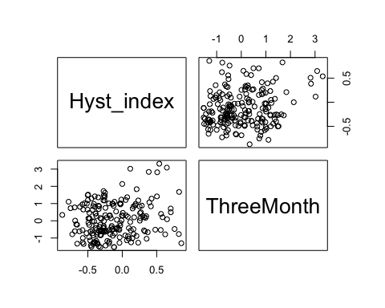

HI_FI_fDOM %>% ggplot(aes(x = ThreeMonth, y = Hyst_index)) +   
 geom_hline(yintercept = 0, linetype = "dotted", size = 1) +  
 geom_errorbar(aes(ymin=HI_ymin, ymax=HI_ymax), colour="black", alpha=0.5, size=.5, width = 0.1)+   
 geom_point(aes(color = site.ID), size = 2) +  
 scale_color_manual(values = c("orange red", viridis::viridis(6)), "Catchment")+theme_bw() +  
 geom_smooth(method = "lm", na.rm = TRUE, fullrange = TRUE, aes(group = 1)) +   
 stat_poly_eq(formula = y~x,  
 label.y = "top", label.x = "right",  
 aes(label = paste(..eq.label.., ..rr.label.., sep = "~~~")),   
 parse = TRUE) +   
 ylab("Hysteresis Index") +  
 ggtitle("HI vs. ThreeMonth")

## `geom_smooth()` using formula 'y ~ x'

## Warning: Removed 1 rows containing non-finite values (stat_poly_eq).

## Warning: Removed 1 rows containing missing values (geom_point).

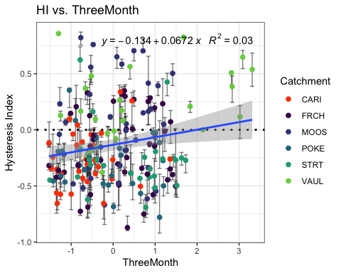

fDOM_data.5 <- HI_FI_fDOM[,c("Hyst_index","Intensity")]  
  
pairs(fDOM_data.5)

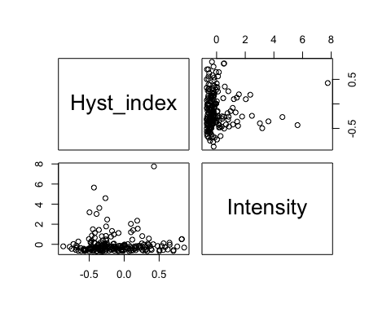

HI_FI_fDOM %>% ggplot(aes(x = Intensity, y = Hyst_index)) +   
 geom_hline(yintercept = 0, linetype = "dotted", size = 1) +  
 geom_errorbar(aes(ymin=HI_ymin, ymax=HI_ymax), colour="black", alpha=0.5, size=.5, width = 0.1)+   
 geom_point(aes(color = site.ID), size = 2) +  
 scale_color_manual(values = c("orange red", viridis::viridis(6)), "Catchment")+theme_bw() +  
 geom_smooth(method = "lm", na.rm = TRUE, fullrange = TRUE, aes(group = 1)) +   
 stat_poly_eq(formula = y~x,  
 label.y = "top", label.x = "right",  
 aes(label = paste(..eq.label.., ..rr.label.., sep = "~~~")),   
 parse = TRUE) +   
 ylab("Hysteresis Index") +  
 ggtitle("HI vs. Intensity")

## `geom_smooth()` using formula 'y ~ x'

## Warning: Removed 2 rows containing non-finite values (stat_poly_eq).

## Warning: Removed 2 rows containing missing values (geom_point).

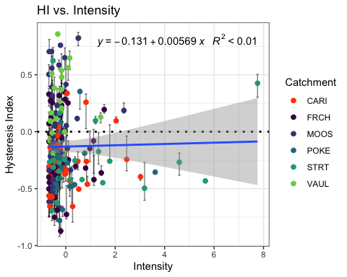

fDOM_data.6 <- HI_FI_fDOM[,c("Hyst_index","StormTemp")]  
  
pairs(fDOM_data.6)

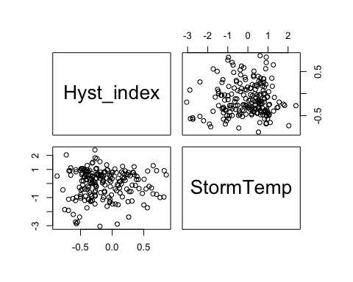

HI_FI_fDOM %>% ggplot(aes(x = StormTemp, y = Hyst_index)) +   
 geom_hline(yintercept = 0, linetype = "dotted", size = 1) +  
 geom_errorbar(aes(ymin=HI_ymin, ymax=HI_ymax), colour="black", alpha=0.5, size=.5, width = 0.1)+   
 geom_point(aes(color = site.ID), size = 2) +  
 scale_color_manual(values = c("orange red", viridis::viridis(6)), "Catchment")+theme_bw() +  
 geom_smooth(method = "lm", na.rm = TRUE, fullrange = TRUE, aes(group = 1)) +   
 stat_poly_eq(formula = y~x,  
 label.y = "top", label.x = "right",  
 aes(label = paste(..eq.label.., ..rr.label.., sep = "~~~")),   
 parse = TRUE) +   
 ylab("Hysteresis Index") +  
 ggtitle("HI vs. StormTemp")

## `geom_smooth()` using formula 'y ~ x'

## Warning: Removed 1 rows containing non-finite values (stat_poly_eq).

## Warning: Removed 1 rows containing missing values (geom_point).

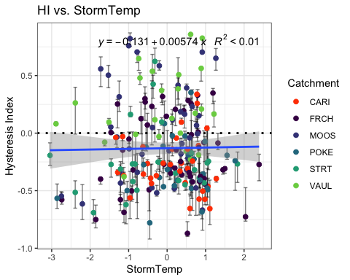

fDOM_data.7 <- HI_FI_fDOM[,c("Hyst_index","TempWeek")]  
  
pairs(fDOM_data.7)

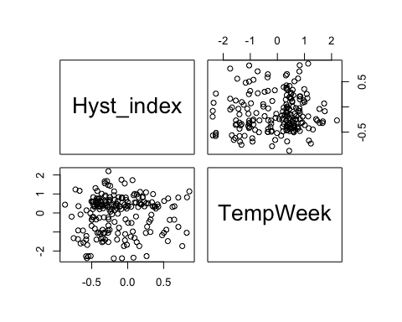

HI_FI_fDOM %>% ggplot(aes(x = TempWeek, y = Hyst_index)) +   
 geom_hline(yintercept = 0, linetype = "dotted", size = 1) +  
 geom_errorbar(aes(ymin=HI_ymin, ymax=HI_ymax), colour="black", alpha=0.5, size=.5, width = 0.1)+   
 geom_point(aes(color = site.ID), size = 2) +  
 scale_color_manual(values = c("orange red", viridis::viridis(6)), "Catchment")+theme_bw() +  
 geom_smooth(method = "lm", na.rm = TRUE, fullrange = TRUE, aes(group = 1)) +   
 stat_poly_eq(formula = y~x,  
 label.y = "top", label.x = "right",  
 aes(label = paste(..eq.label.., ..rr.label.., sep = "~~~")),   
 parse = TRUE) +   
 ylab("Hysteresis Index") +  
 ggtitle("HI vs. TempWeek")

## `geom_smooth()` using formula 'y ~ x'

## Warning: Removed 2 rows containing non-finite values (stat_poly_eq).

## Warning: Removed 2 rows containing missing values (geom_point).

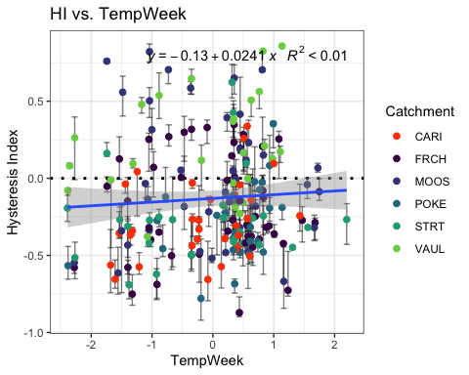

fDOM_data.8 <- HI_FI_fDOM[,c("Hyst_index","TimeSinceChena")]  
  
pairs(fDOM_data.8)

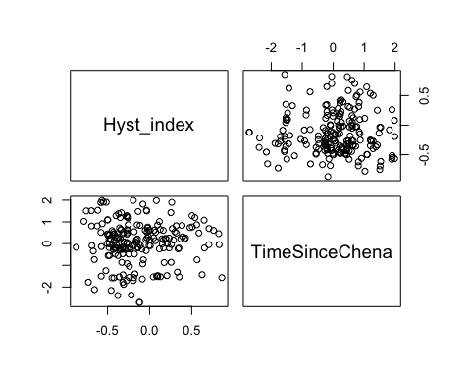

HI_FI_fDOM %>% ggplot(aes(x = TimeSinceChena, y = Hyst_index)) +   
 geom_hline(yintercept = 0, linetype = "dotted", size = 1) +  
 geom_errorbar(aes(ymin=HI_ymin, ymax=HI_ymax), colour="black", alpha=0.5, size=.5, width = 0.1)+   
 geom_point(aes(color = site.ID), size = 2) +  
 scale_color_manual(values = c("orange red", viridis::viridis(6)), "Catchment")+theme_bw() +  
 geom_smooth(method = "lm", na.rm = TRUE, fullrange = TRUE, aes(group = 1)) +   
 stat_poly_eq(formula = y~x,  
 label.y = "top", label.x = "right",  
 aes(label = paste(..eq.label.., ..rr.label.., sep = "~~~")),   
 parse = TRUE) +   
 ylab("Hysteresis Index") +  
 ggtitle("HI vs. TimeSinceChena")

## `geom_smooth()` using formula 'y ~ x'

## Warning: Removed 1 rows containing non-finite values (stat_poly_eq).

## Warning: Removed 1 rows containing missing values (geom_point).

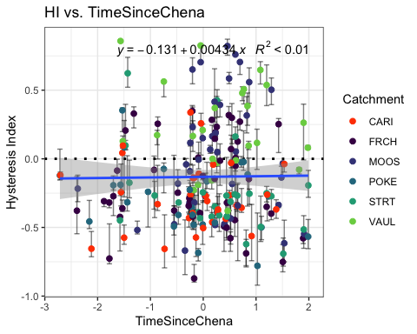 It appears that fDOM has slightly more site variation. It seems like there is a clearer distinction between sites and fDOM responses. Lets see if that shows in the model…

fDOM_data <- HI_FI_fDOM[,c("Hyst_index", "site.ID", "StormPrecip", "StormTemp", "PrecipWeek", "PrecipMonth", "ThreeMonth", "TempWeek", "Intensity", "TimeSinceChena", "burn", "pf", "year")]  
  
fDOM_data <- na.omit(fDOM_data) # 241 to 237  
cor(fDOM_data[, c(1,3:10)])

## Hyst_index StormPrecip StormTemp PrecipWeek PrecipMonth  
## Hyst_index 1.000000000 -0.004342514 0.01436595 0.168707757 0.26005762  
## StormPrecip -0.004342514 1.000000000 0.18660736 0.061001095 0.02481178  
## StormTemp 0.014365954 0.186607359 1.00000000 0.117901295 0.19845923  
## PrecipWeek 0.168707757 0.061001095 0.11790129 1.000000000 0.49753326  
## PrecipMonth 0.260057619 0.024811778 0.19845923 0.497533257 1.00000000  
## ThreeMonth 0.190943328 -0.119652618 -0.19204777 0.153737431 0.57622694  
## TempWeek 0.064013465 0.273948841 0.81824188 0.165240963 0.24401524  
## Intensity 0.016386653 0.300843347 0.12701695 0.002025812 0.02721456  
## TimeSinceChena 0.013294520 -0.194205835 -0.70987611 -0.124448073 0.09255937  
## ThreeMonth TempWeek Intensity TimeSinceChena  
## Hyst_index 0.19094333 0.06401347 0.016386653 0.01329452  
## StormPrecip -0.11965262 0.27394884 0.300843347 -0.19420583  
## StormTemp -0.19204777 0.81824188 0.127016947 -0.70987611  
## PrecipWeek 0.15373743 0.16524096 0.002025812 -0.12444807  
## PrecipMonth 0.57622694 0.24401524 0.027214561 0.09255937  
## ThreeMonth 1.00000000 -0.09989433 -0.022268748 0.55414010  
## TempWeek -0.09989433 1.00000000 0.152746884 -0.62113797  
## Intensity -0.02226875 0.15274688 1.000000000 -0.09378536  
## TimeSinceChena 0.55414010 -0.62113797 -0.093785361 1.00000000

1. Storm temperature is heavily correlated with temp week (0.798) but temp week is more correlated with HI (0.0892 vs. -0.0032)
2. Precip week is correlated with precip month (0.546) but precip month is more correlated with HI (0.281 vs. 0.190)
3. Precip month is correlated with three month (0.627) but precip month is more correlated with HI (0.281 vs. 0.224)
4. Three month is correlated with Time since Chena (0.567) but three month is more correlated with HI ( 0.224 vs. 0.0603)

* this makes me want to drop time since chena and three month

## Linear mixed model fit by REML ['lmerMod']  
## Formula: Hyst_index ~ StormPrecip + PrecipWeek + PrecipMonth + ThreeMonth +   
## Intensity + StormTemp + TempWeek + TimeSinceChena + (1 | site.ID)  
## Data: fDOM_data  
##   
## REML criterion at convergence: 160.5  
##   
## Scaled residuals:   
## Min 1Q Median 3Q Max   
## -2.22310 -0.64020 -0.09397 0.61844 2.83747   
##   
## Random effects:  
## Groups Name Variance Std.Dev.  
## site.ID (Intercept) 0.03702 0.1924   
## Residual 0.10137 0.3184   
## Number of obs: 199, groups: site.ID, 6  
##   
## Fixed effects:  
## Estimate Std. Error t value  
## (Intercept) -0.12757 0.08195 -1.557  
## StormPrecip -0.02199 0.02584 -0.851  
## PrecipWeek 0.01736 0.02793 0.621  
## PrecipMonth 0.06092 0.03631 1.678  
## ThreeMonth 0.01977 0.03981 0.496  
## Intensity 0.03649 0.02446 1.492  
## StormTemp -0.03653 0.04669 -0.782  
## TempWeek 0.01540 0.04346 0.354  
## TimeSinceChena -0.05406 0.04467 -1.210  
##   
## Correlation of Fixed Effects:  
## (Intr) StrmPr PrcpWk PrcpMn ThrMnt Intnst StrmTm TempWk  
## StormPrecip -0.003   
## PrecipWeek -0.003 -0.022   
## PrecipMonth 0.008 0.018 -0.459   
## ThreeMonth -0.007 0.036 0.034 -0.549   
## Intensity -0.013 -0.301 0.041 -0.056 0.024   
## StormTemp -0.013 0.129 0.159 -0.133 -0.093 -0.039   
## TempWeek 0.010 -0.240 -0.028 -0.089 -0.062 -0.013 -0.633   
## TimeSincChn -0.013 0.026 0.206 0.004 -0.549 -0.014 0.449 0.140

1. Scaled residuals look appropriate
2. The site accounts for slightly more variation

3)Precip month is the most significant

vif(M0.fDOM)

## StormPrecip PrecipWeek PrecipMonth ThreeMonth Intensity   
## 1.227942 1.439445 2.428707 2.689162 1.137856   
## StormTemp TempWeek TimeSinceChena   
## 4.118253 3.482768 3.480245

Any values over 2 indicate heavy correlation…lets remove ThreeMonth and StormTemp as this is what we did for NO3-

## Linear mixed model fit by REML ['lmerMod']  
## Formula: Hyst_index ~ StormPrecip + PrecipWeek + PrecipMonth + Intensity +   
## TempWeek + TimeSinceChena + (1 | site.ID)  
## Data: fDOM_data  
##   
## REML criterion at convergence: 152.3  
##   
## Scaled residuals:   
## Min 1Q Median 3Q Max   
## -2.24464 -0.63503 -0.08978 0.61110 2.82502   
##   
## Random effects:  
## Groups Name Variance Std.Dev.  
## site.ID (Intercept) 0.03803 0.1950   
## Residual 0.10065 0.3173   
## Number of obs: 199, groups: site.ID, 6  
##   
## Fixed effects:  
## Estimate Std. Error t value  
## (Intercept) -0.12808 0.08293 -1.544  
## StormPrecip -0.01997 0.02551 -0.783  
## PrecipWeek 0.02027 0.02745 0.738  
## PrecipMonth 0.06576 0.02950 2.229  
## Intensity 0.03564 0.02435 1.463  
## TempWeek -0.00389 0.03310 -0.118  
## TimeSinceChena -0.02876 0.03268 -0.880  
##   
## Correlation of Fixed Effects:  
## (Intr) StrmPr PrcpWk PrcpMn Intnst TempWk  
## StormPrecip -0.001   
## PrecipWeek 0.000 -0.046   
## PrecipMonth 0.002 0.077 -0.510   
## Intensity -0.013 -0.300 0.047 -0.061   
## TempWeek 0.001 -0.201 0.105 -0.388 -0.046   
## TimeSincChn -0.015 -0.010 0.220 -0.372 0.019 0.646

vif(M1.fDOM)

## StormPrecip PrecipWeek PrecipMonth Intensity TempWeek   
## 1.204642 1.399431 1.614316 1.135765 2.034450   
## TimeSinceChena   
## 1.876081

None of our VIFs are over 2 which is good! however as was true with NO3 PrecipWeek and PrecipMonth are correlated (0.54) and TimeSinceChena and TempWeek are correlated (-0.58)

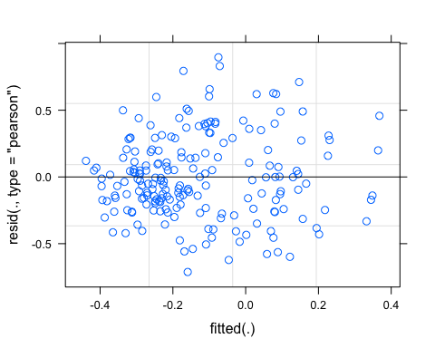 Potentially some funneling of the residuals from left to right

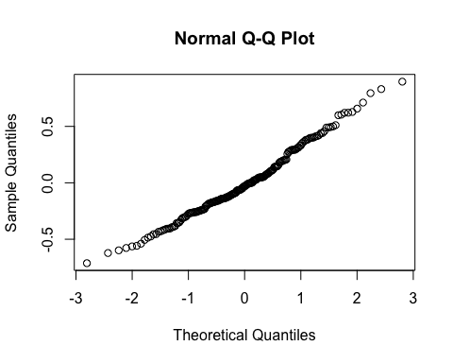

pr <- ggpredict(M1.fDOM, terms = c("PrecipMonth"))  
plot(pr, add.data = TRUE)

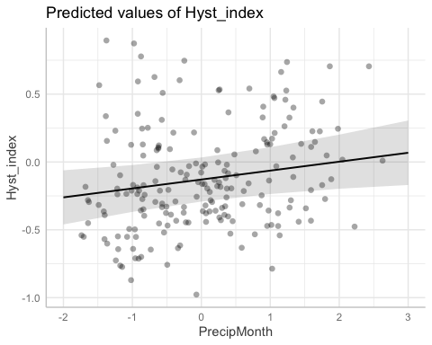

### Altnerative slopes

## Linear mixed model fit by REML ['lmerMod']  
## Formula: Hyst_index ~ StormPrecip + PrecipWeek + PrecipMonth + Intensity +   
## TempWeek + TimeSinceChena + (PrecipWeek | site.ID)  
## Data: fDOM_data  
##   
## REML criterion at convergence: 144.8  
##   
## Scaled residuals:   
## Min 1Q Median 3Q Max   
## -2.49178 -0.58713 -0.08038 0.53157 2.49249   
##   
## Random effects:  
## Groups Name Variance Std.Dev. Corr   
## site.ID (Intercept) 0.038534 0.19630   
## PrecipWeek 0.008412 0.09172 -0.62  
## Residual 0.094114 0.30678   
## Number of obs: 199, groups: site.ID, 6  
##   
## Fixed effects:  
## Estimate Std. Error t value  
## (Intercept) -0.127214 0.083244 -1.528  
## StormPrecip -0.016349 0.024666 -0.663  
## PrecipWeek 0.002041 0.046211 0.044  
## PrecipMonth 0.082418 0.029170 2.825  
## Intensity 0.035964 0.023506 1.530  
## TempWeek -0.008316 0.032516 -0.256  
## TimeSinceChena -0.031915 0.032315 -0.988  
##   
## Correlation of Fixed Effects:  
## (Intr) StrmPr PrcpWk PrcpMn Intnst TempWk  
## StormPrecip -0.001   
## PrecipWeek -0.488 -0.027   
## PrecipMonth 0.002 0.077 -0.305   
## Intensity -0.013 -0.297 0.023 -0.057   
## TempWeek 0.002 -0.203 0.064 -0.396 -0.046   
## TimeSincChn -0.015 -0.012 0.133 -0.389 0.015 0.656

### Altnerative slopes

pr <- ggpredict(M2.fDOM, terms = c("PrecipMonth"))  
plot(pr, add.data = TRUE)

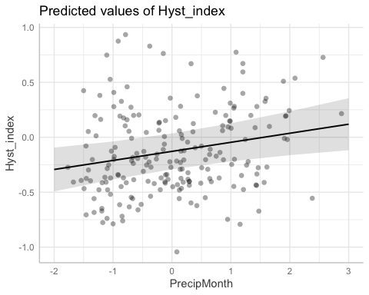

f11 <- formula(Hyst_index ~ StormPrecip + PrecipWeek + PrecipMonth + Intensity + TempWeek + TimeSinceChena + (1|site.ID) + (1|year))  
  
M11.fDOM <- lmer(f11, data = fDOM_data)

f12 <- formula(Hyst_index ~ StormPrecip + PrecipWeek + PrecipMonth + Intensity + TempWeek + TimeSinceChena + (0+PrecipWeek|site.ID) + (1|site.ID) + (1|year))  
  
M12.fDOM <- lmer(f12, data = fDOM_data)

aictab(list(M0.fDOM, M1.fDOM, M2.fDOM, M10.fDOM,M11.fDOM,M12.fDOM))

## Warning in aictab.AIClmerMod(list(M0.fDOM, M1.fDOM, M2.fDOM, M10.fDOM, M11.fDOM, :   
## Model names have been supplied automatically in the table

## Warning in aictab.AIClmerMod(list(M0.fDOM, M1.fDOM, M2.fDOM, M10.fDOM, M11.fDOM, :   
## Model selection for fixed effects is only appropriate with ML estimation:  
## REML (default) should only be used to select random effects for a constant set of fixed effects

##   
## Model selection based on AICc:  
##   
## K AICc Delta_AICc AICcWt Cum.Wt Res.LL  
## Mod6 11 167.05 0.00 0.36 0.36 -71.82  
## Mod4 10 167.34 0.29 0.31 0.67 -73.09  
## Mod3 11 168.20 1.14 0.20 0.88 -72.39  
## Mod5 10 170.07 3.02 0.08 0.96 -74.45  
## Mod2 9 171.28 4.23 0.04 1.00 -76.17  
## Mod1 11 183.87 16.81 0.00 1.00 -80.23

Mod6: Reduced model with uncorrelated random intercept and slope with random effect of year Mod5: Reduced model with random intercept with year and site as random effects Mod4: Reduced model with uncorrelated random intercept and random slope strucuture Mod3: Reduced model (no StormTemp or ThreeMonth precip) and random intercept structure Mod2: Reduced model (’’) with random slopes structure Mod1: Full model with random intercept structure

Mod2 with random intercept structure is the better model.

m1 <- lm(Hyst_index ~ StormPrecip + PrecipWeek + PrecipMonth + Intensity + TempWeek + TimeSinceChena, data = fDOM_data)  
dwplot(m1,  
 dot_args = list(color = "black"), # color for the dot  
 whisker_args = list(color = "red"), # color for the whisker  
 vline = geom_vline(xintercept = 0, colour = "grey50", linetype = 2)) +  
 xlab("Coefficient") +   
 ggtitle("") +  
 theme_classic()

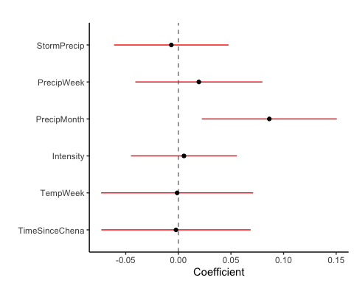

ggsave("~/Documents/Storms/Output_from_analysis/From_07_Modelling/HI/fDOM/coefficient.png")

## Saving 5 x 4 in image

CI overlapping 0 are nonsignificant…This shows us that the only predictor that is significant is PrecipMonth precip

plot(M1.fDOM, site.ID ~ resid(.), abline = 0 ) # generate diagnostic plots

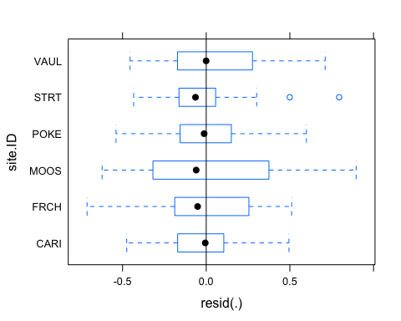 This plot shows us that there are some outliers in POKE, STRT, and CARI and that the variability within MOOS is greater than in other sites we therefore examine the sites in isolation standardized residuals versus fitted values

plot(M1.fDOM, resid(., type = "pearson") ~ fitted(.) | site.ID, id = 0.05,   
 adj = -0.3, pch = 20, col = "gray40")

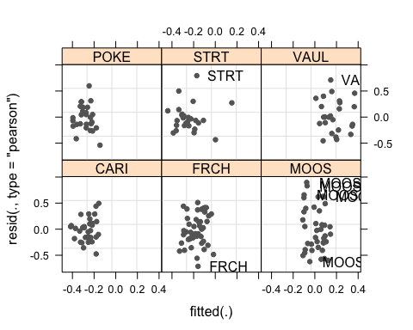 The plot shows the standardized residuals (or Pearson’s residuals) versus fitted values and suggests that there are outliers in the data (the names elements in the plots). To check if these outliers are a cause for concern, we will now use a Levene’s test to check if the variance is distributed homogeneously (homoscedasticity) or whether the assumption of variance homogeneity is violated (due to the outliers).

### Mixed effect model is a pseudo r^2

sjPlot::tab_model(M12.fDOM)

## Warning: Argument 'df_method' is deprecated. Please use 'ci_method' instead.

Hyst_index

Predictors

Estimates

CI

p

(Intercept)

-0.13

-0.31 – 0.05

0.156

StormPrecip

-0.02

-0.06 – 0.03

0.495

PrecipWeek

0.02

-0.07 – 0.11

0.612

PrecipMonth

0.07

0.01 – 0.12

0.031

Intensity

0.04

-0.01 – 0.08

0.116

TempWeek

-0.00

-0.07 – 0.06

0.916

TimeSinceChena

-0.02

-0.08 – 0.04

0.528

Random Effects

σ2

0.09

τ00 site.ID.1

0.04

τ00 year

0.00

τ11 site.ID.PrecipWeek

0.01

ρ01

ρ01

ICC

0.11

N site.ID

6

N year

4

Observations

199

Marginal R2 / Conditional R2

0.069 / 0.166

r.squaredGLMM(M12.fDOM)

## R2m R2c  
## [1,] 0.05032169 0.3884576

The R2 values of the summary table are correct as Marginal and conditional are both there. The more appropriate conditional and marginal coefficient of determination for generalized mixed-effect models can be extracted using the r.squaredGLMM function from the MuMIn package

The marginal R2 (marginal coefficient of determination) represents the variance explained by the fixed effects while the conditional R2 is interpreted as a variance explained by the entire model, including both fixed and random effects

sjPlot::tab_model(M2.fDOM)

## Warning: Argument 'df_method' is deprecated. Please use 'ci_method' instead.

Hyst_index

Predictors

Estimates

CI

p

(Intercept)

-0.13

-0.29 – 0.04

0.128

StormPrecip

-0.02

-0.07 – 0.03

0.508

PrecipWeek

0.00

-0.09 – 0.09

0.965

PrecipMonth

0.08

0.02 – 0.14

0.005

Intensity

0.04

-0.01 – 0.08

0.128

TempWeek

-0.01

-0.07 – 0.06

0.798

TimeSinceChena

-0.03

-0.10 – 0.03

0.325

Random Effects

σ2

0.09

τ00 site.ID

0.04

τ11 site.ID.PrecipWeek

0.01

ρ01 site.ID

-0.62

ICC

0.33

N site.ID

6

Observations

199

Marginal R2 / Conditional R2

0.055 / 0.368

r.squaredGLMM(M2.fDOM)

## R2m R2c  
## [1,] 0.05459239 0.3678255

This tells us that 31% of the variance can be explained…when I did the Levens test and added weights to the model it was closer to 42% but we talked about how that is a bad test and any transformation of the data would be more appropriate so let me quickly log transform this model and see if that helps with anything

## Linear mixed model fit by REML ['lmerMod']  
## Formula: log(Hyst_index + 1) ~ StormPrecip + PrecipWeek + PrecipMonth +   
## Intensity + TempWeek + TimeSinceChena + (1 | site.ID)  
## Data: fDOM_data  
##   
## REML criterion at convergence: 238.6  
##   
## Scaled residuals:   
## Min 1Q Median 3Q Max   
## -4.3974 -0.5432 0.0443 0.6814 1.9923   
##   
## Random effects:  
## Groups Name Variance Std.Dev.  
## site.ID (Intercept) 0.04426 0.2104   
## Residual 0.15891 0.3986   
## Number of obs: 199, groups: site.ID, 6  
##   
## Fixed effects:  
## Estimate Std. Error t value  
## (Intercept) -0.226566 0.090702 -2.498  
## StormPrecip -0.017838 0.032012 -0.557  
## PrecipWeek 0.003036 0.034481 0.088  
## PrecipMonth 0.098012 0.037049 2.646  
## Intensity 0.039232 0.030529 1.285  
## TempWeek 0.004507 0.041572 0.108  
## TimeSinceChena -0.039963 0.041041 -0.974  
##   
## Correlation of Fixed Effects:  
## (Intr) StrmPr PrcpWk PrcpMn Intnst TempWk  
## StormPrecip -0.001   
## PrecipWeek 0.000 -0.046   
## PrecipMonth 0.002 0.076 -0.510   
## Intensity -0.015 -0.299 0.046 -0.060   
## TempWeek 0.001 -0.200 0.105 -0.388 -0.046   
## TimeSincChn -0.017 -0.009 0.220 -0.372 0.018 0.646

1. The scaled residuals look worse

plot(Mlog.fDOM)

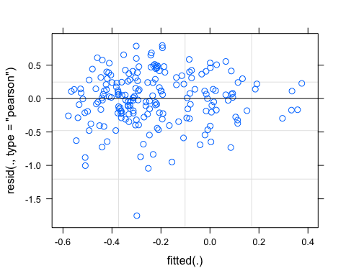

qqnorm(resid(Mlog.fDOM))

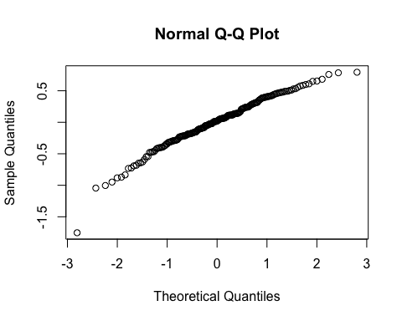

r.squaredGLMM(Mlog.fDOM)

## R2m R2c  
## [1,] 0.05871395 0.2637699

Worse so lets stick with the original model

sjPlot::plot_model(M1.fDOM, type = "pred", terms = c("PrecipMonth")) +  
 # show uncentered date rather than centered date  
 scale_x_continuous(name = "PrecipMonth",   
 breaks = seq(-500, 300, 100),   
 labels = seq(1150, 1950, 100))

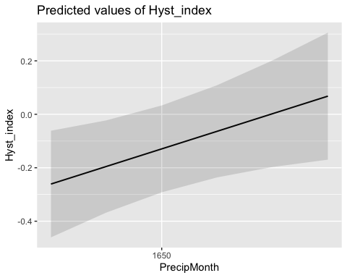

### Permafrost

f4.fDOM <- formula(Hyst_index ~ StormPrecip*pf + PrecipWeek*pf + PrecipMonth*pf + Intensity*pf + TempWeek*pf + TimeSinceChena*pf + (1|site.ID))  
  
M4.fDOM <- lmer(f4.fDOM, data = fDOM_data)  
summary(M4.fDOM)

## Linear mixed model fit by REML ['lmerMod']  
## Formula: Hyst_index ~ StormPrecip * pf + PrecipWeek * pf + PrecipMonth *   
## pf + Intensity * pf + TempWeek * pf + TimeSinceChena * pf +   
## (1 | site.ID)  
## Data: fDOM_data  
##   
## REML criterion at convergence: 171.2  
##   
## Scaled residuals:   
## Min 1Q Median 3Q Max   
## -2.13311 -0.67562 -0.08935 0.57697 2.78387   
##   
## Random effects:  
## Groups Name Variance Std.Dev.  
## site.ID (Intercept) 0.03859 0.1965   
## Residual 0.10159 0.3187   
## Number of obs: 199, groups: site.ID, 6  
##   
## Fixed effects:  
## Estimate Std. Error t value  
## (Intercept) -0.004291 0.147625 -0.029  
## StormPrecip -0.006442 0.044127 -0.146  
## pfmedium -0.168972 0.179392 -0.942  
## PrecipWeek 0.057745 0.061272 0.942  
## PrecipMonth 0.056550 0.073017 0.774  
## Intensity 0.017946 0.030173 0.595  
## TempWeek -0.054752 0.085927 -0.637  
## TimeSinceChena -0.104049 0.099121 -1.050  
## StormPrecip:pfmedium -0.039589 0.056601 -0.699  
## pfmedium:PrecipWeek -0.059154 0.069211 -0.855  
## pfmedium:PrecipMonth 0.022541 0.080389 0.280  
## pfmedium:Intensity 0.062767 0.056614 1.109  
## pfmedium:TempWeek 0.057611 0.093981 0.613  
## pfmedium:TimeSinceChena 0.089088 0.105255 0.846

##   
## Correlation matrix not shown by default, as p = 14 > 12.  
## Use print(x, correlation=TRUE) or  
## vcov(x) if you need it

This does not show us that pf has really an effect on on predictors

### burn

f5.fDOM <- formula(Hyst_index ~ StormPrecip*burn + PrecipWeek*burn + PrecipMonth*burn + Intensity*burn + TempWeek*burn + TimeSinceChena*burn + (1|site.ID))  
  
M5.fDOM <- lmer(f5.fDOM, data = fDOM_data)  
summary(M5.fDOM)

## Linear mixed model fit by REML ['lmerMod']  
## Formula: Hyst_index ~ StormPrecip * burn + PrecipWeek * burn + PrecipMonth *   
## burn + Intensity * burn + TempWeek * burn + TimeSinceChena *   
## burn + (1 | site.ID)  
## Data: fDOM_data  
##   
## REML criterion at convergence: 171.5  
##   
## Scaled residuals:   
## Min 1Q Median 3Q Max   
## -2.3678 -0.6297 -0.1106 0.5460 2.7961   
##   
## Random effects:  
## Groups Name Variance Std.Dev.  
## site.ID (Intercept) 0.03411 0.1847   
## Residual 0.10199 0.3194   
## Number of obs: 199, groups: site.ID, 6  
##   
## Fixed effects:  
## Estimate Std. Error t value  
## (Intercept) -0.200526 0.096957 -2.068  
## StormPrecip -0.032189 0.032050 -1.004  
## burnunburned 0.217618 0.168664 1.290  
## PrecipWeek 0.007469 0.033261 0.225  
## PrecipMonth 0.043600 0.038864 1.122  
## Intensity 0.034063 0.025603 1.330  
## TempWeek 0.008717 0.038902 0.224  
## TimeSinceChena -0.036824 0.038028 -0.968  
## StormPrecip:burnunburned 0.014612 0.059524 0.245  
## burnunburned:PrecipWeek 0.047907 0.060313 0.794  
## burnunburned:PrecipMonth 0.036371 0.062518 0.582  
## burnunburned:Intensity 0.067896 0.095863 0.708  
## burnunburned:TempWeek -0.017907 0.080347 -0.223  
## burnunburned:TimeSinceChena 0.037462 0.080803 0.464

##   
## Correlation matrix not shown by default, as p = 14 > 12.  
## Use print(x, correlation=TRUE) or  
## vcov(x) if you need it

Burn also doesnt have any significance here

SPC

#### Scatter plot matrix

HI_FI_SPC_CARI <- filter(HI_FI_SPC, site.ID == "CARI")  
HI_FI_SPC_FRCH <- filter(HI_FI_SPC, site.ID == "FRCH")  
HI_FI_SPC_MOOS <- filter(HI_FI_SPC, site.ID == "MOOS")  
HI_FI_SPC_POKE <- filter(HI_FI_SPC, site.ID == "POKE")  
HI_FI_SPC_VAUL <- filter(HI_FI_SPC, site.ID == "VAUL")  
HI_FI_SPC_STRT <- filter(HI_FI_SPC, site.ID == "STRT")  
  
  
SPC_data.1 <- HI_FI_SPC[,c("Hyst_index","StormPrecip")]  
  
pairs(SPC_data.1)

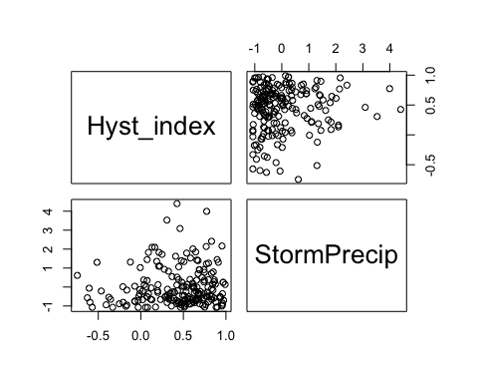

HI_FI_SPC %>% ggplot(aes(x = StormPrecip, y = Hyst_index)) +   
 geom_hline(yintercept = 0, linetype = "dotted", size = 1) +  
 geom_errorbar(aes(ymin=HI_ymin, ymax=HI_ymax), colour="black", alpha=0.5, size=.5, width = 0.1)+   
 geom_point(aes(color = site.ID), size = 2) +  
 scale_color_manual(values = c("orange red", viridis::viridis(6)), "Catchment")+theme_bw() +  
 geom_smooth(method = "lm", na.rm = TRUE, fullrange = TRUE, aes(group = 1)) +   
 stat_poly_eq(formula = y~x,  
 label.y = "top", label.x = "right",  
 aes(label = paste(..eq.label.., ..rr.label.., sep = "~~~")),   
 parse = TRUE) +   
 ylab("Hysteresis Index") +  
 ggtitle("HI vs. StormPrecip")

## `geom_smooth()` using formula 'y ~ x'

## Warning: Removed 1 rows containing non-finite values (stat_poly_eq).

## Warning: Removed 1 rows containing missing values (geom_point).

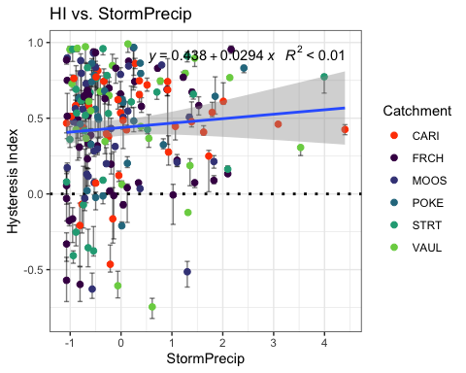

SPC_data.2 <- HI_FI_SPC[,c("Hyst_index","PrecipWeek")]  
  
pairs(SPC_data.2)

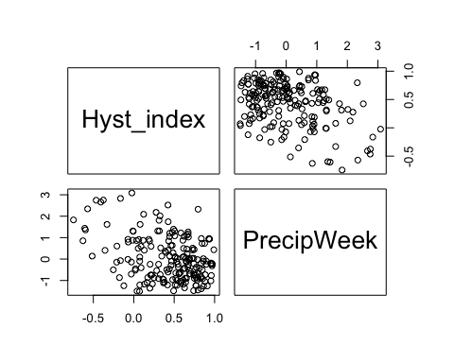

HI_FI_SPC %>% ggplot(aes(x = PrecipWeek, y = Hyst_index)) +   
 geom_hline(yintercept = 0, linetype = "dotted", size = 1) +  
 geom_errorbar(aes(ymin=HI_ymin, ymax=HI_ymax), colour="black", alpha=0.5, size=.5, width = 0.1)+   
 geom_point(aes(color = site.ID), size = 2) +  
 scale_color_manual(values = c("orange red", viridis::viridis(6)), "Catchment")+theme_bw() +  
 geom_smooth(method = "lm", na.rm = TRUE, fullrange = TRUE, aes(group = 1)) +   
 stat_poly_eq(formula = y~x,  
 label.y = "top", label.x = "right",  
 aes(label = paste(..eq.label.., ..rr.label.., sep = "~~~")),   
 parse = TRUE) +   
 ylab("Hysteresis Index") +  
 ggtitle("HI vs. PrecipWeek")

## `geom_smooth()` using formula 'y ~ x'

## Warning: Removed 1 rows containing non-finite values (stat_poly_eq).

## Warning: Removed 1 rows containing missing values (geom_point).

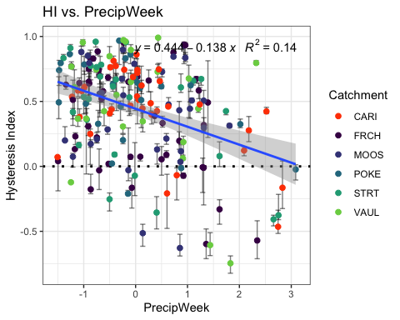

SPC_data.3 <- HI_FI_SPC[,c("Hyst_index","PrecipMonth")]  
  
pairs(SPC_data.3)

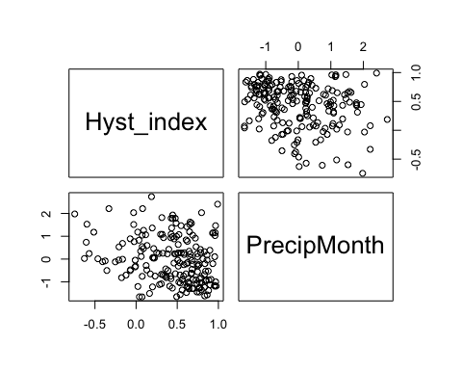

HI_FI_SPC %>% ggplot(aes(x = PrecipMonth, y = Hyst_index)) +   
 geom_hline(yintercept = 0, linetype = "dotted", size = 1) +  
 geom_errorbar(aes(ymin=HI_ymin, ymax=HI_ymax), colour="black", alpha=0.5, size=.5, width = 0.1)+   
 geom_point(aes(color = site.ID), size = 2) +  
 scale_color_manual(values = c("orange red", viridis::viridis(6)), "Catchment")+theme_bw() +  
 geom_smooth(method = "lm", na.rm = TRUE, fullrange = TRUE, aes(group = 1)) +   
 stat_poly_eq(formula = y~x,  
 label.y = "top", label.x = "right",  
 aes(label = paste(..eq.label.., ..rr.label.., sep = "~~~")),   
 parse = TRUE) +   
 ylab("Hysteresis Index") +  
 ggtitle("HI vs. PrecipMonth")

## `geom_smooth()` using formula 'y ~ x'

## Warning: Removed 1 rows containing non-finite values (stat_poly_eq).

## Warning: Removed 1 rows containing missing values (geom_point).

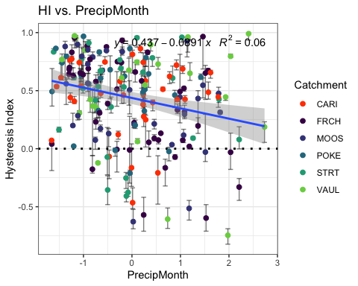

SPC_data.4 <- HI_FI_SPC[,c("Hyst_index","ThreeMonth")]  
  
pairs(SPC_data.4)

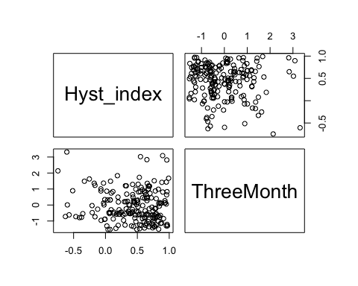

HI_FI_SPC %>% ggplot(aes(x = ThreeMonth, y = Hyst_index)) +   
 geom_hline(yintercept = 0, linetype = "dotted", size = 1) +  
 geom_errorbar(aes(ymin=HI_ymin, ymax=HI_ymax), colour="black", alpha=0.5, size=.5, width = 0.1)+   
 geom_point(aes(color = site.ID), size = 2) +  
 scale_color_manual(values = c("orange red", viridis::viridis(6)), "Catchment")+theme_bw() +  
 geom_smooth(method = "lm", na.rm = TRUE, fullrange = TRUE, aes(group = 1)) +   
 stat_poly_eq(formula = y~x,  
 label.y = "top", label.x = "right",  
 aes(label = paste(..eq.label.., ..rr.label.., sep = "~~~")),   
 parse = TRUE) +   
 ylab("Hysteresis Index") +  
 ggtitle("HI vs. ThreeMonth")

## `geom_smooth()` using formula 'y ~ x'

## Warning: Removed 1 rows containing non-finite values (stat_poly_eq).

## Warning: Removed 1 rows containing missing values (geom_point).

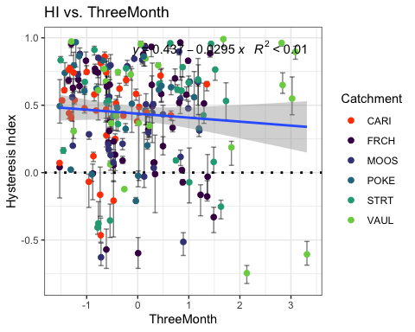

SPC_data.5 <- HI_FI_SPC[,c("Hyst_index","Intensity")]  
  
pairs(SPC_data.5)

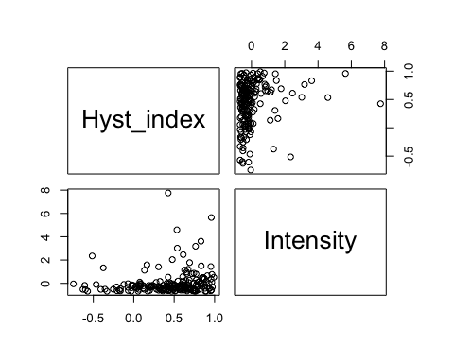

HI_FI_SPC %>% ggplot(aes(x = Intensity, y = Hyst_index)) +   
 geom_hline(yintercept = 0, linetype = "dotted", size = 1) +  
 geom_errorbar(aes(ymin=HI_ymin, ymax=HI_ymax), colour="black", alpha=0.5, size=.5, width = 0.1)+   
 geom_point(aes(color = site.ID), size = 2) +  
 scale_color_manual(values = c("orange red", viridis::viridis(6)), "Catchment")+theme_bw() +  
 geom_smooth(method = "lm", na.rm = TRUE, fullrange = TRUE, aes(group = 1)) +   
 stat_poly_eq(formula = y~x,  
 label.y = "top", label.x = "right",  
 aes(label = paste(..eq.label.., ..rr.label.., sep = "~~~")),   
 parse = TRUE) +   
 ylab("Hysteresis Index") +  
 ggtitle("HI vs. Intensity")

## `geom_smooth()` using formula 'y ~ x'

## Warning: Removed 2 rows containing non-finite values (stat_poly_eq).

## Warning: Removed 2 rows containing missing values (geom_point).

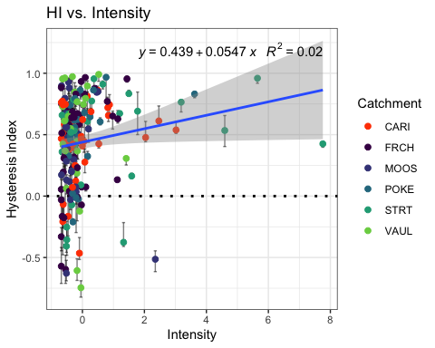

SPC_data.6 <- HI_FI_SPC[,c("Hyst_index","StormTemp")]  
  
pairs(SPC_data.6)

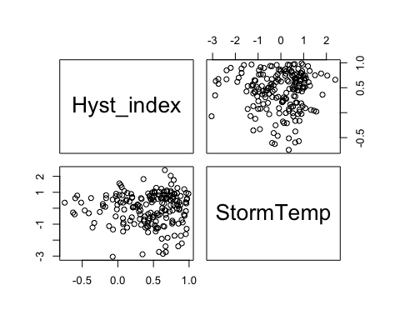

HI_FI_SPC %>% ggplot(aes(x = StormTemp, y = Hyst_index)) +   
 geom_hline(yintercept = 0, linetype = "dotted", size = 1) +  
 geom_errorbar(aes(ymin=HI_ymin, ymax=HI_ymax), colour="black", alpha=0.5, size=.5, width = 0.1)+   
 geom_point(aes(color = site.ID), size = 2) +  
 scale_color_manual(values = c("orange red", viridis::viridis(6)), "Catchment")+theme_bw() +  
 geom_smooth(method = "lm", na.rm = TRUE, fullrange = TRUE, aes(group = 1)) +   
 stat_poly_eq(formula = y~x,  
 label.y = "top", label.x = "right",  
 aes(label = paste(..eq.label.., ..rr.label.., sep = "~~~")),   
 parse = TRUE) +   
 ylab("Hysteresis Index") +  
 ggtitle("HI vs. StormTemp")

## `geom_smooth()` using formula 'y ~ x'

## Warning: Removed 1 rows containing non-finite values (stat_poly_eq).

## Warning: Removed 1 rows containing missing values (geom_point).

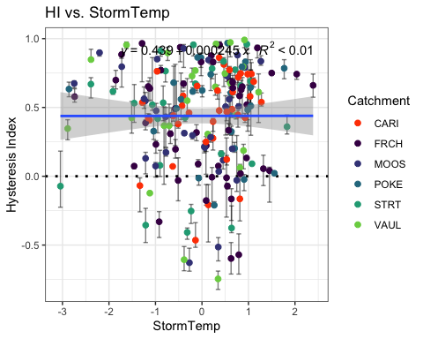

SPC_data.7 <- HI_FI_SPC[,c("Hyst_index","TempWeek")]  
  
pairs(SPC_data.7)

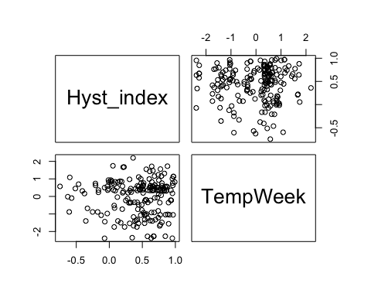

HI_FI_SPC %>% ggplot(aes(x = TempWeek, y = Hyst_index)) +   
 geom_hline(yintercept = 0, linetype = "dotted", size = 1) +  
 geom_errorbar(aes(ymin=HI_ymin, ymax=HI_ymax), colour="black", alpha=0.5, size=.5, width = 0.1)+   
 geom_point(aes(color = site.ID), size = 2) +  
 scale_color_manual(values = c("orange red", viridis::viridis(6)), "Catchment")+theme_bw() +  
 geom_smooth(method = "lm", na.rm = TRUE, fullrange = TRUE, aes(group = 1)) +   
 stat_poly_eq(formula = y~x,  
 label.y = "top", label.x = "right",  
 aes(label = paste(..eq.label.., ..rr.label.., sep = "~~~")),   
 parse = TRUE) +   
 ylab("Hysteresis Index") +  
 ggtitle("HI vs. TempWeek")

## `geom_smooth()` using formula 'y ~ x'

## Warning: Removed 2 rows containing non-finite values (stat_poly_eq).

## Warning: Removed 2 rows containing missing values (geom_point).

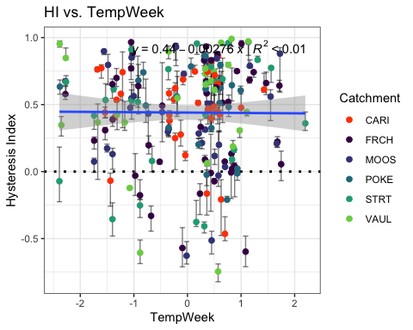

SPC_data.8 <- HI_FI_SPC[,c("Hyst_index","TimeSinceChena")]  
  
pairs(SPC_data.8)

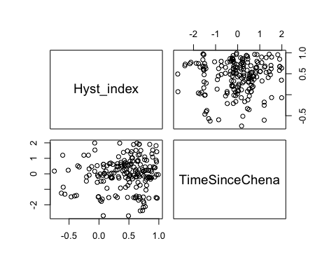

HI_FI_SPC %>% ggplot(aes(x = TimeSinceChena, y = Hyst_index)) +   
 geom_hline(yintercept = 0, linetype = "dotted", size = 1) +  
 geom_errorbar(aes(ymin=HI_ymin, ymax=HI_ymax), colour="black", alpha=0.5, size=.5, width = 0.1)+   
 geom_point(aes(color = site.ID), size = 2) +  
 scale_color_manual(values = c("orange red", viridis::viridis(6)), "Catchment")+theme_bw() +  
 geom_smooth(method = "lm", na.rm = TRUE, fullrange = TRUE, aes(group = 1)) +   
 stat_poly_eq(formula = y~x,  
 label.y = "top", label.x = "right",  
 aes(label = paste(..eq.label.., ..rr.label.., sep = "~~~")),   
 parse = TRUE) +   
 ylab("Hysteresis Index") +  
 ggtitle("HI vs. TimeSinceChena")

## `geom_smooth()` using formula 'y ~ x'

## Warning: Removed 1 rows containing non-finite values (stat_poly_eq).

## Warning: Removed 1 rows containing missing values (geom_point).

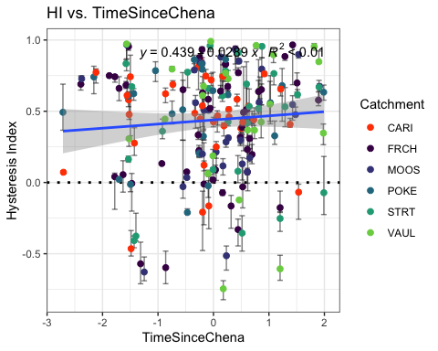

SPC_data <- HI_FI_SPC[,c("Hyst_index", "site.ID", "StormPrecip", "StormTemp", "PrecipWeek", "PrecipMonth", "ThreeMonth", "TempWeek", "Intensity", "TimeSinceChena", "burn", "pf", "year")]  
  
SPC_data <- na.omit(SPC_data) # 232-228  
cor(SPC_data[,c(1,3:10)])

## Hyst_index StormPrecip StormTemp PrecipWeek PrecipMonth  
## Hyst_index 1.000000000 0.07036545 -0.006827228 -0.37701455 -0.23795700  
## StormPrecip 0.070365451 1.00000000 0.195592705 0.04681797 0.02476547  
## StormTemp -0.006827228 0.19559270 1.000000000 0.12089052 0.19679643  
## PrecipWeek -0.377014552 0.04681797 0.120890516 1.00000000 0.50909139  
## PrecipMonth -0.237957002 0.02476547 0.196796430 0.50909139 1.00000000  
## ThreeMonth -0.078287580 -0.10547996 -0.205317473 0.17764735 0.58438497  
## TempWeek -0.010334268 0.28102768 0.812999149 0.17411212 0.22449389  
## Intensity 0.149204460 0.31978192 0.132265986 -0.01784728 0.01664514  
## TimeSinceChena 0.066369243 -0.19839914 -0.705367934 -0.13780396 0.08893153  
## ThreeMonth TempWeek Intensity TimeSinceChena  
## Hyst_index -0.07828758 -0.01033427 0.14920446 0.06636924  
## StormPrecip -0.10547996 0.28102768 0.31978192 -0.19839914  
## StormTemp -0.20531747 0.81299915 0.13226599 -0.70536793  
## PrecipWeek 0.17764735 0.17411212 -0.01784728 -0.13780396  
## PrecipMonth 0.58438497 0.22449389 0.01664514 0.08893153  
## ThreeMonth 1.00000000 -0.13314633 -0.01894927 0.55026331  
## TempWeek -0.13314633 1.00000000 0.16441814 -0.62658246  
## Intensity -0.01894927 0.16441814 1.00000000 -0.09767640  
## TimeSinceChena 0.55026331 -0.62658246 -0.09767640 1.00000000

1. StormTemp is heavily correlated with TempWeek (0.794) but TempWeek is more correlated with HI (0.024 vs. 0.01)
2. StormTemp is also correlated with TimeSinceChena (-0.722) but TimeSinceChena is more correlated with HI (0.033 vs. -0.01)
3. PrecipWeek is correlated with PrecipMonth (0.552) but PrecipWeek is more correlated with HI (-0.314 vs. -0.246)
4. PrecipMonth is correlated with ThreeMonth (0.631) but PrecipMonth is more correlated with HI (-0.246 vs. -0.114)
5. ThreeMonth is correlated with TimeSinceChena (0.563) but ThreeMonth is more correlated with HI ( -0.114 vs. 0.033)

* this makes me want to drop time since chena and three month

## boundary (singular) fit: see ?isSingular

## Linear mixed model fit by REML ['lmerMod']  
## Formula: Hyst_index ~ StormPrecip + PrecipWeek + PrecipMonth + ThreeMonth +   
## Intensity + StormTemp + TempWeek + TimeSinceChena + (1 | site.ID)  
## Data: SPC_data  
##   
## REML criterion at convergence: 183.2  
##   
## Scaled residuals:   
## Min 1Q Median 3Q Max   
## -2.9656 -0.6880 0.1716 0.7037 1.9639   
##   
## Random effects:  
## Groups Name Variance Std.Dev.  
## site.ID (Intercept) 0.0000 0.0000   
## Residual 0.1254 0.3541   
## Number of obs: 192, groups: site.ID, 6  
##   
## Fixed effects:  
## Estimate Std. Error t value  
## (Intercept) 0.444955 0.025665 17.337  
## StormPrecip 0.016426 0.027763 0.592  
## PrecipWeek -0.116923 0.030653 -3.814  
## PrecipMonth -0.049425 0.039805 -1.242  
## ThreeMonth -0.001637 0.040938 -0.040  
## Intensity 0.045226 0.025793 1.753  
## StormTemp 0.034422 0.050507 0.682  
## TempWeek 0.026733 0.046396 0.576  
## TimeSinceChena 0.063863 0.047248 1.352  
##   
## Correlation of Fixed Effects:  
## (Intr) StrmPr PrcpWk PrcpMn ThrMnt Intnst StrmTm TempWk  
## StormPrecip -0.023   
## PrecipWeek -0.055 -0.013   
## PrecipMonth 0.009 -0.018 -0.480   
## ThreeMonth 0.044 0.064 0.034 -0.532   
## Intensity -0.027 -0.292 0.042 0.011 -0.033   
## StormTemp -0.027 0.074 0.181 -0.201 -0.015 -0.019   
## TempWeek 0.040 -0.188 -0.041 -0.049 -0.096 -0.040 -0.612   
## TimeSincChn -0.027 0.012 0.225 -0.051 -0.499 0.001 0.431 0.174  
## optimizer (nloptwrap) convergence code: 0 (OK)  
## boundary (singular) fit: see ?isSingular

1. Scaled residuals do not look as normal as they should
2. The site accounts for none of the variation
3. Precip week is the most significant

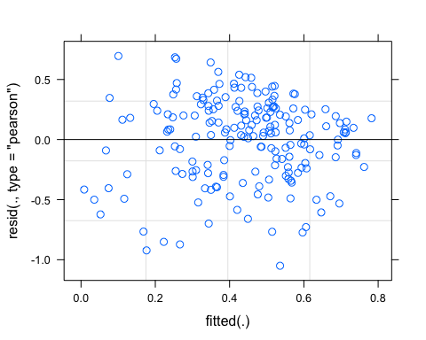 Looks good

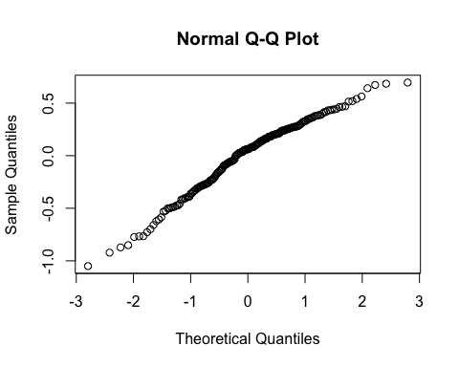 A little bent

vif(M0.SPC)

## StormPrecip PrecipWeek PrecipMonth ThreeMonth Intensity   
## 1.199697 1.481964 2.384983 2.507552 1.126216   
## StormTemp TempWeek TimeSinceChena   
## 3.901823 3.259753 3.334771

Any VIF>2 indicates high correlation….StormTemp and TimeSinceChena are above three…lets remove StormTemp and ThreeMonth

## boundary (singular) fit: see ?isSingular

## StormPrecip PrecipWeek PrecipMonth Intensity TempWeek   
## 1.187981 1.431557 1.604967 1.124582 2.004131   
## TimeSinceChena   
## 1.907504

1. all VIFs are below 2 which is good!
2. PrecipWeek and PrecipMonth (0.55)
3. TimeSinceChena and TempWeek (-0.59)

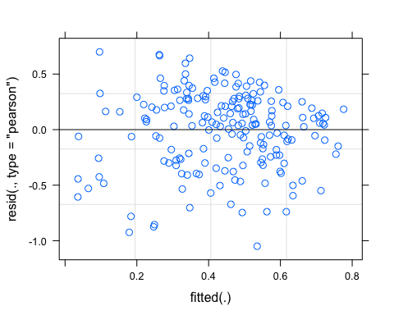

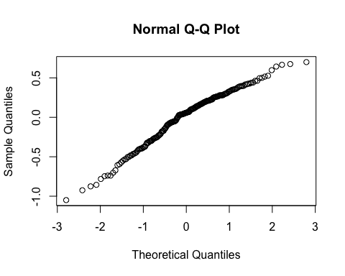

pr <- ggpredict(M1.SPC, terms = c("PrecipWeek"))  
plot(pr, add.data = TRUE)

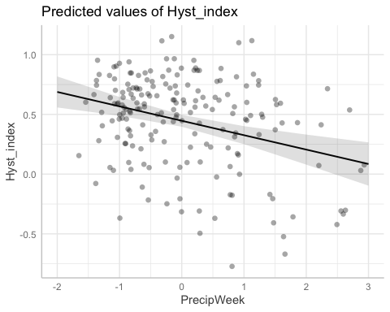

### alternative slope

## boundary (singular) fit: see ?isSingular

## boundary (singular) fit: see ?isSingular

f11 <- formula(Hyst_index ~ StormPrecip + PrecipWeek + PrecipMonth + Intensity + TempWeek + TimeSinceChena + (1|site.ID) + (1|year))  
  
M11.SPC <- lmer(f11, data = SPC_data)

## boundary (singular) fit: see ?isSingular

f12 <- formula(Hyst_index ~ StormPrecip + PrecipWeek + PrecipMonth + Intensity + TempWeek + TimeSinceChena + (0+PrecipWeek|site.ID) + (1|site.ID) + (1|year))  
  
M12.SPC <- lmer(f12, data = SPC_data)

## boundary (singular) fit: see ?isSingular

aictab(list(M0.SPC, M1.SPC, M2.SPC, M10.SPC,M11.SPC,M12.SPC))

## Warning in aictab.AIClmerMod(list(M0.SPC, M1.SPC, M2.SPC, M10.SPC, M11.SPC, :   
## Model names have been supplied automatically in the table

## Warning in aictab.AIClmerMod(list(M0.SPC, M1.SPC, M2.SPC, M10.SPC, M11.SPC, :   
## Model selection for fixed effects is only appropriate with ML estimation:  
## REML (default) should only be used to select random effects for a constant set of fixed effects

##   
## Model selection based on AICc:  
##   
## K AICc Delta_AICc AICcWt Cum.Wt Res.LL  
## Mod2 9 193.98 0.00 0.40 0.40 -87.49  
## Mod5 10 194.44 0.46 0.32 0.72 -86.61  
## Mod4 10 196.20 2.23 0.13 0.85 -87.49  
## Mod6 11 196.69 2.71 0.10 0.96 -86.61  
## Mod3 11 198.46 4.48 0.04 1.00 -87.49  
## Mod1 11 206.68 12.71 0.00 1.00 -91.61

Mod5: Reduced model with random intercept structure with random year and site effect Mod2: Reduced model (no StormTemp or ThreeMonth Precip) with random intercept structure Mod6: Reduced model with unncorelated structure with random year and site effect Mod4: Reduced model (’‘) with uncorrelated random slopes and intercept Mod3: Reduced model (’’) with random slope structure Mod1: Full model with random intercept structure

m1 <- lm(Hyst_index ~ StormPrecip + PrecipWeek + PrecipMonth + Intensity + TempWeek + TimeSinceChena, data = SPC_data)  
dwplot(m1,  
 dot_args = list(color = "black"), # color for the dot  
 whisker_args = list(color = "red"), # color for the whisker  
 vline = geom_vline(xintercept = 0, colour = "grey50", linetype = 2)) +  
 xlab("Coefficient") +   
 ggtitle("") +  
 theme_classic()

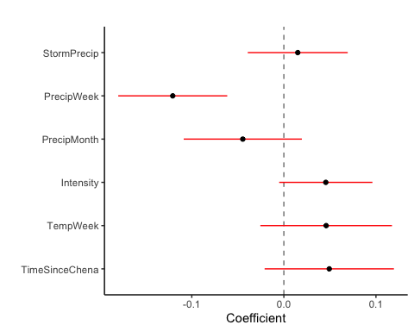

ggsave("~/Documents/Storms/Output_from_analysis/From_07_Modelling/HI/SPC/coefficient.png")

## Saving 5 x 4 in image

CI overlapping 0 are nonsignificant. PrecipWeek and maybe PrecipMonth are significant

plot(M1.SPC, site.ID ~ resid(.), abline = 0 ) # generate diagnostic plots

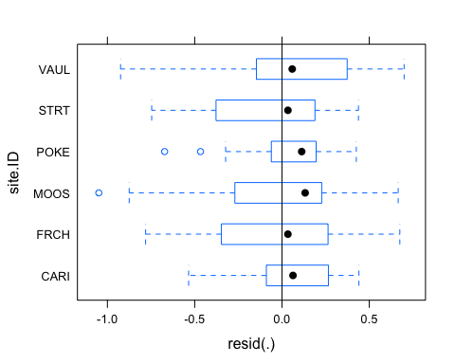 This plot shows us that there are some outliers in VAUL, POKE, and MOOS and that the variability within VAUL is greater than in other sites we therefore examine the sites in isolation standardized residuals versus fitted values

plot(M1.SPC, resid(., type = "pearson") ~ fitted(.) | site.ID, id = 0.05,   
 adj = -0.3, pch = 20, col = "gray40")

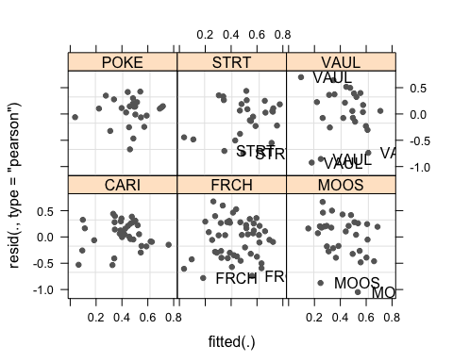 The plot shows the standardized residuals (or Pearson’s residuals) versus fitted values and suggests that there are outliers in the data (the names elements in the plots). To check if these outliers are a cause for concern, we will now use a Levene’s test to check if the variance is distributed homogeneously (homoscedasticity) or whether the assumption of variance homogeneity is violated (due to the outliers).

### Mixed effect model is a pseudo r^2

sjPlot::tab_model(M11.SPC)

## Warning: Argument 'df_method' is deprecated. Please use 'ci_method' instead.

Hyst_index

Predictors

Estimates

CI

p

(Intercept)

0.45

0.37 – 0.53

<0.001

StormPrecip

0.01

-0.04 – 0.07

0.593

PrecipWeek

-0.13

-0.19 – -0.07

<0.001

PrecipMonth

-0.04

-0.10 – 0.03

0.269

Intensity

0.05

-0.00 – 0.10

0.066

TempWeek

0.05

-0.03 – 0.12

0.207

TimeSinceChena

0.04

-0.03 – 0.11

0.285

Random Effects

σ2

0.12

τ00 site.ID

0.00

τ00 year

0.00

N site.ID

6

N year

4

Observations

192

Marginal R2 / Conditional R2

0.186 / NA

r.squaredGLMM(M11.SPC)

## R2m R2c  
## [1,] 0.1819277 0.205781

The R2 values of the summary table are correct as Marginal and conditional are bothe there. The more appropriate conditional and marginal coefficient of determination for generalized mixed-effect models can be extracted using the r.squaredGLMM function from the MuMIn package

The marginal R2 (marginal coefficient of determination) represents the variance explained by the fixed effects while the conditional R2 is interpreted as a variance explained by the entire model, including both fixed and random effects

r.squaredGLMM(M1.SPC)

## R2m R2c  
## [1,] 0.1727037 0.1727037

Only ~14% of the variance is explained in this model…ouch

sjPlot::plot_model(M1.SPC, type = "pred", terms = c("PrecipWeek")) +  
 # show uncentered date rather than centered date  
 scale_x_continuous(name = "PrecipWeek",   
 breaks = seq(-500, 300, 100),   
 labels = seq(1150, 1950, 100))

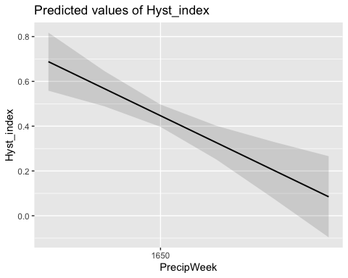

### Permafrost

f4.SPC <- formula(Hyst_index ~ StormPrecip*pf + PrecipWeek*pf + PrecipMonth*pf + Intensity*pf + TempWeek*pf + TimeSinceChena*pf + (1|site.ID))  
  
M4.SPC <- lmer(f4.SPC, data = SPC_data)

## boundary (singular) fit: see ?isSingular

summary(M4.SPC)

## Linear mixed model fit by REML ['lmerMod']  
## Formula: Hyst_index ~ StormPrecip * pf + PrecipWeek * pf + PrecipMonth *   
## pf + Intensity * pf + TempWeek * pf + TimeSinceChena * pf +   
## (1 | site.ID)  
## Data: SPC_data  
##   
## REML criterion at convergence: 191.6  
##   
## Scaled residuals:   
## Min 1Q Median 3Q Max   
## -3.0486 -0.6632 0.1442 0.7601 2.1793   
##   
## Random effects:  
## Groups Name Variance Std.Dev.  
## site.ID (Intercept) 0.0000 0.0000   
## Residual 0.1231 0.3509   
## Number of obs: 192, groups: site.ID, 6  
##   
## Fixed effects:  
## Estimate Std. Error t value  
## (Intercept) 0.431881 0.054812 7.879  
## StormPrecip -0.006283 0.046703 -0.135  
## pfmedium 0.017650 0.062638 0.282  
## PrecipWeek -0.164997 0.067102 -2.459  
## PrecipMonth -0.020821 0.077565 -0.268  
## Intensity 0.033996 0.031020 1.096  
## TempWeek 0.186954 0.092963 2.011  
## TimeSinceChena 0.151595 0.106386 1.425  
## StormPrecip:pfmedium 0.022277 0.060770 0.367  
## pfmedium:PrecipWeek 0.072399 0.075473 0.959  
## pfmedium:PrecipMonth -0.047617 0.086049 -0.553  
## pfmedium:Intensity 0.039403 0.062302 0.632  
## pfmedium:TempWeek -0.190750 0.101659 -1.876  
## pfmedium:TimeSinceChena -0.117899 0.113200 -1.042

##   
## Correlation matrix not shown by default, as p = 14 > 12.  
## Use print(x, correlation=TRUE) or  
## vcov(x) if you need it

## optimizer (nloptwrap) convergence code: 0 (OK)  
## boundary (singular) fit: see ?isSingular

Nothing sticking out here

### burn

f5.SPC <- formula(Hyst_index ~ StormPrecip*burn + PrecipWeek*burn + PrecipMonth*burn + Intensity*burn + TempWeek*burn + TimeSinceChena*burn + (1|site.ID))  
  
M5.SPC <- lmer(f5.SPC, data = SPC_data)

## boundary (singular) fit: see ?isSingular

summary(M5.SPC)

## Linear mixed model fit by REML ['lmerMod']  
## Formula: Hyst_index ~ StormPrecip * burn + PrecipWeek * burn + PrecipMonth *   
## burn + Intensity * burn + TempWeek * burn + TimeSinceChena *   
## burn + (1 | site.ID)  
## Data: SPC_data  
##   
## REML criterion at convergence: 196.7  
##   
## Scaled residuals:   
## Min 1Q Median 3Q Max   
## -2.9841 -0.6464 0.1912 0.7062 2.0449   
##   
## Random effects:  
## Groups Name Variance Std.Dev.  
## site.ID (Intercept) 0.0000 0.000   
## Residual 0.1267 0.356   
## Number of obs: 192, groups: site.ID, 6  
##   
## Fixed effects:  
## Estimate Std. Error t value  
## (Intercept) 0.45485 0.03382 13.448  
## StormPrecip 0.02752 0.03481 0.791  
## burnunburned 0.01174 0.05884 0.200  
## PrecipWeek -0.13093 0.03657 -3.580  
## PrecipMonth -0.02166 0.04429 -0.489  
## Intensity 0.03574 0.02726 1.311  
## TempWeek 0.02155 0.04409 0.489  
## TimeSinceChena 0.03093 0.04203 0.736  
## StormPrecip:burnunburned -0.07154 0.06613 -1.082  
## burnunburned:PrecipWeek 0.04277 0.06690 0.639  
## burnunburned:PrecipMonth -0.05535 0.06879 -0.805  
## burnunburned:Intensity 0.16045 0.11897 1.349  
## burnunburned:TempWeek 0.09192 0.08331 1.103  
## burnunburned:TimeSinceChena 0.08652 0.08452 1.024

##   
## Correlation matrix not shown by default, as p = 14 > 12.  
## Use print(x, correlation=TRUE) or  
## vcov(x) if you need it

## optimizer (nloptwrap) convergence code: 0 (OK)  
## boundary (singular) fit: see ?isSingular

Nothing sticking out here

TURB

#### Scatter plot matrix

HI_FI_turb_CARI <- filter(HI_FI_turb, site.ID == "CARI")  
HI_FI_turb_FRCH <- filter(HI_FI_turb, site.ID == "FRCH")  
HI_FI_turb_MOOS <- filter(HI_FI_turb, site.ID == "MOOS")  
HI_FI_turb_POKE <- filter(HI_FI_turb, site.ID == "POKE")  
HI_FI_turb_VAUL <- filter(HI_FI_turb, site.ID == "VAUL")  
HI_FI_turb_STRT <- filter(HI_FI_turb, site.ID == "STRT")  
  
turb_data.1 <- HI_FI_turb[,c("Hyst_index","StormPrecip")]  
  
pairs(turb_data.1)

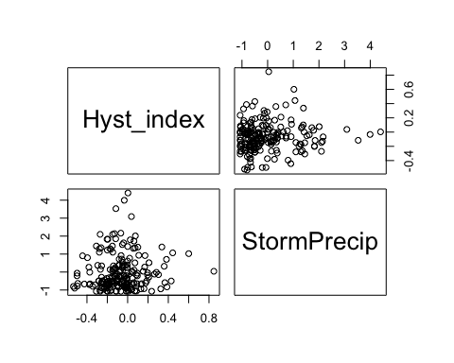

HI_FI_turb %>% ggplot(aes(x = StormPrecip, y = Hyst_index)) +   
 geom_hline(yintercept = 0, linetype = "dotted", size = 1) +  
 geom_errorbar(aes(ymin=HI_ymin, ymax=HI_ymax), colour="black", alpha=0.5, size=.5, width = 0.1)+   
 geom_point(aes(color = site.ID), size = 2) +  
 scale_color_manual(values = c("orange red", viridis::viridis(6)), "Catchment")+theme_bw() +  
 geom_smooth(method = "lm", na.rm = TRUE, fullrange = TRUE, aes(group = 1)) +   
 stat_poly_eq(formula = y~x,  
 label.y = "top", label.x = "right",  
 aes(label = paste(..eq.label.., ..rr.label.., sep = "~~~")),   
 parse = TRUE) +   
 ylab("Hysteresis Index") +  
 ggtitle("HI vs. StormPrecip")

## `geom_smooth()` using formula 'y ~ x'

## Warning: Removed 1 rows containing non-finite values (stat_poly_eq).

## Warning: Removed 1 rows containing missing values (geom_point).

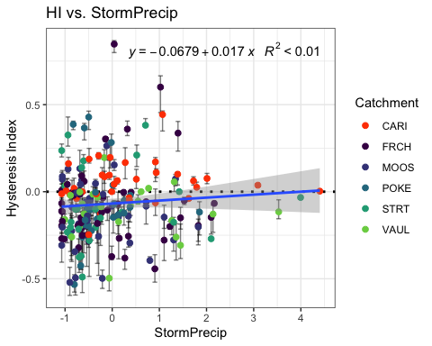

turb_data.2 <- HI_FI_turb[,c("Hyst_index","PrecipWeek")]  
  
pairs(turb_data.2)

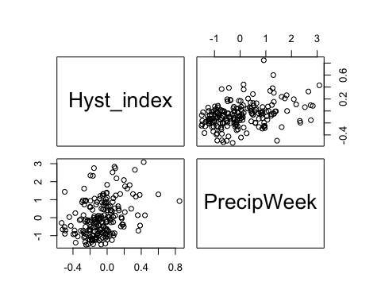

HI_FI_turb %>% ggplot(aes(x = PrecipWeek, y = Hyst_index)) +   
 geom_hline(yintercept = 0, linetype = "dotted", size = 1) +  
 geom_errorbar(aes(ymin=HI_ymin, ymax=HI_ymax), colour="black", alpha=0.5, size=.5, width = 0.1)+   
 geom_point(aes(color = site.ID), size = 2) +  
 scale_color_manual(values = c("orange red", viridis::viridis(6)), "Catchment")+theme_bw() +  
 geom_smooth(method = "lm", na.rm = TRUE, fullrange = TRUE, aes(group = 1)) +   
 stat_poly_eq(formula = y~x,  
 label.y = "top", label.x = "right",  
 aes(label = paste(..eq.label.., ..rr.label.., sep = "~~~")),   
 parse = TRUE) +   
 ylab("Hysteresis Index") +  
 ggtitle("HI vs. PrecipWeek")

## `geom_smooth()` using formula 'y ~ x'

## Warning: Removed 1 rows containing non-finite values (stat_poly_eq).

## Warning: Removed 1 rows containing missing values (geom_point).

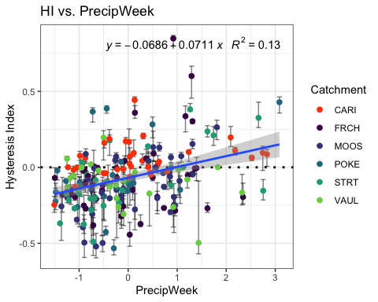

turb_data.3 <- HI_FI_turb[,c("Hyst_index","PrecipMonth")]  
  
pairs(turb_data.3)

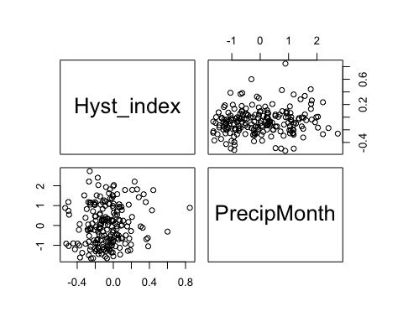

HI_FI_turb %>% ggplot(aes(x = PrecipMonth, y = Hyst_index)) +   
 geom_hline(yintercept = 0, linetype = "dotted", size = 1) +  
 geom_errorbar(aes(ymin=HI_ymin, ymax=HI_ymax), colour="black", alpha=0.5, size=.5, width = 0.1)+   
 geom_point(aes(color = site.ID), size = 2) +  
 scale_color_manual(values = c("orange red", viridis::viridis(6)), "Catchment")+theme_bw() +  
 geom_smooth(method = "lm", na.rm = TRUE, fullrange = TRUE, aes(group = 1)) +   
 stat_poly_eq(formula = y~x,  
 label.y = "top", label.x = "right",  
 aes(label = paste(..eq.label.., ..rr.label.., sep = "~~~")),   
 parse = TRUE) +   
 ylab("Hysteresis Index") +  
 ggtitle("HI vs. PrecipMonth")

## `geom_smooth()` using formula 'y ~ x'

## Warning: Removed 1 rows containing non-finite values (stat_poly_eq).

## Warning: Removed 1 rows containing missing values (geom_point).

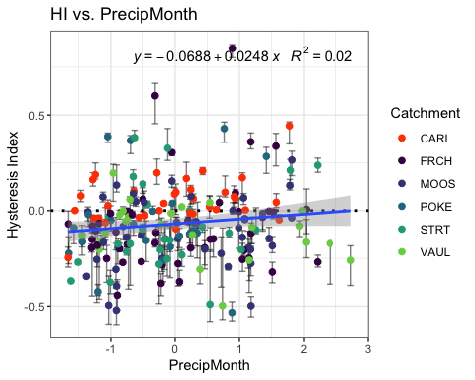

turb_data.4 <- HI_FI_turb[,c("Hyst_index","ThreeMonth")]  
  
pairs(SPC_data.4)



HI_FI_turb %>% ggplot(aes(x = ThreeMonth, y = Hyst_index)) +   
 geom_hline(yintercept = 0, linetype = "dotted", size = 1) +  
 geom_errorbar(aes(ymin=HI_ymin, ymax=HI_ymax), colour="black", alpha=0.5, size=.5, width = 0.1)+   
 geom_point(aes(color = site.ID), size = 2) +  
 scale_color_manual(values = c("orange red", viridis::viridis(6)), "Catchment")+theme_bw() +  
 geom_smooth(method = "lm", na.rm = TRUE, fullrange = TRUE, aes(group = 1)) +   
 stat_poly_eq(formula = y~x,  
 label.y = "top", label.x = "right",  
 aes(label = paste(..eq.label.., ..rr.label.., sep = "~~~")),   
 parse = TRUE) +   
 ylab("Hysteresis Index") +  
 ggtitle("HI vs. ThreeMonth")

## `geom_smooth()` using formula 'y ~ x'

## Warning: Removed 1 rows containing non-finite values (stat_poly_eq).

## Warning: Removed 1 rows containing missing values (geom_point).

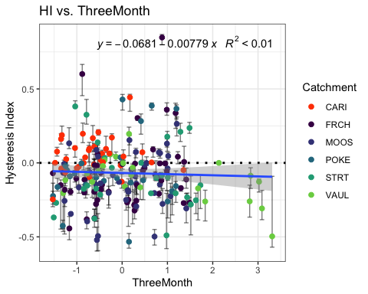

turb_data.5 <- HI_FI_turb[,c("Hyst_index","Intensity")]  
  
pairs(turb_data.5)

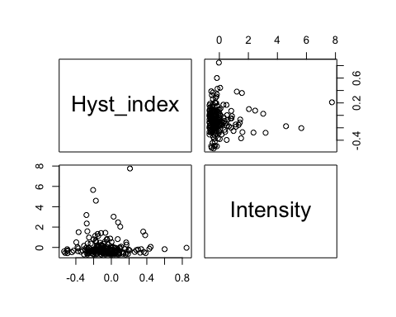

HI_FI_turb %>% ggplot(aes(x = Intensity, y = Hyst_index)) +   
 geom_hline(yintercept = 0, linetype = "dotted", size = 1) +  
 geom_errorbar(aes(ymin=HI_ymin, ymax=HI_ymax), colour="black", alpha=0.5, size=.5, width = 0.1)+   
 geom_point(aes(color = site.ID), size = 2) +  
 scale_color_manual(values = c("orange red", viridis::viridis(6)), "Catchment")+theme_bw() +  
 geom_smooth(method = "lm", na.rm = TRUE, fullrange = TRUE, aes(group = 1)) +   
 stat_poly_eq(formula = y~x,  
 label.y = "top", label.x = "right",  
 aes(label = paste(..eq.label.., ..rr.label.., sep = "~~~")),   
 parse = TRUE) +   
 ylab("Hysteresis Index") +  
 ggtitle("HI vs. Intensity")

## `geom_smooth()` using formula 'y ~ x'

## Warning: Removed 3 rows containing non-finite values (stat_poly_eq).

## Warning: Removed 3 rows containing missing values (geom_point).

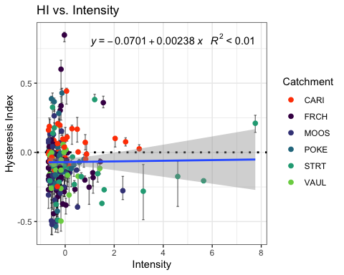

turb_data.6 <- HI_FI_turb[,c("Hyst_index","StormTemp")]  
  
pairs(turb_data.6)

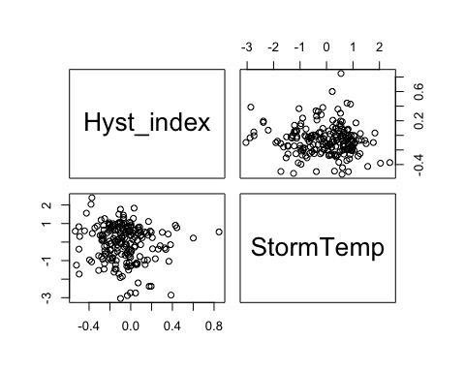

HI_FI_turb %>% ggplot(aes(x = StormTemp, y = Hyst_index)) +   
 geom_hline(yintercept = 0, linetype = "dotted", size = 1) +  
 geom_errorbar(aes(ymin=HI_ymin, ymax=HI_ymax), colour="black", alpha=0.5, size=.5, width = 0.1)+   
 geom_point(aes(color = site.ID), size = 2) +  
 scale_color_manual(values = c("orange red", viridis::viridis(6)), "Catchment")+theme_bw() +  
 geom_smooth(method = "lm", na.rm = TRUE, fullrange = TRUE, aes(group = 1)) +   
 stat_poly_eq(formula = y~x,  
 label.y = "top", label.x = "right",  
 aes(label = paste(..eq.label.., ..rr.label.., sep = "~~~")),   
 parse = TRUE) +   
 ylab("Hysteresis Index") +  
 ggtitle("HI vs. StormTemp")

## `geom_smooth()` using formula 'y ~ x'

## Warning: Removed 1 rows containing non-finite values (stat_poly_eq).

## Warning: Removed 1 rows containing missing values (geom_point).

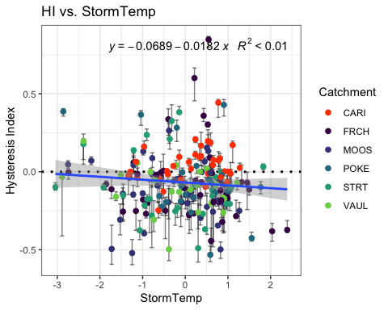

turb_data.7 <- HI_FI_turb[,c("Hyst_index","TempWeek")]  
  
pairs(turb_data.7)

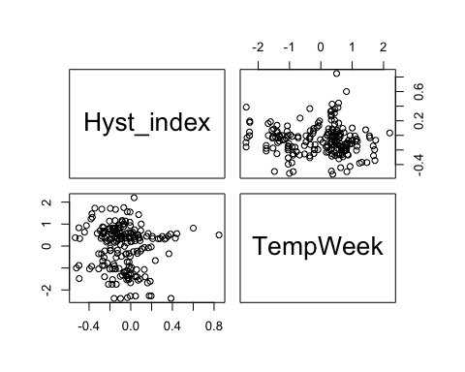

HI_FI_turb %>% ggplot(aes(x = TempWeek, y = Hyst_index)) +   
 geom_hline(yintercept = 0, linetype = "dotted", size = 1) +  
 geom_errorbar(aes(ymin=HI_ymin, ymax=HI_ymax), colour="black", alpha=0.5, size=.5, width = 0.1)+   
 geom_point(aes(color = site.ID), size = 2) +  
 scale_color_manual(values = c("orange red", viridis::viridis(6)), "Catchment")+theme_bw() +  
 geom_smooth(method = "lm", na.rm = TRUE, fullrange = TRUE, aes(group = 1)) +   
 stat_poly_eq(formula = y~x,  
 label.y = "top", label.x = "right",  
 aes(label = paste(..eq.label.., ..rr.label.., sep = "~~~")),   
 parse = TRUE) +   
 ylab("Hysteresis Index") +  
 ggtitle("HI vs. TempWeek")

## `geom_smooth()` using formula 'y ~ x'

## Warning: Removed 2 rows containing non-finite values (stat_poly_eq).

## Warning: Removed 2 rows containing missing values (geom_point).

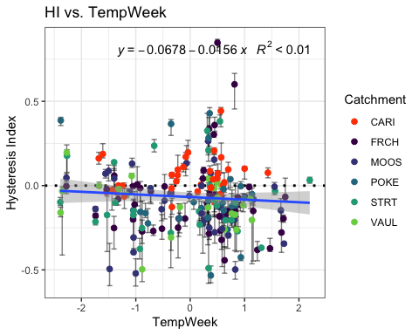

turb_data.8 <- HI_FI_turb[,c("Hyst_index","TimeSinceChena")]  
  
pairs(turb_data.8)

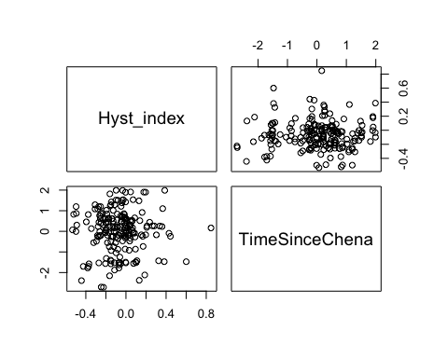

HI_FI_turb %>% ggplot(aes(x = TimeSinceChena, y = Hyst_index)) +   
 geom_hline(yintercept = 0, linetype = "dotted", size = 1) +  
 geom_errorbar(aes(ymin=HI_ymin, ymax=HI_ymax), colour="black", alpha=0.5, size=.5, width = 0.1)+   
 geom_point(aes(color = site.ID), size = 2) +  
 scale_color_manual(values = c("orange red", viridis::viridis(6)), "Catchment")+theme_bw() +  
 geom_smooth(method = "lm", na.rm = TRUE, fullrange = TRUE, aes(group = 1)) +   
 stat_poly_eq(formula = y~x,  
 label.y = "top", label.x = "right",  
 aes(label = paste(..eq.label.., ..rr.label.., sep = "~~~")),   
 parse = TRUE) +   
 ylab("Hysteresis Index") +  
 ggtitle("HI vs. TimeSinceChena")

## `geom_smooth()` using formula 'y ~ x'

## Warning: Removed 1 rows containing non-finite values (stat_poly_eq).

## Warning: Removed 1 rows containing missing values (geom_point).

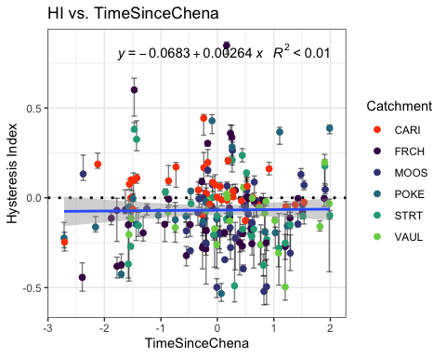

turb_data <- HI_FI_turb[,c("Hyst_index", "site.ID", "StormPrecip", "StormTemp", "PrecipWeek", "PrecipMonth", "ThreeMonth", "TempWeek", "Intensity", "TimeSinceChena", "burn", "pf", "year")]  
  
turb_data <- na.omit(turb_data) # 240 to 235  
cor(turb_data[,c(1,3:10)])

## Hyst_index StormPrecip StormTemp PrecipWeek PrecipMonth  
## Hyst_index 1.000000000 0.08792776 -0.08893642 0.341462114 0.10414010  
## StormPrecip 0.087927762 1.00000000 0.17312879 0.041259065 0.02024594  
## StormTemp -0.088936421 0.17312879 1.00000000 0.101138949 0.19553243  
## PrecipWeek 0.341462114 0.04125906 0.10113895 1.000000000 0.49644951  
## PrecipMonth 0.104140101 0.02024594 0.19553243 0.496449512 1.00000000  
## ThreeMonth -0.058493548 -0.12381048 -0.19671492 0.155694576 0.58041929  
## TempWeek -0.072678013 0.26899091 0.81540223 0.153330830 0.22426207  
## Intensity 0.010538064 0.32108732 0.11312337 0.004123254 0.02824008  
## TimeSinceChena -0.001912109 -0.20834455 -0.70505896 -0.142353327 0.09660757  
## ThreeMonth TempWeek Intensity TimeSinceChena  
## Hyst_index -0.05849355 -0.07267801 0.010538064 -0.001912109  
## StormPrecip -0.12381048 0.26899091 0.321087321 -0.208344548  
## StormTemp -0.19671492 0.81540223 0.113123373 -0.705058965  
## PrecipWeek 0.15569458 0.15333083 0.004123254 -0.142353327  
## PrecipMonth 0.58041929 0.22426207 0.028240075 0.096607573  
## ThreeMonth 1.00000000 -0.11970728 -0.033898506 0.558655435  
## TempWeek -0.11970728 1.00000000 0.156647696 -0.619376278  
## Intensity -0.03389851 0.15664770 1.000000000 -0.112202335  
## TimeSinceChena 0.55865543 -0.61937628 -0.112202335 1.000000000

1. StormTemp is heavily correlated with TempWeek (0.797) but StormTemp is more correlated with HI (-0.07 vs. -0.06)
2. StormTemp is also correlated with TimeSinceChena (-0.722) but StormTemp is more correlated with HI (-0.07 vs. -0.02)
3. PrecipWeek is correlated with PrecipMonth (0.542) but PrecipWeek is more correlated with HI (0.228 vs. -0.004)
4. PrecipMonth is correlated with ThreeMonth (0.628) but ThreeMonth is more correlated with HI (-0.139 vs. -0.004)
5. ThreeMonth is correlated with TimeSinceChena (0.571) but ThreeMonth is more correlated with HI ( -0.139 vs. -0.028)

* this makes me want to drop time since chena and three month

## Linear mixed model fit by REML ['lmerMod']  
## Formula: Hyst_index ~ StormPrecip + PrecipWeek + PrecipMonth + ThreeMonth +   
## Intensity + StormTemp + TempWeek + TimeSinceChena + (1 | site.ID)  
## Data: turb_data  
##   
## REML criterion at convergence: -57  
##   
## Scaled residuals:   
## Min 1Q Median 3Q Max   
## -2.4542 -0.4624 -0.0763 0.5113 4.8431   
##   
## Random effects:  
## Groups Name Variance Std.Dev.  
## site.ID (Intercept) 0.002212 0.04703   
## Residual 0.033460 0.18292   
## Number of obs: 199, groups: site.ID, 6  
##   
## Fixed effects:  
## Estimate Std. Error t value  
## (Intercept) -0.0692632 0.0233810 -2.962  
## StormPrecip 0.0145044 0.0149283 0.972  
## PrecipWeek 0.0711731 0.0160720 4.428  
## PrecipMonth 0.0114981 0.0203983 0.564  
## ThreeMonth -0.0299419 0.0221907 -1.349  
## Intensity -0.0004561 0.0144325 -0.032  
## StormTemp -0.0287144 0.0268385 -1.070  
## TempWeek -0.0070136 0.0243131 -0.288  
## TimeSinceChena 0.0104262 0.0251373 0.415  
##   
## Correlation of Fixed Effects:  
## (Intr) StrmPr PrcpWk PrcpMn ThrMnt Intnst StrmTm TempWk  
## StormPrecip 0.007   
## PrecipWeek 0.006 0.022   
## PrecipMonth 0.005 -0.009 -0.460   
## ThreeMonth -0.016 0.033 -0.002 -0.538   
## Intensity -0.015 -0.304 0.034 -0.049 0.011   
## StormTemp 0.008 0.140 0.222 -0.178 -0.080 -0.001   
## TempWeek 0.003 -0.227 -0.056 -0.056 -0.058 -0.034 -0.636   
## TimeSincChn 0.003 0.057 0.269 -0.030 -0.533 0.014 0.460 0.122

1. Scaled residuals dont look ideal
2. The site accounts for slightly more variation

3)Precip week is the most significant

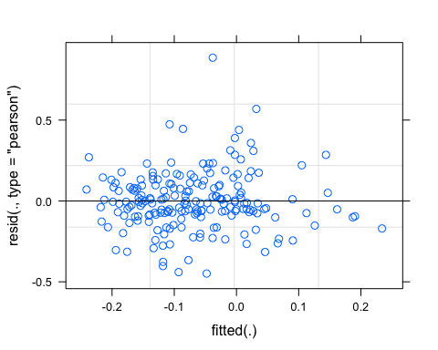 perhaps some funnelling

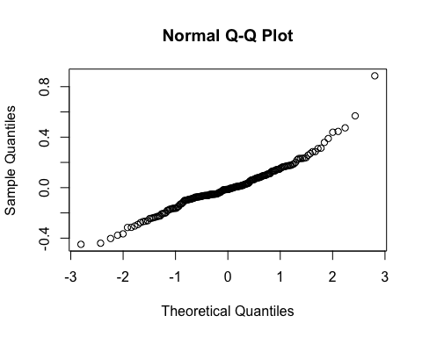

vif(M0.turb)

## StormPrecip PrecipWeek PrecipMonth ThreeMonth Intensity   
## 1.232211 1.485987 2.416970 2.655747 1.142906   
## StormTemp TempWeek TimeSinceChena   
## 4.127953 3.386612 3.498834

Any VIF > 2 indicates high correlation….lets remove StormTemp and ThreeMonth

## StormPrecip PrecipWeek PrecipMonth Intensity TempWeek   
## 1.206166 1.412279 1.596735 1.143427 1.977654   
## TimeSinceChena   
## 1.891506

## Linear mixed model fit by REML ['lmerMod']  
## Formula: Hyst_index ~ StormPrecip + PrecipWeek + PrecipMonth + Intensity +   
## TempWeek + TimeSinceChena + (1 | site.ID)  
## Data: turb_data  
##   
## REML criterion at convergence: -65  
##   
## Scaled residuals:   
## Min 1Q Median 3Q Max   
## -2.9012 -0.4814 -0.0485 0.4863 4.7391   
##   
## Random effects:  
## Groups Name Variance Std.Dev.  
## site.ID (Intercept) 0.002387 0.04885   
## Residual 0.033630 0.18338   
## Number of obs: 199, groups: site.ID, 6  
##   
## Fixed effects:  
## Estimate Std. Error t value  
## (Intercept) -0.069593 0.024016 -2.898  
## StormPrecip 0.017595 0.014813 1.188  
## PrecipWeek 0.075307 0.015711 4.793  
## PrecipMonth -0.008646 0.016627 -0.520  
## Intensity -0.000219 0.014489 -0.015  
## TempWeek -0.027248 0.018629 -1.463  
## TimeSinceChena 0.004999 0.018538 0.270  
##   
## Correlation of Fixed Effects:  
## (Intr) StrmPr PrcpWk PrcpMn Intnst TempWk  
## StormPrecip 0.007   
## PrecipWeek 0.005 -0.010   
## PrecipMonth -0.002 0.052 -0.519   
## Intensity -0.015 -0.309 0.035 -0.054   
## TempWeek 0.008 -0.176 0.116 -0.370 -0.043   
## TimeSincChn -0.011 0.021 0.244 -0.374 0.027 0.641

1. VIFs are all below 2…woot
2. PrecipWeek and PrecipMonth (0.54)
3. TimeSinceChena (-0.588) 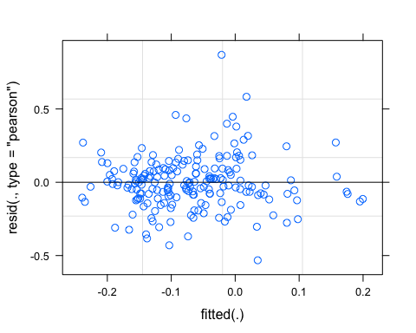

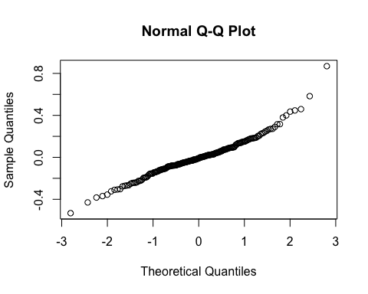

pr <- ggpredict(M1.turb, terms = c("PrecipWeek"))  
plot(pr, add.data = TRUE)

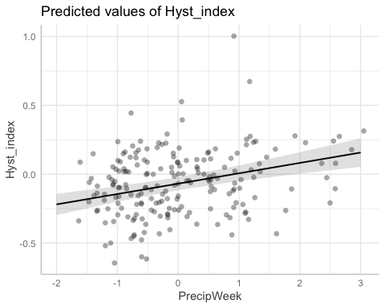

### Alternative slopes

## Linear mixed model fit by REML ['lmerMod']  
## Formula: Hyst_index ~ StormPrecip + PrecipWeek + PrecipMonth + Intensity +   
## TempWeek + TimeSinceChena + (PrecipWeek | site.ID)  
## Data: turb_data  
##   
## REML criterion at convergence: -68.4  
##   
## Scaled residuals:   
## Min 1Q Median 3Q Max   
## -2.6136 -0.4939 -0.0115 0.4624 4.8026   
##   
## Random effects:  
## Groups Name Variance Std.Dev. Corr   
## site.ID (Intercept) 0.002872 0.05359   
## PrecipWeek 0.001835 0.04284 -0.39  
## Residual 0.032117 0.17921   
## Number of obs: 199, groups: site.ID, 6  
##   
## Fixed effects:  
## Estimate Std. Error t value  
## (Intercept) -0.0669896 0.0255424 -2.623  
## StormPrecip 0.0165691 0.0145135 1.142  
## PrecipWeek 0.0757678 0.0235930 3.211  
## PrecipMonth -0.0104257 0.0166591 -0.626  
## Intensity -0.0006923 0.0142083 -0.049  
## TempWeek -0.0204242 0.0184384 -1.108  
## TimeSinceChena 0.0093068 0.0183956 0.506  
##   
## Correlation of Fixed Effects:  
## (Intr) StrmPr PrcpWk PrcpMn Intnst TempWk  
## StormPrecip 0.006   
## PrecipWeek -0.245 -0.008   
## PrecipMonth -0.005 0.055 -0.358   
## Intensity -0.015 -0.310 0.018 -0.053   
## TempWeek 0.011 -0.177 0.081 -0.377 -0.043   
## TimeSincChn -0.008 0.020 0.167 -0.385 0.025 0.647

## Linear mixed model fit by REML ['lmerMod']  
## Formula: Hyst_index ~ StormPrecip + PrecipWeek + PrecipMonth + Intensity +   
## TempWeek + TimeSinceChena + (0 + PrecipWeek | site.ID) + (1 | site.ID)  
## Data: turb_data  
##   
## REML criterion at convergence: -68.1  
##   
## Scaled residuals:   
## Min 1Q Median 3Q Max   
## -2.4790 -0.4928 -0.0135 0.4716 4.8036   
##   
## Random effects:  
## Groups Name Variance Std.Dev.  
## site.ID PrecipWeek 0.001967 0.04435   
## site.ID.1 (Intercept) 0.002863 0.05351   
## Residual 0.032078 0.17910   
## Number of obs: 199, groups: site.ID, 6  
##   
## Fixed effects:  
## Estimate Std. Error t value  
## (Intercept) -0.067305 0.025534 -2.636  
## StormPrecip 0.017827 0.014537 1.226  
## PrecipWeek 0.074168 0.024087 3.079  
## PrecipMonth -0.007983 0.016726 -0.477  
## Intensity -0.001608 0.014297 -0.112  
## TempWeek -0.021587 0.018417 -1.172  
## TimeSinceChena 0.008426 0.018352 0.459  
##   
## Correlation of Fixed Effects:  
## (Intr) StrmPr PrcpWk PrcpMn Intnst TempWk  
## StormPrecip 0.009   
## PrecipWeek 0.007 -0.007   
## PrecipMonth -0.003 0.057 -0.353   
## Intensity -0.018 -0.315 0.020 -0.061   
## TempWeek 0.009 -0.174 0.078 -0.375 -0.044   
## TimeSincChn -0.010 0.022 0.162 -0.382 0.024 0.647

pr <- ggpredict(M10.turb, terms = c("PrecipWeek"))  
plot(pr, add.data = TRUE)

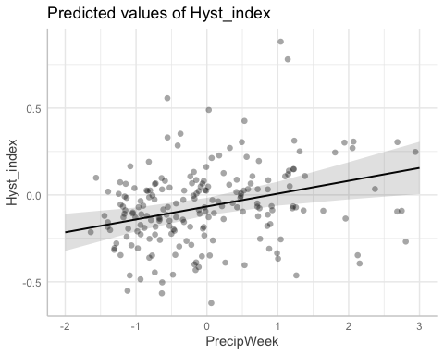

f11 <- formula(Hyst_index ~ StormPrecip + PrecipWeek + PrecipMonth + Intensity + TempWeek + TimeSinceChena + (1|site.ID) + (1|year))  
  
M11.Turb <- lmer(f11, data = turb_data)

f12 <- formula(Hyst_index ~ StormPrecip + PrecipWeek + PrecipMonth + Intensity + TempWeek + TimeSinceChena + (0+PrecipWeek|site.ID) + (1|site.ID) + (1|year))  
  
M12.Turb <- lmer(f12, data = turb_data)

aictab(list(M0.turb, M1.turb, M2.turb, M10.turb, M11.Turb,M12.Turb))

## Warning in aictab.AIClmerMod(list(M0.turb, M1.turb, M2.turb, M10.turb, M11.Turb, :   
## Model names have been supplied automatically in the table

## Warning in aictab.AIClmerMod(list(M0.turb, M1.turb, M2.turb, M10.turb, M11.Turb, :   
## Model selection for fixed effects is only appropriate with ML estimation:  
## REML (default) should only be used to select random effects for a constant set of fixed effects

##   
## Model selection based on AICc:  
##   
## K AICc Delta_AICc AICcWt Cum.Wt Res.LL  
## Mod6 11 -47.51 0.00 0.31 0.31 35.46  
## Mod4 10 -46.89 0.62 0.23 0.54 34.03  
## Mod5 10 -46.89 0.62 0.23 0.76 34.03  
## Mod2 9 -46.06 1.45 0.15 0.91 32.51  
## Mod3 11 -44.96 2.55 0.09 1.00 34.19  
## Mod1 11 -33.62 13.88 0.00 1.00 28.52

Mod6: Uncorrelated random slope and random intercept with year and site as effect Mod4: Reduced model with uncorrelated random slope and random intercept Mod5: Reduced model with random intercept and year effect Mod3: Reduced model (no StormTemp, ThreeMonth Precip) with random slope intercept structure Mod2: Reduced model (’’) with random intercept structure Mod1: Full model with random intercept structure

m1 <- lm(Hyst_index ~ StormPrecip + PrecipWeek + PrecipMonth + Intensity + TempWeek + TimeSinceChena, data = turb_data)  
dwplot(m1,  
 dot_args = list(color = "black"), # color for the dot  
 whisker_args = list(color = "red"), # color for the whisker  
 vline = geom_vline(xintercept = 0, colour = "grey50", linetype = 2)) +  
 xlab("Coefficient") +   
 ggtitle("") +  
 theme_classic()

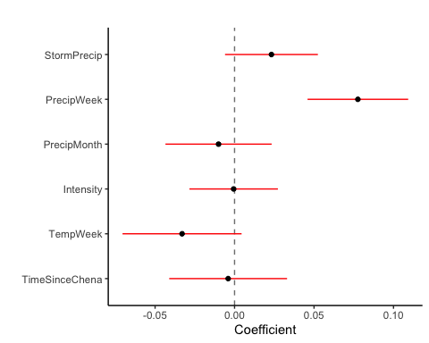

ggsave("~/Documents/Storms/Output_from_analysis/From_07_Modelling/HI/Turb/coefficient.png")

## Saving 5 x 4 in image

CI overlapping 0 are nonsignificant which is almost everything besides PrecipMonth and PrecipWeek for our reduced model

plot(M1.turb, site.ID ~ resid(.), abline = 0 ) # generate diagnostic plots

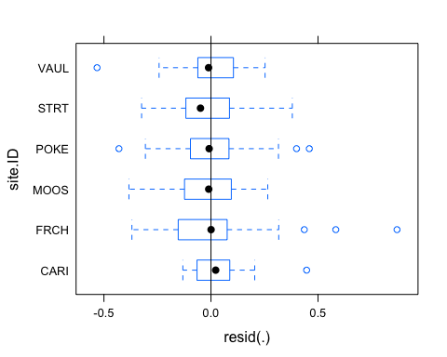 This plot shows us that there are some outliers in all of our sites and that the variability within FRCH is greater than in other sites we therefore examine the sites in isolation standardized residuals versus fitted values

plot(M1.turb, resid(., type = "pearson") ~ fitted(.) | site.ID, id = 0.05,   
 adj = -0.3, pch = 20, col = "gray40")

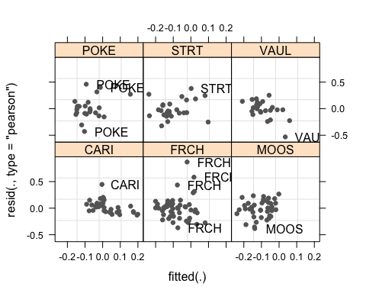 The plot shows the standardized residuals (or Pearson’s residuals) versus fitted values and suggests that there are outliers in the data (the names elements in the plots). To check if these outliers are a cause for concern, we will now use a Levene’s test to check if the variance is distributed homogeneously (homoscedasticity) or whether the assumption of variance homogeneity is violated (due to the outliers).

### Mixed effect model is a pseudo r^2

sjPlot::tab_model(M12.Turb)

## Warning: Argument 'df_method' is deprecated. Please use 'ci_method' instead.

Hyst_index

Predictors

Estimates

CI

p

(Intercept)

-0.07

-0.13 – -0.00

0.050

StormPrecip

0.02

-0.01 – 0.05

0.181

PrecipWeek

0.07

0.02 – 0.11

0.006

PrecipMonth

0.00

-0.03 – 0.03

0.963

Intensity

-0.00

-0.03 – 0.02

0.798

TempWeek

-0.02

-0.06 – 0.01

0.236

TimeSinceChena

0.01

-0.03 – 0.04

0.784

Random Effects

σ2

0.03

τ00 site.ID.1

0.00

τ00 year

0.00

τ11 site.ID.PrecipWeek

0.00

ρ01

ρ01

ICC

0.10

N site.ID

6

N year

4

Observations

199

Marginal R2 / Conditional R2

0.121 / 0.208

r.squaredGLMM(M12.Turb)

## R2m R2c  
## [1,] 0.1109493 0.2712167

The R2 values of the summary table are correct as Marginal and conditional are bothe there. The more appropriate conditional and marginal coefficient of determination for generalized mixed-effect models can be extracted using the r.squaredGLMM function from the MuMIn package

The marginal R2 (marginal coefficient of determination) represents the variance explained by the fixed effects while the conditional R2 is interpreted as a variance explained by the entire model, including both fixed and random effects

r.squaredGLMM(M10.turb)

## R2m R2c  
## [1,] 0.1240189 0.2380502

only 12%…ouch

sjPlot::plot_model(M1.turb, type = "pred", terms = c("PrecipWeek")) +  
 # show uncentered date rather than centered date  
 scale_x_continuous(name = "PrecipWeek",   
 breaks = seq(-500, 300, 100),   
 labels = seq(1150, 1950, 100))

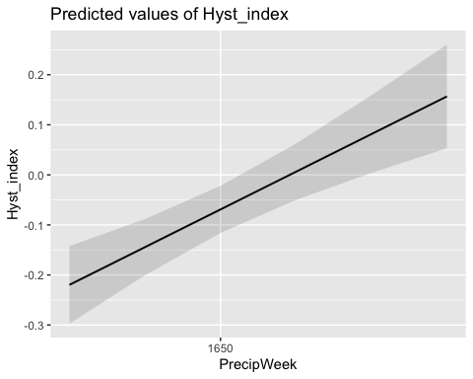

### Permafrost

f4.turb <- formula(Hyst_index ~ StormPrecip*pf + PrecipWeek*pf + PrecipMonth*pf + Intensity*pf + TempWeek*pf + TimeSinceChena*pf + (1|site.ID))  
  
M4.turb <- lmer(f4.turb, data = turb_data)  
summary(M4.turb)

## Linear mixed model fit by REML ['lmerMod']  
## Formula: Hyst_index ~ StormPrecip * pf + PrecipWeek * pf + PrecipMonth *   
## pf + Intensity * pf + TempWeek * pf + TimeSinceChena * pf +   
## (1 | site.ID)  
## Data: turb_data  
##   
## REML criterion at convergence: -36.5  
##   
## Scaled residuals:   
## Min 1Q Median 3Q Max   
## -2.5805 -0.5067 0.0069 0.4979 4.6217   
##   
## Random effects:  
## Groups Name Variance Std.Dev.  
## site.ID (Intercept) 0.002697 0.05194   
## Residual 0.034018 0.18444   
## Number of obs: 199, groups: site.ID, 6  
##   
## Fixed effects:  
## Estimate Std. Error t value  
## (Intercept) -0.099858 0.046675 -2.139  
## StormPrecip 0.006822 0.025601 0.266  
## pfmedium 0.047495 0.055745 0.852  
## PrecipWeek 0.071538 0.036090 1.982  
## PrecipMonth -0.041779 0.042398 -0.985  
## Intensity 0.004236 0.017557 0.241  
## TempWeek -0.031125 0.050029 -0.622  
## TimeSinceChena -0.021108 0.056864 -0.371  
## StormPrecip:pfmedium 0.009623 0.032712 0.294  
## pfmedium:PrecipWeek 0.004638 0.040436 0.115  
## pfmedium:PrecipMonth 0.045673 0.046425 0.984  
## pfmedium:Intensity 0.002352 0.034999 0.067  
## pfmedium:TempWeek 0.004390 0.054405 0.081  
## pfmedium:TimeSinceChena 0.032944 0.060323 0.546

##   
## Correlation matrix not shown by default, as p = 14 > 12.  
## Use print(x, correlation=TRUE) or  
## vcov(x) if you need it

Permafrost does have a significant effect with PrecipMonth

### burn

f5.turb <- formula(Hyst_index ~ StormPrecip*burn + PrecipWeek*burn + PrecipMonth*burn + Intensity*burn + TempWeek*burn + TimeSinceChena*burn + (1|site.ID))  
  
M5.turb <- lmer(f5.turb, data = turb_data)  
summary(M5.turb)

## Linear mixed model fit by REML ['lmerMod']  
## Formula: Hyst_index ~ StormPrecip * burn + PrecipWeek * burn + PrecipMonth *   
## burn + Intensity * burn + TempWeek * burn + TimeSinceChena *   
## burn + (1 | site.ID)  
## Data: turb_data  
##   
## REML criterion at convergence: -36.1  
##   
## Scaled residuals:   
## Min 1Q Median 3Q Max   
## -2.7064 -0.5223 -0.0665 0.4579 4.7703   
##   
## Random effects:  
## Groups Name Variance Std.Dev.  
## site.ID (Intercept) 0.002724 0.05219   
## Residual 0.034033 0.18448   
## Number of obs: 199, groups: site.ID, 6  
##   
## Fixed effects:  
## Estimate Std. Error t value  
## (Intercept) -0.057974 0.031163 -1.860  
## StormPrecip 0.020513 0.018835 1.089  
## burnunburned -0.030828 0.054607 -0.565  
## PrecipWeek 0.085731 0.018871 4.543  
## PrecipMonth 0.004498 0.021964 0.205  
## Intensity -0.004552 0.015366 -0.296  
## TempWeek -0.036420 0.022444 -1.623  
## TimeSinceChena -0.007921 0.021739 -0.364  
## StormPrecip:burnunburned -0.007907 0.034273 -0.231  
## burnunburned:PrecipWeek -0.031965 0.034862 -0.917  
## burnunburned:PrecipMonth -0.022476 0.035047 -0.641  
## burnunburned:Intensity 0.017510 0.055503 0.315  
## burnunburned:TempWeek 0.037964 0.043050 0.882  
## burnunburned:TimeSinceChena 0.047335 0.044182 1.071

##   
## Correlation matrix not shown by default, as p = 14 > 12.  
## Use print(x, correlation=TRUE) or  
## vcov(x) if you need it

Fire has significant interaction with TimeSinceChena

Catchment effects

CV.all <- antecedent_HI_FI_1_0 %>% group_by(response_var,site.ID, year) %>%  
 summarize(meanHI = mean(Hyst_index),  
 meanFI = mean(Flush_index, na.rm = TRUE),  
 meanBETA = mean(beta, na.rm = TRUE),  
 sdHI = sd(Hyst_index),  
 sdFI = sd(Flush_index, na.rm = TRUE),  
 sdBETA = sd(beta, na.rm = TRUE),  
 CVhi = sdHI/meanHI,  
 CVfi = sdFI/meanFI,  
 CVbeta = sdBETA/meanBETA,  
 pf = paste(pf),  
 burn = paste(burn)) # calculating mean HI and CV for each year and each site

## `summarise()` has grouped output by 'response_var', 'site.ID', 'year'. You can  
## override using the `.groups` argument.

CV.all <- CV.all[!duplicated(CV.all$meanHI), ] # removing duplicated rows   
  
chem <- read_csv("~/Documents/Storms/Output_from_analysis/From_07_Modelling/Results_figures/Discharge_chem/all.chem.csv",   
 col_types = cols(fDOM.QSU = col_double(),   
 nitrateuM = col_double(), SpCond.uScm = col_double(),   
 Turbidity.FNU = col_double())) # reading in all chem data

## Warning: Missing column names filled in: 'X1' [1]

chem.mean <- chem %>% group_by(Site, year) %>%   
 summarize(meanfDOM = mean(fDOM.QSU, na.rm = TRUE)) # generating mean fDOM concentration by site and year

## `summarise()` has grouped output by 'Site'. You can override using the `.groups`  
## argument.

names(chem.mean) <- c("site.ID", "year", "meanfDOM") # changing the names so they can be merged  
  
CV.all.model <- left_join(CV.all, chem.mean, by = c("site.ID", "year")) # merging TNDOC and CV to run for the model   
  
NO3.CV <- subset(CV.all.model, CV.all$response_var == "NO3")  
fDOM.CV <- subset(CV.all.model, CV.all$response_var == "fDOM")  
SPC.CV <- subset(CV.all.model, CV.all$response_var == "SPC")  
turb.CV <- subset(CV.all.model, CV.all$response_var == "turb")

NO3_data.1 <- NO3.CV[,c("CVhi","meanfDOM")]  
  
NO3.CV %>% ggplot(aes(x = meanfDOM, y = CVhi)) +   
 geom_hline(yintercept = 0, linetype = "dotted", size = 1) +  
 geom_point(aes(color = site.ID), size = 2) +  
 scale_color_manual(values = c("orange red", viridis::viridis(6)), "Catchment")+  
 theme_bw() +  
 geom_smooth(method = "lm", na.rm = TRUE, fullrange = TRUE, aes(group = 1)) +   
 stat_poly_eq(formula = y~x,  
 label.y = "top", label.x = "right",  
 aes(label = paste(..eq.label.., ..rr.label.., sep = "~~~")),   
 parse = TRUE) +   
 ylab("CV Hysteresis Index") +  
 ggtitle("HI vs. fDOM")

## `geom_smooth()` using formula 'y ~ x'

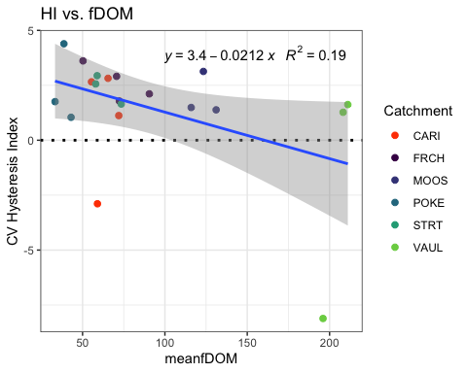

NO3.CV %>% ggplot(aes(x = pf, y = CVhi)) +   
 geom_hline(yintercept = 0, linetype = "dotted", size = 1) +  
 geom_point(aes(color = site.ID), size = 2) +  
 scale_color_manual(values = c("orange red", viridis::viridis(6)), "Catchment")+  
 theme_bw() +  
 geom_smooth(method = "lm", na.rm = TRUE, fullrange = TRUE, aes(group = 1)) +   
 stat_poly_eq(formula = y~x,  
 label.y = "top", label.x = "right",  
 aes(label = paste(..eq.label.., ..rr.label.., sep = "~~~")),   
 parse = TRUE) +   
 ylab("CV Hysteresis Index") +  
 ggtitle("HI vs. pf")

## `geom_smooth()` using formula 'y ~ x'

## Warning: Not enough data to perform fit for group 1; computing mean instead.

## Warning: Not enough data to perform fit for group 2; computing mean instead.

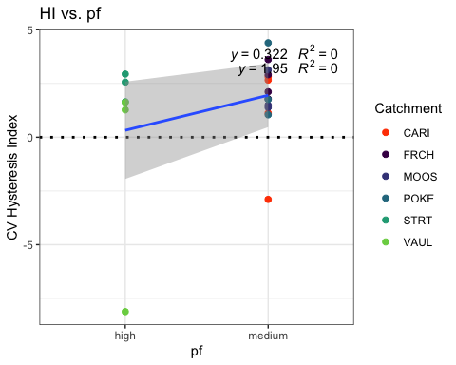

NO3.CV$carbon <- NA  
NO3.CV[c(9:11,18:20), 16] <- "High"  
NO3.CV[c(1:8,12:17), 16] <- "Low"  
  
NO3.CV %>% ggplot(aes(x = carbon, y = CVhi)) +   
 geom_hline(yintercept = 0, linetype = "dotted", size = 1) +  
 geom_point(aes(color = site.ID), size = 2) +  
 scale_color_manual(values = c("orange red", viridis::viridis(6)), "Catchment")+  
 theme_bw() +  
 geom_smooth(method = "lm", na.rm = TRUE, fullrange = TRUE, aes(group = 1)) +   
 stat_poly_eq(formula = y~x,  
 label.y = "top", label.x = "right",  
 aes(label = paste(..eq.label.., ..rr.label.., sep = "~~~")),   
 parse = TRUE) +   
 ylab("CV Hysteresis Index") +  
 ggtitle("HI vs. carbon")

## `geom_smooth()` using formula 'y ~ x'

## Warning: Not enough data to perform fit for group 1; computing mean instead.  
  
## Warning: Not enough data to perform fit for group 2; computing mean instead.

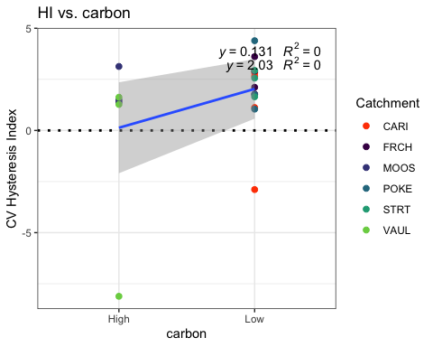

NO3.CV %>% ggplot(aes(x = burn, y = CVhi)) +   
 geom_hline(yintercept = 0, linetype = "dotted", size = 1) +  
 geom_point(aes(color = site.ID), size = 2) +  
 scale_color_manual(values = c("orange red", viridis::viridis(6)), "Catchment")+  
 theme_bw() +  
 geom_smooth(method = "lm", na.rm = TRUE, fullrange = TRUE, aes(group = 1)) +   
 stat_poly_eq(formula = y~x,  
 label.y = "top", label.x = "right",  
 aes(label = paste(..eq.label.., ..rr.label.., sep = "~~~")),   
 parse = TRUE) +   
 ylab("CV Hysteresis Index") +  
 ggtitle("HI vs. burn")

## `geom_smooth()` using formula 'y ~ x'

## Warning: Not enough data to perform fit for group 1; computing mean instead.

## Warning: Not enough data to perform fit for group 2; computing mean instead.

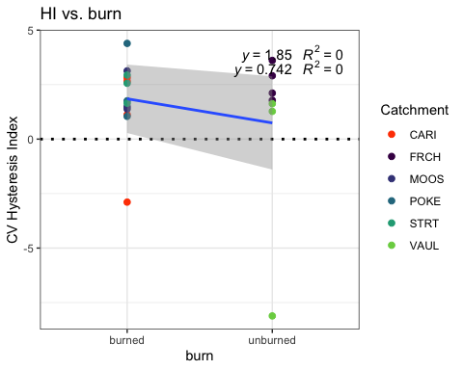

fcvno3 <- formula(CVhi ~ pf*meanfDOM + burn*meanfDOM + (1|year)) # this is the proposed model   
  
Mcvno3 <- lmer(fcvno3, data = NO3.CV)  
summary(Mcvno3)

## Linear mixed model fit by REML ['lmerMod']  
## Formula: CVhi ~ pf * meanfDOM + burn * meanfDOM + (1 | year)  
## Data: NO3.CV  
##   
## REML criterion at convergence: 98.2  
##   
## Scaled residuals:   
## Min 1Q Median 3Q Max   
## -2.33350 -0.29710 0.03709 0.56740 1.22829   
##   
## Random effects:  
## Groups Name Variance Std.Dev.  
## year (Intercept) 2.176 1.475   
## Residual 5.320 2.307   
## Number of obs: 20, groups: year, 4  
##   
## Fixed effects:  
## Estimate Std. Error t value  
## (Intercept) 1.23970 5.21179 0.238  
## pfmedium 1.09023 5.29007 0.206  
## meanfDOM 0.01828 0.07766 0.235  
## burnunburned 4.74812 5.92422 0.801  
## pfmedium:meanfDOM -0.02802 0.07805 -0.359  
## meanfDOM:burnunburned -0.05465 0.08082 -0.676  
##   
## Correlation of Fixed Effects:  
## (Intr) pfmedm mnfDOM brnnbr pf:DOM  
## pfmedium -0.932   
## meanfDOM -0.955 0.911   
## burnunburnd -0.852 0.780 0.923   
## pfmdm:mnDOM 0.912 -0.957 -0.960 -0.879   
## mnfDOM:brnn 0.903 -0.849 -0.978 -0.973 0.936

plot(Mcvno3)

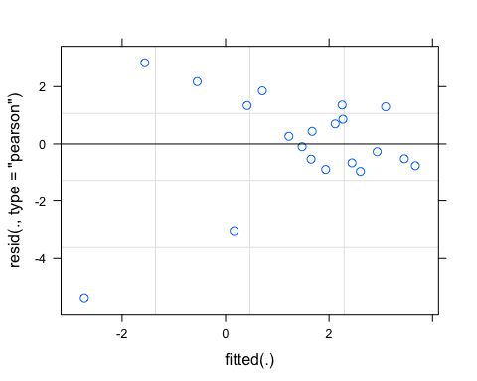

qqnorm(resid(Mcvno3))

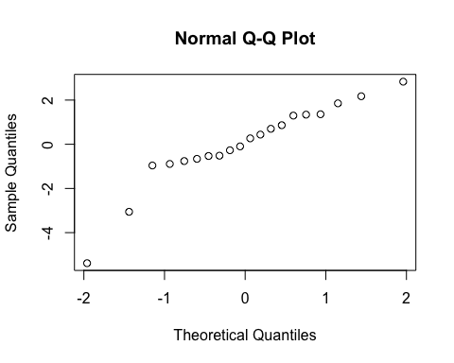

sjPlot::tab_model(Mcvno3)

## Warning: Argument 'df_method' is deprecated. Please use 'ci_method' instead.

CVhi

Predictors

Estimates

CI

p

(Intercept)

1.24

-10.12 – 12.60

0.816

pf [medium]

1.09

-10.44 – 12.62

0.840

meanfDOM

0.02

-0.15 – 0.19

0.818

burn [unburned]

4.75

-8.16 – 17.66

0.438

pf [medium] * meanfDOM

-0.03

-0.20 – 0.14

0.726

meanfDOM * burn[unburned]

-0.05

-0.23 – 0.12

0.512

Random Effects

σ2

5.32

τ00 year

2.18

ICC

0.29

N year

4

Observations

20

Marginal R2 / Conditional R2

0.210 / 0.439

r.squaredGLMM(Mcvno3)

## R2m R2c  
## [1,] 0.2096947 0.4390817

m1 <- lm(CVhi ~ pf*meanfDOM + burn*meanfDOM, data = NO3.CV)  
dwplot(m1,  
 dot_args = list(color = "black"), # color for the dot  
 whisker_args = list(color = "red"), # color for the whisker  
 vline = geom_vline(xintercept = 0, colour = "grey50", linetype = 2)) +  
 xlab("Coefficient") +   
 ggtitle("") +  
 theme_classic()

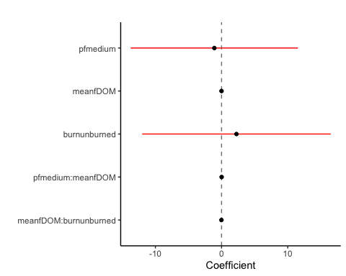

fDOM

fDOM.CV %>% ggplot(aes(x = meanfDOM, y = CVhi)) +   
 geom_hline(yintercept = 0, linetype = "dotted", size = 1) +  
 geom_point(aes(color = site.ID), size = 2) +  
 scale_color_manual(values = c("orange red", viridis::viridis(6)), "Catchment")+  
 theme_bw() +  
 geom_smooth(method = "lm", na.rm = TRUE, fullrange = TRUE, aes(group = 1)) +   
 stat_poly_eq(formula = y~x,  
 label.y = "top", label.x = "right",  
 aes(label = paste(..eq.label.., ..rr.label.., sep = "~~~")),   
 parse = TRUE) +   
 ylab("CV Hysteresis Index") +  
 ggtitle("HI vs. fDOM")

## `geom_smooth()` using formula 'y ~ x'

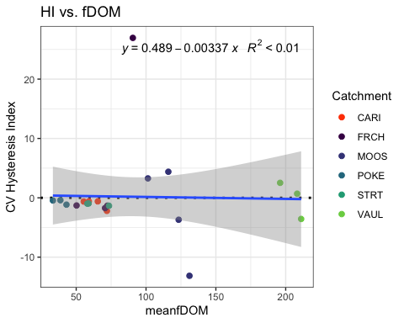

fDOM.CV %>% ggplot(aes(x = pf, y = CVhi)) +   
 geom_hline(yintercept = 0, linetype = "dotted", size = 1) +  
 geom_point(aes(color = site.ID), size = 2) +  
 scale_color_manual(values = c("orange red", viridis::viridis(6)), "Catchment")+  
 theme_bw() +  
 geom_smooth(method = "lm", na.rm = TRUE, fullrange = TRUE, aes(group = 1)) +   
 stat_poly_eq(formula = y~x,  
 label.y = "top", label.x = "right",  
 aes(label = paste(..eq.label.., ..rr.label.., sep = "~~~")),   
 parse = TRUE) +   
 ylab("CV Hysteresis Index") +  
 ggtitle("HI vs. pf")

## `geom_smooth()` using formula 'y ~ x'

## Warning: Not enough data to perform fit for group 1; computing mean instead.

## Warning: Not enough data to perform fit for group 2; computing mean instead.

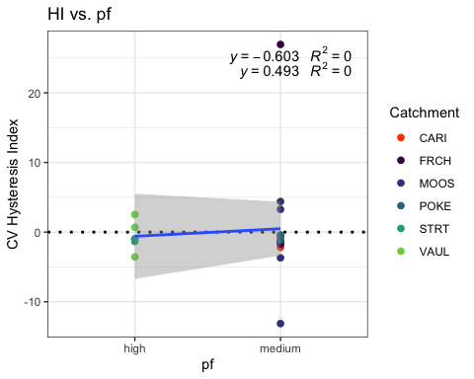

fDOM.CV$carbon <- NA  
fDOM.CV[c(9:12,19:21), 16] <- "High"  
fDOM.CV[c(1:8,13:18), 16] <- "Low"  
  
fDOM.CV %>% ggplot(aes(x = carbon, y = CVhi)) +   
 geom_hline(yintercept = 0, linetype = "dotted", size = 1) +  
 geom_point(aes(color = site.ID), size = 2) +  
 scale_color_manual(values = c("orange red", viridis::viridis(6)), "Catchment")+  
 theme_bw() +  
 geom_smooth(method = "lm", na.rm = TRUE, fullrange = TRUE, aes(group = 1)) +   
 stat_poly_eq(formula = y~x,  
 label.y = "top", label.x = "right",  
 aes(label = paste(..eq.label.., ..rr.label.., sep = "~~~")),   
 parse = TRUE) +   
 ylab("CV Hysteresis Index") +  
 ggtitle("HI vs. carbon")

## `geom_smooth()` using formula 'y ~ x'

## Warning: Not enough data to perform fit for group 1; computing mean instead.  
  
## Warning: Not enough data to perform fit for group 2; computing mean instead.

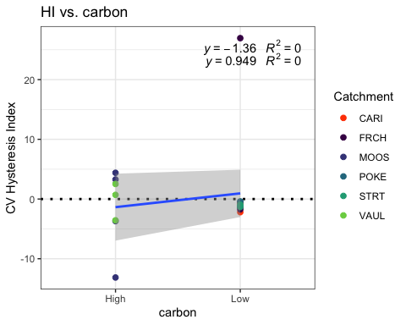

fDOM.CV %>% ggplot(aes(x = burn, y = CVhi)) +   
 geom_hline(yintercept = 0, linetype = "dotted", size = 1) +  
 geom_point(aes(color = site.ID), size = 2) +  
 scale_color_manual(values = c("orange red", viridis::viridis(6)), "Catchment")+  
 theme_bw() +  
 geom_smooth(method = "lm", na.rm = TRUE, fullrange = TRUE, aes(group = 1)) +   
 stat_poly_eq(formula = y~x,  
 label.y = "top", label.x = "right",  
 aes(label = paste(..eq.label.., ..rr.label.., sep = "~~~")),   
 parse = TRUE) +   
 ylab("CV Hysteresis Index") +  
 ggtitle("HI vs. burn")

## `geom_smooth()` using formula 'y ~ x'

## Warning: Not enough data to perform fit for group 1; computing mean instead.

## Warning: Not enough data to perform fit for group 2; computing mean instead.

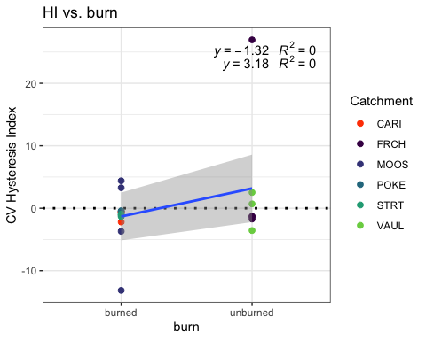

fcvfdom <- formula(CVhi ~ pf*meanfDOM + burn*meanfDOM + (1|year))  
  
Mcvfdom <- lmer(fcvfdom, data = fDOM.CV)

## boundary (singular) fit: see ?isSingular

summary(Mcvfdom)

## Linear mixed model fit by REML ['lmerMod']  
## Formula: CVhi ~ pf * meanfDOM + burn * meanfDOM + (1 | year)  
## Data: fDOM.CV  
##   
## REML criterion at convergence: 127.1  
##   
## Scaled residuals:   
## Min 1Q Median 3Q Max   
## -1.72561 -0.44575 -0.06432 0.43041 1.77372   
##   
## Random effects:  
## Groups Name Variance Std.Dev.  
## year (Intercept) 0.00 0.000   
## Residual 32.76 5.723   
## Number of obs: 21, groups: year, 4  
##   
## Fixed effects:  
## Estimate Std. Error t value  
## (Intercept) 37.7825 12.4334 3.039  
## pfmedium -36.4782 12.4745 -2.924  
## meanfDOM -0.6146 0.1835 -3.350  
## burnunburned -36.3944 14.0655 -2.588  
## pfmedium:meanfDOM 0.5797 0.1796 3.228  
## meanfDOM:burnunburned 0.6078 0.1908 3.185  
##   
## Correlation of Fixed Effects:  
## (Intr) pfmedm mnfDOM brnnbr pf:DOM  
## pfmedium -0.942   
## meanfDOM -0.965 0.903   
## burnunburnd -0.854 0.759 0.917   
## pfmdm:mnDOM 0.929 -0.954 -0.961 -0.869   
## mnfDOM:brnn 0.908 -0.833 -0.976 -0.971 0.932  
## optimizer (nloptwrap) convergence code: 0 (OK)  
## boundary (singular) fit: see ?isSingular

plot(Mcvfdom)

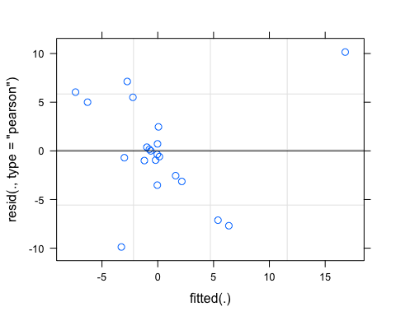

qqnorm(resid(Mcvfdom))

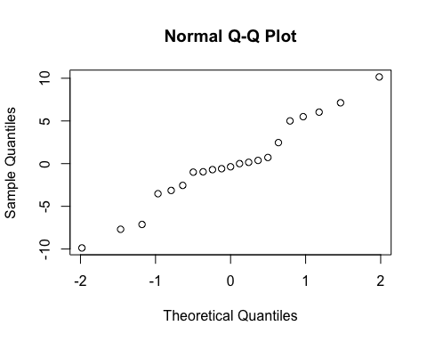

sjPlot::tab_model(Mcvfdom)

## Warning: Argument 'df_method' is deprecated. Please use 'ci_method' instead.

CVhi

Predictors

Estimates

CI

p

(Intercept)

37.78

10.92 – 64.64

0.010

pf [medium]

-36.48

-63.43 – -9.53

0.012

meanfDOM

-0.61

-1.01 – -0.22

0.005

burn [unburned]

-36.39

-66.78 – -6.01

0.023

pf [medium] * meanfDOM

0.58

0.19 – 0.97

0.007

meanfDOM * burn[unburned]

0.61

0.20 – 1.02

0.007

Random Effects

σ2

32.76

τ00 year

0.00

N year

4

Observations

21

Marginal R2 / Conditional R2

0.427 / NA

r.squaredGLMM(Mcvfdom)

## R2m R2c  
## [1,] 0.4266879 0.4266879

m1 <- lm(CVhi ~ pf*meanfDOM + burn*meanfDOM, data = fDOM.CV)  
dwplot(m1,  
 dot_args = list(color = "black"), # color for the dot  
 whisker_args = list(color = "red"), # color for the whisker  
 vline = geom_vline(xintercept = 0, colour = "grey50", linetype = 2)) +  
 xlab("Coefficient") +   
 ggtitle("") +  
 theme_classic()

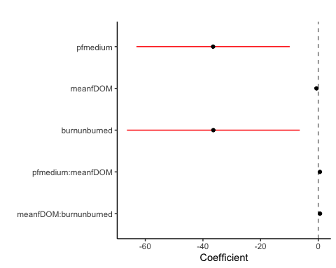

SPC

SPC.CV %>% ggplot(aes(x = meanfDOM, y = CVhi)) +   
 geom_hline(yintercept = 0, linetype = "dotted", size = 1) +  
 geom_point(aes(color = site.ID), size = 2) +  
 scale_color_manual(values = c("orange red", viridis::viridis(6)), "Catchment")+  
 theme_bw() +  
 geom_smooth(method = "lm", na.rm = TRUE, fullrange = TRUE, aes(group = 1)) +   
 stat_poly_eq(formula = y~x,  
 label.y = "top", label.x = "right",  
 aes(label = paste(..eq.label.., ..rr.label.., sep = "~~~")),   
 parse = TRUE) +   
 ylab("CV Hysteresis Index") +  
 ggtitle("HI vs. fDOM")

## `geom_smooth()` using formula 'y ~ x'

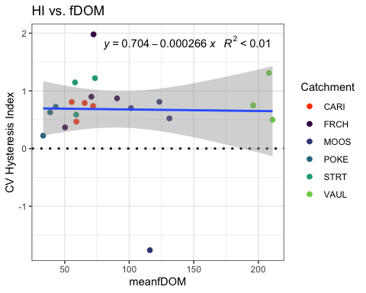

SPC.CV %>% ggplot(aes(x = pf, y = CVhi)) +   
 geom_hline(yintercept = 0, linetype = "dotted", size = 1) +  
 geom_point(aes(color = site.ID), size = 2) +  
 scale_color_manual(values = c("orange red", viridis::viridis(6)), "Catchment")+  
 theme_bw() +  
 geom_smooth(method = "lm", na.rm = TRUE, fullrange = TRUE, aes(group = 1)) +   
 stat_poly_eq(formula = y~x,  
 label.y = "top", label.x = "right",  
 aes(label = paste(..eq.label.., ..rr.label.., sep = "~~~")),   
 parse = TRUE) +   
 ylab("CV Hysteresis Index") +  
 ggtitle("HI vs. pf")

## `geom_smooth()` using formula 'y ~ x'

## Warning: Not enough data to perform fit for group 1; computing mean instead.

## Warning: Not enough data to perform fit for group 2; computing mean instead.

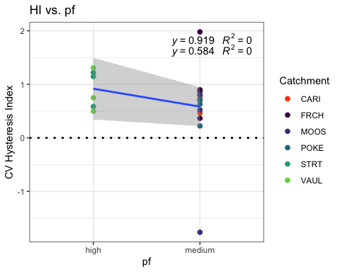

SPC.CV$carbon <- NA  
SPC.CV[c(9:12,19:21), 16] <- "High"  
SPC.CV[c(1:8,13:18), 16] <- "Low"  
  
SPC.CV %>% ggplot(aes(x = carbon, y = CVhi)) +   
 geom_hline(yintercept = 0, linetype = "dotted", size = 1) +  
 geom_point(aes(color = site.ID), size = 2) +  
 scale_color_manual(values = c("orange red", viridis::viridis(6)), "Catchment")+  
 theme_bw() +  
 geom_smooth(method = "lm", na.rm = TRUE, fullrange = TRUE, aes(group = 1)) +   
 stat_poly_eq(formula = y~x,  
 label.y = "top", label.x = "right",  
 aes(label = paste(..eq.label.., ..rr.label.., sep = "~~~")),   
 parse = TRUE) +   
 ylab("CV Hysteresis Index") +  
 ggtitle("HI vs. carbon")

## `geom_smooth()` using formula 'y ~ x'

## Warning: Not enough data to perform fit for group 1; computing mean instead.  
  
## Warning: Not enough data to perform fit for group 2; computing mean instead.

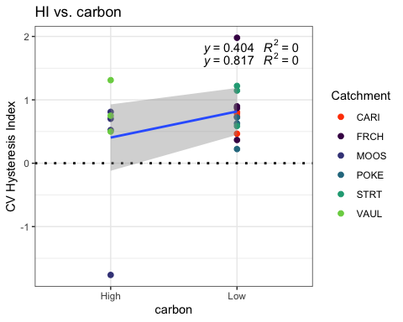

SPC.CV %>% ggplot(aes(x = burn, y = CVhi)) +   
 geom_hline(yintercept = 0, linetype = "dotted", size = 1) +  
 geom_point(aes(color = site.ID), size = 2) +  
 scale_color_manual(values = c("orange red", viridis::viridis(6)), "Catchment")+  
 theme_bw() +  
 geom_smooth(method = "lm", na.rm = TRUE, fullrange = TRUE, aes(group = 1)) +   
 stat_poly_eq(formula = y~x,  
 label.y = "top", label.x = "right",  
 aes(label = paste(..eq.label.., ..rr.label.., sep = "~~~")),   
 parse = TRUE) +   
 ylab("CV Hysteresis Index") +  
 ggtitle("HI vs. burn")

## `geom_smooth()` using formula 'y ~ x'

## Warning: Not enough data to perform fit for group 1; computing mean instead.

## Warning: Not enough data to perform fit for group 2; computing mean instead.

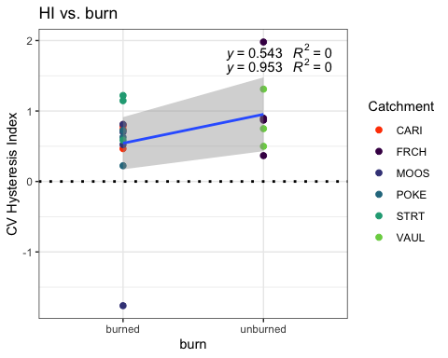

fcvspc <- formula(CVhi ~ pf*meanfDOM + burn*meanfDOM + (1|year))  
  
Mcvspc <- lmer(fcvspc, data = SPC.CV)

## boundary (singular) fit: see ?isSingular

summary(Mcvspc)

## Linear mixed model fit by REML ['lmerMod']  
## Formula: CVhi ~ pf * meanfDOM + burn * meanfDOM + (1 | year)  
## Data: SPC.CV  
##   
## REML criterion at convergence: 63.5  
##   
## Scaled residuals:   
## Min 1Q Median 3Q Max   
## -2.8500 -0.4363 0.1188 0.6061 1.3856   
##   
## Random effects:  
## Groups Name Variance Std.Dev.  
## year (Intercept) 0.0000 0.0000   
## Residual 0.4717 0.6868   
## Number of obs: 21, groups: year, 4  
##   
## Fixed effects:  
## Estimate Std. Error t value  
## (Intercept) 2.08293 1.49204 1.396  
## pfmedium -1.21157 1.49698 -0.809  
## meanfDOM -0.01757 0.02201 -0.798  
## burnunburned -0.40822 1.68789 -0.242  
## pfmedium:meanfDOM 0.01173 0.02155 0.544  
## meanfDOM:burnunburned 0.01364 0.02290 0.596  
##   
## Correlation of Fixed Effects:  
## (Intr) pfmedm mnfDOM brnnbr pf:DOM  
## pfmedium -0.942   
## meanfDOM -0.965 0.903   
## burnunburnd -0.854 0.759 0.917   
## pfmdm:mnDOM 0.929 -0.954 -0.961 -0.869   
## mnfDOM:brnn 0.908 -0.833 -0.976 -0.971 0.932  
## optimizer (nloptwrap) convergence code: 0 (OK)  
## boundary (singular) fit: see ?isSingular

plot(Mcvspc)

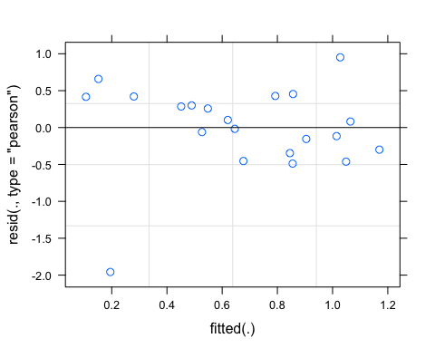

qqnorm(resid(Mcvspc))

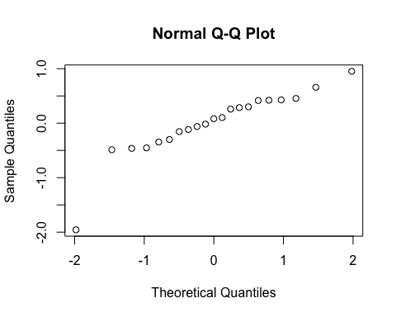

sjPlot::tab_model(Mcvspc)

## Warning: Argument 'df_method' is deprecated. Please use 'ci_method' instead.

CVhi

Predictors

Estimates

CI

p

(Intercept)

2.08

-1.14 – 5.31

0.186

pf [medium]

-1.21

-4.45 – 2.02

0.433

meanfDOM

-0.02

-0.07 – 0.03

0.439

burn [unburned]

-0.41

-4.05 – 3.24

0.813

pf [medium] * meanfDOM

0.01

-0.03 – 0.06

0.595

meanfDOM * burn[unburned]

0.01

-0.04 – 0.06

0.562

Random Effects

σ2

0.47

τ00 year

0.00

N year

4

Observations

21

Marginal R2 / Conditional R2

0.178 / NA

r.squaredGLMM(Mcvspc)

## R2m R2c  
## [1,] 0.1782368 0.1782368

m1 <- lm(CVhi ~ pf*meanfDOM + burn*meanfDOM, data = SPC.CV)  
dwplot(m1,  
 dot_args = list(color = "black"), # color for the dot  
 whisker_args = list(color = "red"), # color for the whisker  
 vline = geom_vline(xintercept = 0, colour = "grey50", linetype = 2)) +  
 xlab("Coefficient") +   
 ggtitle("") +  
 theme_classic()

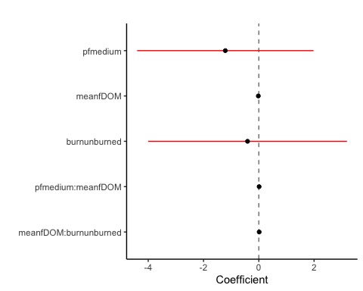

Turb

turb.CV %>% ggplot(aes(x = meanfDOM, y = CVhi)) +   
 geom_hline(yintercept = 0, linetype = "dotted", size = 1) +  
 geom_point(aes(color = site.ID), size = 2) +  
 scale_color_manual(values = c("orange red", viridis::viridis(6)), "Catchment")+  
 theme_bw() +  
 geom_smooth(method = "lm", na.rm = TRUE, fullrange = TRUE, aes(group = 1)) +   
 stat_poly_eq(formula = y~x,  
 label.y = "top", label.x = "right",  
 aes(label = paste(..eq.label.., ..rr.label.., sep = "~~~")),   
 parse = TRUE) +   
 ylab("CV Hysteresis Index") +  
 ggtitle("HI vs. fDOM")

## `geom_smooth()` using formula 'y ~ x'

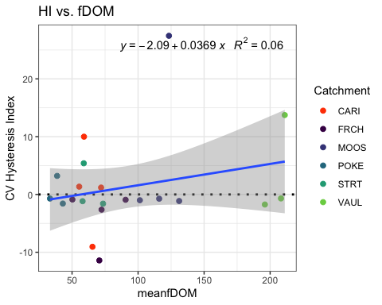

turb.CV %>% ggplot(aes(x = pf, y = CVhi)) +   
 geom_hline(yintercept = 0, linetype = "dotted", size = 1) +  
 geom_point(aes(color = site.ID), size = 2) +  
 scale_color_manual(values = c("orange red", viridis::viridis(6)), "Catchment")+  
 theme_bw() +  
 geom_smooth(method = "lm", na.rm = TRUE, fullrange = TRUE, aes(group = 1)) +   
 stat_poly_eq(formula = y~x,  
 label.y = "top", label.x = "right",  
 aes(label = paste(..eq.label.., ..rr.label.., sep = "~~~")),   
 parse = TRUE) +   
 ylab("CV Hysteresis Index") +  
 ggtitle("HI vs. pf")

## `geom_smooth()` using formula 'y ~ x'

## Warning: Not enough data to perform fit for group 1; computing mean instead.

## Warning: Not enough data to perform fit for group 2; computing mean instead.

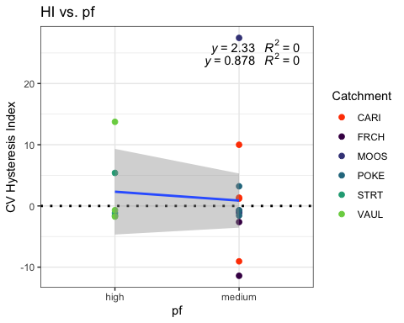

turb.CV$carbon <- NA  
turb.CV[c(9:12,19:21), 16] <- "High"  
turb.CV[c(1:8,13:18), 16] <- "Low"  
  
turb.CV %>% ggplot(aes(x = carbon, y = CVhi)) +   
 geom_hline(yintercept = 0, linetype = "dotted", size = 1) +  
 geom_point(aes(color = site.ID), size = 2) +  
 scale_color_manual(values = c("orange red", viridis::viridis(6)), "Catchment")+  
 theme_bw() +  
 geom_smooth(method = "lm", na.rm = TRUE, fullrange = TRUE, aes(group = 1)) +   
 stat_poly_eq(formula = y~x,  
 label.y = "top", label.x = "right",  
 aes(label = paste(..eq.label.., ..rr.label.., sep = "~~~")),   
 parse = TRUE) +   
 ylab("CV Hysteresis Index") +  
 ggtitle("HI vs. carbon")

## `geom_smooth()` using formula 'y ~ x'

## Warning: Not enough data to perform fit for group 1; computing mean instead.  
  
## Warning: Not enough data to perform fit for group 2; computing mean instead.

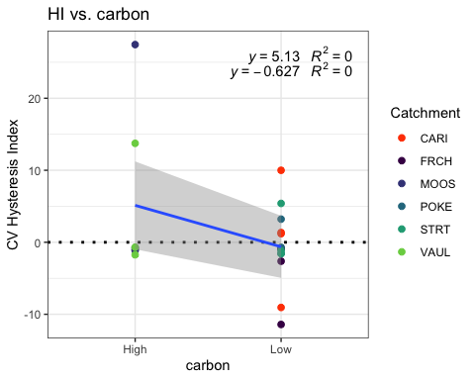

turb.CV %>% ggplot(aes(x = burn, y = CVhi)) +   
 geom_hline(yintercept = 0, linetype = "dotted", size = 1) +  
 geom_point(aes(color = site.ID), size = 2) +  
 scale_color_manual(values = c("orange red", viridis::viridis(6)), "Catchment")+  
 theme_bw() +  
 geom_smooth(method = "lm", na.rm = TRUE, fullrange = TRUE, aes(group = 1)) +   
 stat_poly_eq(formula = y~x,  
 label.y = "top", label.x = "right",  
 aes(label = paste(..eq.label.., ..rr.label.., sep = "~~~")),   
 parse = TRUE) +   
 ylab("CV Hysteresis Index") +  
 ggtitle("HI vs. burn")

## `geom_smooth()` using formula 'y ~ x'

## Warning: Not enough data to perform fit for group 1; computing mean instead.

## Warning: Not enough data to perform fit for group 2; computing mean instead.

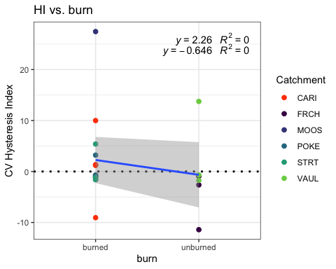

turb.CV <- turb.CV[-c(1,10),] # removing CARI 2018/MOOS 2019 due to it being an outlier   
  
fcvturb <- formula(CVhi ~ pf*meanfDOM + burn*meanfDOM + (1|year))  
  
Mcvturb <- lmer(fcvturb, data = turb.CV)

## boundary (singular) fit: see ?isSingular

summary(Mcvturb)

## Linear mixed model fit by REML ['lmerMod']  
## Formula: CVhi ~ pf * meanfDOM + burn * meanfDOM + (1 | year)  
## Data: turb.CV  
##   
## REML criterion at convergence: 111.2  
##   
## Scaled residuals:   
## Min 1Q Median 3Q Max   
## -1.43064 -0.53401 -0.08581 0.35682 1.84250   
##   
## Random effects:  
## Groups Name Variance Std.Dev.  
## year (Intercept) 0.00 0.000   
## Residual 26.35 5.133   
## Number of obs: 19, groups: year, 4  
##   
## Fixed effects:  
## Estimate Std. Error t value  
## (Intercept) 1.61130 11.22457 0.144  
## pfmedium 2.10882 11.21827 0.188  
## meanfDOM -0.01359 0.16579 -0.082  
## burnunburned -10.82375 12.66997 -0.854  
## pfmedium:meanfDOM -0.02100 0.16111 -0.130  
## meanfDOM:burnunburned 0.07754 0.17216 0.450  
##   
## Correlation of Fixed Effects:  
## (Intr) pfmedm mnfDOM brnnbr pf:DOM  
## pfmedium -0.935   
## meanfDOM -0.965 0.896   
## burnunburnd -0.853 0.750 0.915   
## pfmdm:mnDOM 0.922 -0.953 -0.952 -0.863   
## mnfDOM:brnn 0.909 -0.826 -0.975 -0.970 0.925  
## optimizer (nloptwrap) convergence code: 0 (OK)  
## boundary (singular) fit: see ?isSingular

plot(Mcvturb)

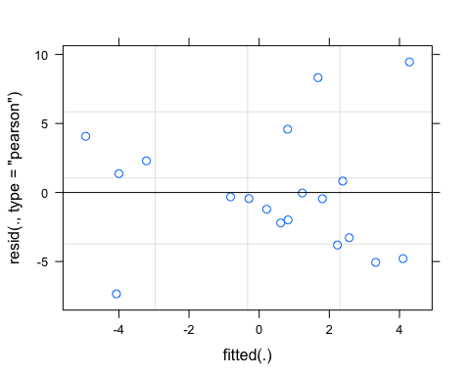

qqnorm(resid(Mcvturb))

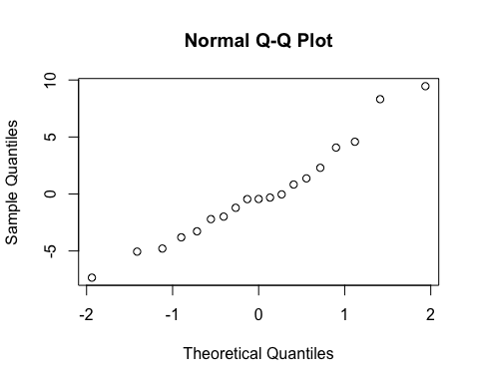

sjPlot::tab_model(Mcvturb)

## Warning: Argument 'df_method' is deprecated. Please use 'ci_method' instead.

CVhi

Predictors

Estimates

CI

p

(Intercept)

1.61

-23.09 – 26.32

0.888

pf [medium]

2.11

-22.58 – 26.80

0.854

meanfDOM

-0.01

-0.38 – 0.35

0.936

burn [unburned]

-10.82

-38.71 – 17.06

0.411

pf [medium] * meanfDOM

-0.02

-0.38 – 0.33

0.899

meanfDOM * burn[unburned]

0.08

-0.30 – 0.46

0.661

Random Effects

σ2

26.35

τ00 year

0.00

N year

4

Observations

19

Marginal R2 / Conditional R2

0.224 / NA

r.squaredGLMM(Mcvturb)

## R2m R2c  
## [1,] 0.2239499 0.2239499

m1 <- lm(CVhi ~ pf*meanfDOM + burn*meanfDOM, data = turb.CV)  
dwplot(m1,  
 dot_args = list(color = "black"), # color for the dot  
 whisker_args = list(color = "red"), # color for the whisker  
 vline = geom_vline(xintercept = 0, colour = "grey50", linetype = 2)) +  
 xlab("Coefficient") +   
 ggtitle("") +  
 theme_classic()

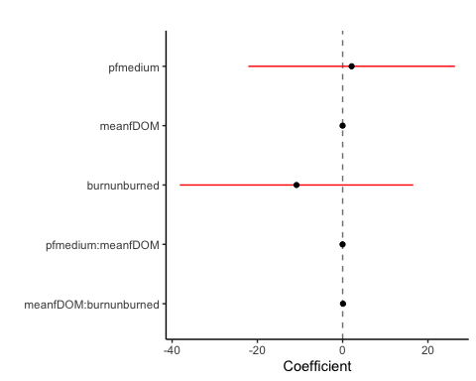

BETA

NO3

NO3.CV %>% ggplot(aes(x = meanfDOM, y = CVbeta)) +   
 geom_hline(yintercept = 0, linetype = "dotted", size = 1) +  
 geom_point(aes(color = site.ID), size = 2) +  
 scale_color_manual(values = c("orange red", viridis::viridis(6)), "Catchment")+  
 theme_bw() +  
 geom_smooth(method = "lm", na.rm = TRUE, fullrange = TRUE, aes(group = 1)) +   
 stat_poly_eq(formula = y~x,  
 label.y = "top", label.x = "right",  
 aes(label = paste(..eq.label.., ..rr.label.., sep = "~~~")),   
 parse = TRUE) +   
 ylab("CV Beta Index") +  
 ggtitle("Beta vs. fDOM")

## `geom_smooth()` using formula 'y ~ x'

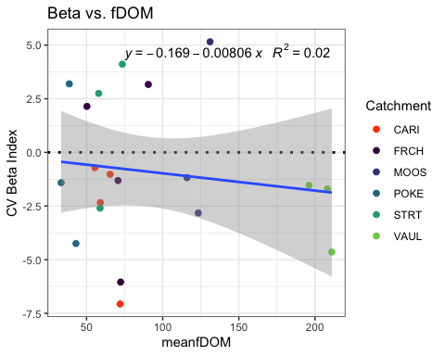

NO3.CV %>% ggplot(aes(x = pf, y = CVbeta)) +   
 geom_hline(yintercept = 0, linetype = "dotted", size = 1) +  
 geom_point(aes(color = site.ID), size = 2) +  
 scale_color_manual(values = c("orange red", viridis::viridis(6)), "Catchment")+  
 theme_bw() +  
 geom_smooth(method = "lm", na.rm = TRUE, fullrange = TRUE, aes(group = 1)) +   
 stat_poly_eq(formula = y~x,  
 label.y = "top", label.x = "right",  
 aes(label = paste(..eq.label.., ..rr.label.., sep = "~~~")),   
 parse = TRUE) +   
 ylab("CV Beta Index") +  
 ggtitle("Beta vs. pf")

## `geom_smooth()` using formula 'y ~ x'

## Warning: Not enough data to perform fit for group 1; computing mean instead.

## Warning: Not enough data to perform fit for group 2; computing mean instead.

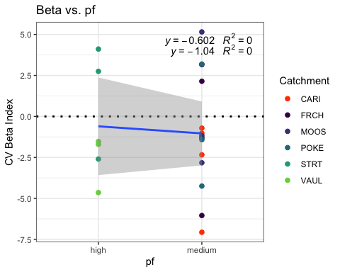

NO3.CV %>% ggplot(aes(x = carbon, y = CVbeta)) +   
 geom_hline(yintercept = 0, linetype = "dotted", size = 1) +  
 geom_point(aes(color = site.ID), size = 2) +  
 scale_color_manual(values = c("orange red", viridis::viridis(6)), "Catchment")+  
 theme_bw() +  
 geom_smooth(method = "lm", na.rm = TRUE, fullrange = TRUE, aes(group = 1)) +   
 stat_poly_eq(formula = y~x,  
 label.y = "top", label.x = "right",  
 aes(label = paste(..eq.label.., ..rr.label.., sep = "~~~")),   
 parse = TRUE) +   
 ylab("CV Beta Index") +  
 ggtitle("Beta vs. carbon")

## `geom_smooth()` using formula 'y ~ x'

## Warning: Not enough data to perform fit for group 1; computing mean instead.  
  
## Warning: Not enough data to perform fit for group 2; computing mean instead.

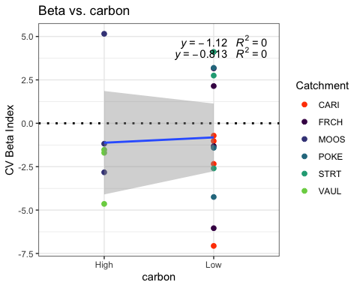

NO3.CV %>% ggplot(aes(x = burn, y = CVbeta)) +   
 geom_hline(yintercept = 0, linetype = "dotted", size = 1) +  
 geom_point(aes(color = site.ID), size = 2) +  
 scale_color_manual(values = c("orange red", viridis::viridis(6)), "Catchment")+  
 theme_bw() +  
 geom_smooth(method = "lm", na.rm = TRUE, fullrange = TRUE, aes(group = 1)) +   
 stat_poly_eq(formula = y~x,  
 label.y = "top", label.x = "right",  
 aes(label = paste(..eq.label.., ..rr.label.., sep = "~~~")),   
 parse = TRUE) +   
 ylab("CV Beta Index") +  
 ggtitle("Beta vs. burn")

## `geom_smooth()` using formula 'y ~ x'

## Warning: Not enough data to perform fit for group 1; computing mean instead.

## Warning: Not enough data to perform fit for group 2; computing mean instead.

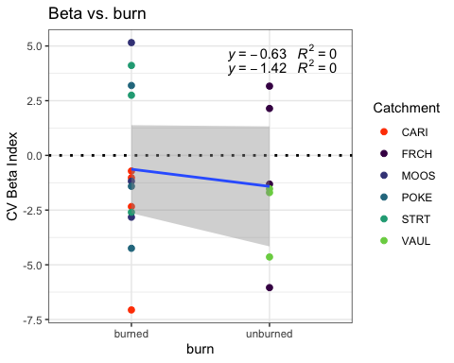

fcvno3 <- formula(CVbeta ~ pf*meanfDOM + burn*meanfDOM + (1|year))  
  
Mcvno3 <- lmer(fcvno3, data = NO3.CV)  
summary(Mcvno3)

## Linear mixed model fit by REML ['lmerMod']  
## Formula: CVbeta ~ pf * meanfDOM + burn * meanfDOM + (1 | year)  
## Data: NO3.CV  
##   
## REML criterion at convergence: 107.5  
##   
## Scaled residuals:   
## Min 1Q Median 3Q Max   
## -1.42948 -0.44899 0.02962 0.39048 1.61858   
##   
## Random effects:  
## Groups Name Variance Std.Dev.  
## year (Intercept) 2.524 1.589   
## Residual 11.099 3.332   
## Number of obs: 20, groups: year, 4  
##   
## Fixed effects:  
## Estimate Std. Error t value  
## (Intercept) -1.24013 7.43911 -0.167  
## pfmedium -1.32968 7.53311 -0.177  
## meanfDOM 0.04785 0.11071 0.432  
## burnunburned 6.45665 8.45263 0.764  
## pfmedium:meanfDOM -0.02732 0.11038 -0.248  
## meanfDOM:burnunburned -0.08342 0.11517 -0.724  
##   
## Correlation of Fixed Effects:  
## (Intr) pfmedm mnfDOM brnnbr pf:DOM  
## pfmedium -0.936   
## meanfDOM -0.959 0.909   
## burnunburnd -0.854 0.774 0.921   
## pfmdm:mnDOM 0.917 -0.956 -0.959 -0.877   
## mnfDOM:brnn 0.906 -0.844 -0.977 -0.972 0.934

plot(Mcvno3)

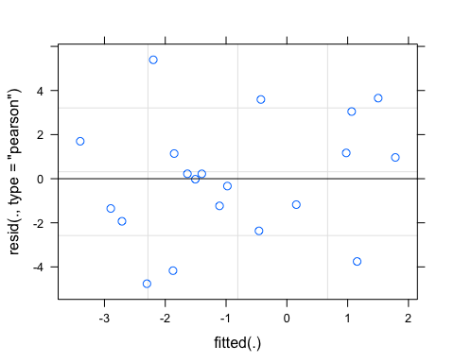

qqnorm(resid(Mcvno3))

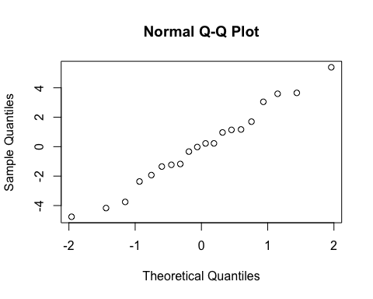

sjPlot::tab_model(Mcvno3)

## Warning: Argument 'df_method' is deprecated. Please use 'ci_method' instead.

CVbeta

Predictors

Estimates

CI

p

(Intercept)

-1.24

-17.45 – 14.97

0.870

pf [medium]

-1.33

-17.74 – 15.08

0.863

meanfDOM

0.05

-0.19 – 0.29

0.673

burn [unburned]

6.46

-11.96 – 24.87

0.460

pf [medium] * meanfDOM

-0.03

-0.27 – 0.21

0.809

meanfDOM * burn[unburned]

-0.08

-0.33 – 0.17

0.483

Random Effects

σ2

11.10

τ00 year

2.52

ICC

0.19

N year

4

Observations

20

Marginal R2 / Conditional R2

0.118 / 0.281

r.squaredGLMM(Mcvno3)

## R2m R2c  
## [1,] 0.1175432 0.2810619

m1 <- lm(CVhi ~ pf*meanfDOM + burn*meanfDOM, data = NO3.CV)  
dwplot(m1,  
 dot_args = list(color = "black"), # color for the dot  
 whisker_args = list(color = "red"), # color for the whisker  
 vline = geom_vline(xintercept = 0, colour = "grey50", linetype = 2)) +  
 xlab("Coefficient") +   
 ggtitle("") +  
 theme_classic()



fDOM

fDOM.CV %>% ggplot(aes(x = meanfDOM, y = CVbeta)) +   
 geom_hline(yintercept = 0, linetype = "dotted", size = 1) +  
 geom_point(aes(color = site.ID), size = 2) +  
 scale_color_manual(values = c("orange red", viridis::viridis(6)), "Catchment")+  
 theme_bw() +  
 geom_smooth(method = "lm", na.rm = TRUE, fullrange = TRUE, aes(group = 1)) +   
 stat_poly_eq(formula = y~x,  
 label.y = "top", label.x = "right",  
 aes(label = paste(..eq.label.., ..rr.label.., sep = "~~~")),   
 parse = TRUE) +   
 ylab("CV Beta Index") +  
 ggtitle("Beta vs. fDOM")

## `geom_smooth()` using formula 'y ~ x'

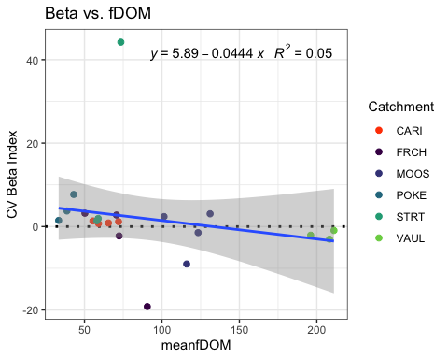

fDOM.CV %>% ggplot(aes(x = pf, y = CVbeta)) +   
 geom_hline(yintercept = 0, linetype = "dotted", size = 1) +  
 geom_point(aes(color = site.ID), size = 2) +  
 scale_color_manual(values = c("orange red", viridis::viridis(6)), "Catchment")+  
 theme_bw() +  
 geom_smooth(method = "lm", na.rm = TRUE, fullrange = TRUE, aes(group = 1)) +   
 stat_poly_eq(formula = y~x,  
 label.y = "top", label.x = "right",  
 aes(label = paste(..eq.label.., ..rr.label.., sep = "~~~")),   
 parse = TRUE) +   
 ylab("CV Beta Index") +  
 ggtitle("Beta vs. pf")

## `geom_smooth()` using formula 'y ~ x'

## Warning: Not enough data to perform fit for group 1; computing mean instead.

## Warning: Not enough data to perform fit for group 2; computing mean instead.

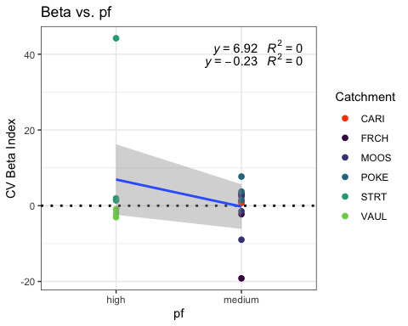

fDOM.CV %>% ggplot(aes(x = carbon, y = CVbeta)) +   
 geom_hline(yintercept = 0, linetype = "dotted", size = 1) +  
 geom_point(aes(color = site.ID), size = 2) +  
 scale_color_manual(values = c("orange red", viridis::viridis(6)), "Catchment")+  
 theme_bw() +  
 geom_smooth(method = "lm", na.rm = TRUE, fullrange = TRUE, aes(group = 1)) +   
 stat_poly_eq(formula = y~x,  
 label.y = "top", label.x = "right",  
 aes(label = paste(..eq.label.., ..rr.label.., sep = "~~~")),   
 parse = TRUE) +   
 ylab("CV Beta Index") +  
 ggtitle("Beta vs. carbon")

## `geom_smooth()` using formula 'y ~ x'

## Warning: Not enough data to perform fit for group 1; computing mean instead.  
  
## Warning: Not enough data to perform fit for group 2; computing mean instead.

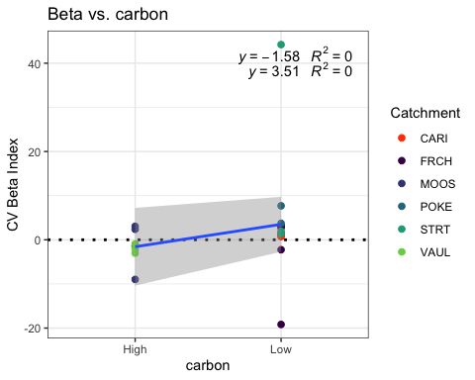

fDOM.CV %>% ggplot(aes(x = burn, y = CVbeta)) +   
 geom_hline(yintercept = 0, linetype = "dotted", size = 1) +  
 geom_point(aes(color = site.ID), size = 2) +  
 scale_color_manual(values = c("orange red", viridis::viridis(6)), "Catchment")+  
 theme_bw() +  
 geom_smooth(method = "lm", na.rm = TRUE, fullrange = TRUE, aes(group = 1)) +   
 stat_poly_eq(formula = y~x,  
 label.y = "top", label.x = "right",  
 aes(label = paste(..eq.label.., ..rr.label.., sep = "~~~")),   
 parse = TRUE) +   
 ylab("CV Beta Index") +  
 ggtitle("Beta vs. burn")

## `geom_smooth()` using formula 'y ~ x'

## Warning: Not enough data to perform fit for group 1; computing mean instead.

## Warning: Not enough data to perform fit for group 2; computing mean instead.

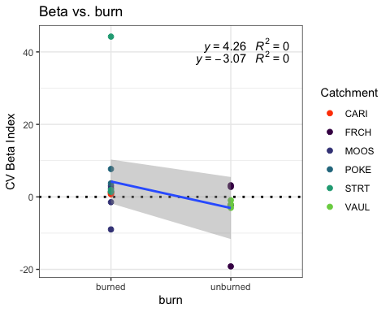

fcvfdom <- formula(CVbeta ~ pf*meanfDOM + burn*meanfDOM + (1|year))  
  
Mcvfdom <- lmer(fcvfdom, data = fDOM.CV)  
summary(Mcvfdom)

## Linear mixed model fit by REML ['lmerMod']  
## Formula: CVbeta ~ pf * meanfDOM + burn * meanfDOM + (1 | year)  
## Data: fDOM.CV  
##   
## REML criterion at convergence: 137.5  
##   
## Scaled residuals:   
## Min 1Q Median 3Q Max   
## -1.37139 -0.19872 -0.08248 0.38532 2.64769   
##   
## Random effects:  
## Groups Name Variance Std.Dev.  
## year (Intercept) 0.6243 0.7902   
## Residual 64.9079 8.0565   
## Number of obs: 21, groups: year, 4  
##   
## Fixed effects:  
## Estimate Std. Error t value  
## (Intercept) -33.0063 17.5338 -1.882  
## pfmedium 36.9779 17.6046 2.100  
## meanfDOM 0.7583 0.2589 2.929  
## burnunburned 56.3862 19.8431 2.842  
## pfmedium:meanfDOM -0.7933 0.2537 -3.127  
## meanfDOM:burnunburned -0.8783 0.2693 -3.262  
##   
## Correlation of Fixed Effects:  
## (Intr) pfmedm mnfDOM brnnbr pf:DOM  
## pfmedium -0.942   
## meanfDOM -0.964 0.903   
## burnunburnd -0.854 0.760 0.918   
## pfmdm:mnDOM 0.929 -0.954 -0.961 -0.870   
## mnfDOM:brnn 0.908 -0.834 -0.976 -0.971 0.932

plot(Mcvfdom)

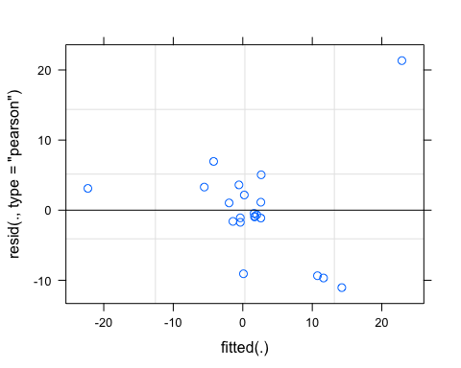

qqnorm(resid(Mcvfdom))

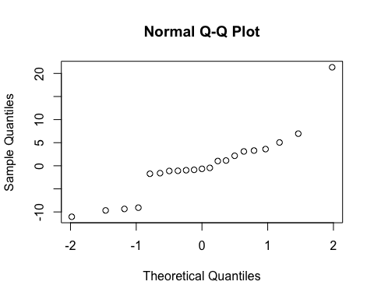

sjPlot::tab_model(Mcvfdom)

## Warning: Argument 'df_method' is deprecated. Please use 'ci_method' instead.

CVbeta

Predictors

Estimates

CI

p

(Intercept)

-33.01

-70.89 – 4.87

0.082

pf [medium]

36.98

-1.05 – 75.01

0.056

meanfDOM

0.76

0.20 – 1.32

0.012

burn [unburned]

56.39

13.52 – 99.25

0.014

pf [medium] * meanfDOM

-0.79

-1.34 – -0.25

0.008

meanfDOM * burn[unburned]

-0.88

-1.46 – -0.30

0.006

Random Effects

σ2

64.91

τ00 year

0.62

ICC

0.01

N year

4

Observations

21

Marginal R2 / Conditional R2

0.534 / 0.538

r.squaredGLMM(Mcvfdom)

## R2m R2c  
## [1,] 0.5337476 0.5381897

m1 <- lm(CVbeta ~ pf*meanfDOM + burn*meanfDOM, data = fDOM.CV)  
dwplot(m1,  
 dot_args = list(color = "black"), # color for the dot  
 whisker_args = list(color = "red"), # color for the whisker  
 vline = geom_vline(xintercept = 0, colour = "grey50", linetype = 2)) +  
 xlab("Coefficient") +   
 ggtitle("") +  
 theme_classic()

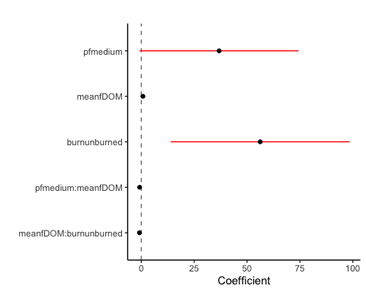

SPC

SPC.CV %>% ggplot(aes(x = meanfDOM, y = CVbeta)) +   
 geom_hline(yintercept = 0, linetype = "dotted", size = 1) +  
 geom_point(aes(color = site.ID), size = 2) +  
 scale_color_manual(values = c("orange red", viridis::viridis(6)), "Catchment")+  
 theme_bw() +  
 geom_smooth(method = "lm", na.rm = TRUE, fullrange = TRUE, aes(group = 1)) +   
 stat_poly_eq(formula = y~x,  
 label.y = "top", label.x = "right",  
 aes(label = paste(..eq.label.., ..rr.label.., sep = "~~~")),   
 parse = TRUE) +   
 ylab("CV Beta Index") +  
 ggtitle("Beta vs. fDOM")

## `geom_smooth()` using formula 'y ~ x'

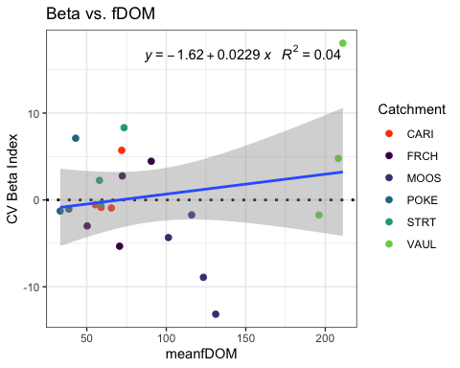

SPC.CV %>% ggplot(aes(x = pf, y = CVbeta)) +   
 geom_hline(yintercept = 0, linetype = "dotted", size = 1) +  
 geom_point(aes(color = site.ID), size = 2) +  
 scale_color_manual(values = c("orange red", viridis::viridis(6)), "Catchment")+  
 theme_bw() +  
 geom_smooth(method = "lm", na.rm = TRUE, fullrange = TRUE, aes(group = 1)) +   
 stat_poly_eq(formula = y~x,  
 label.y = "top", label.x = "right",  
 aes(label = paste(..eq.label.., ..rr.label.., sep = "~~~")),   
 parse = TRUE) +   
 ylab("CV Hysteresis Index") +  
 ggtitle("HI vs. pf")

## `geom_smooth()` using formula 'y ~ x'

## Warning: Not enough data to perform fit for group 1; computing mean instead.

## Warning: Not enough data to perform fit for group 2; computing mean instead.

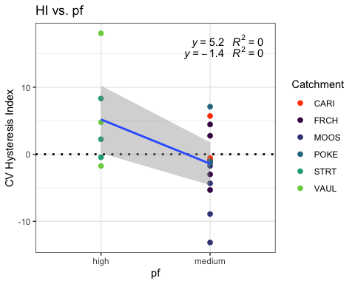

SPC.CV %>% ggplot(aes(x = carbon, y = CVbeta)) +   
 geom_hline(yintercept = 0, linetype = "dotted", size = 1) +  
 geom_point(aes(color = site.ID), size = 2) +  
 scale_color_manual(values = c("orange red", viridis::viridis(6)), "Catchment")+  
 theme_bw() +  
 geom_smooth(method = "lm", na.rm = TRUE, fullrange = TRUE, aes(group = 1)) +   
 stat_poly_eq(formula = y~x,  
 label.y = "top", label.x = "right",  
 aes(label = paste(..eq.label.., ..rr.label.., sep = "~~~")),   
 parse = TRUE) +   
 ylab("CV Beta Index") +  
 ggtitle("Beta vs. carbon")

## `geom_smooth()` using formula 'y ~ x'

## Warning: Not enough data to perform fit for group 1; computing mean instead.  
  
## Warning: Not enough data to perform fit for group 2; computing mean instead.

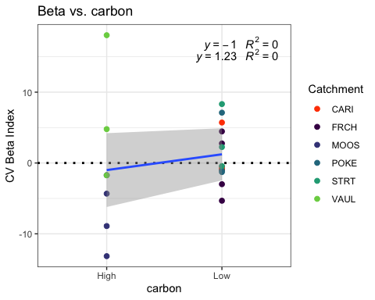

SPC.CV %>% ggplot(aes(x = burn, y = CVbeta)) +   
 geom_hline(yintercept = 0, linetype = "dotted", size = 1) +  
 geom_point(aes(color = site.ID), size = 2) +  
 scale_color_manual(values = c("orange red", viridis::viridis(6)), "Catchment")+  
 theme_bw() +  
 geom_smooth(method = "lm", na.rm = TRUE, fullrange = TRUE, aes(group = 1)) +   
 stat_poly_eq(formula = y~x,  
 label.y = "top", label.x = "right",  
 aes(label = paste(..eq.label.., ..rr.label.., sep = "~~~")),   
 parse = TRUE) +   
 ylab("CV Beta Index") +  
 ggtitle("Beta vs. burn")

## `geom_smooth()` using formula 'y ~ x'

## Warning: Not enough data to perform fit for group 1; computing mean instead.

## Warning: Not enough data to perform fit for group 2; computing mean instead.

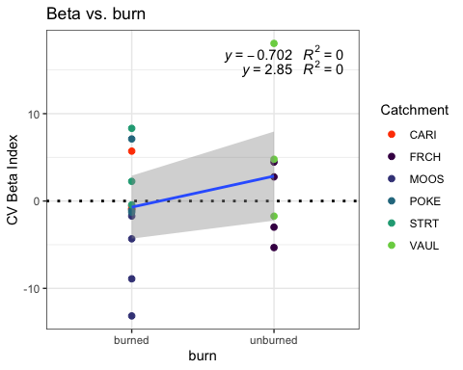

fcvspc <- formula(CVbeta ~ pf*meanfDOM + burn*meanfDOM + (1|year))  
  
Mcvspc <- lmer(fcvspc, data = SPC.CV)  
summary(Mcvspc)

## Linear mixed model fit by REML ['lmerMod']  
## Formula: CVbeta ~ pf * meanfDOM + burn * meanfDOM + (1 | year)  
## Data: SPC.CV  
##   
## REML criterion at convergence: 125.5  
##   
## Scaled residuals:   
## Min 1Q Median 3Q Max   
## -1.43302 -0.62686 -0.00363 0.46117 2.14788   
##   
## Random effects:  
## Groups Name Variance Std.Dev.  
## year (Intercept) 5.203 2.281   
## Residual 25.746 5.074   
## Number of obs: 21, groups: year, 4  
##   
## Fixed effects:  
## Estimate Std. Error t value  
## (Intercept) 13.15081 11.30464 1.163  
## pfmedium -6.15707 11.43936 -0.538  
## meanfDOM -0.16229 0.16820 -0.965  
## burnunburned -13.74453 12.83336 -1.071  
## pfmedium:meanfDOM 0.04795 0.16706 0.287  
## meanfDOM:burnunburned 0.20108 0.17496 1.149  
##   
## Correlation of Fixed Effects:  
## (Intr) pfmedm mnfDOM brnnbr pf:DOM  
## pfmedium -0.938   
## meanfDOM -0.960 0.909   
## burnunburnd -0.856 0.773 0.922   
## pfmdm:mnDOM 0.922 -0.956 -0.963 -0.876   
## mnfDOM:brnn 0.906 -0.844 -0.977 -0.973 0.936

plot(Mcvspc)

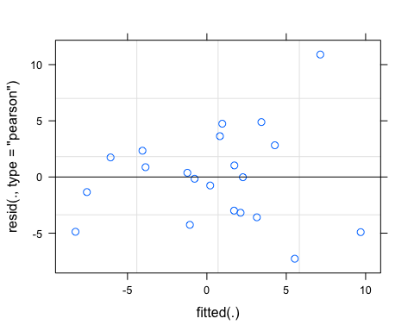

qqnorm(resid(Mcvspc))

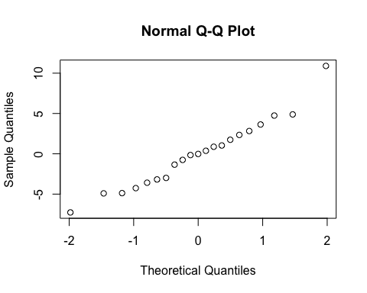

sjPlot::tab_model(Mcvspc)

## Warning: Argument 'df_method' is deprecated. Please use 'ci_method' instead.

CVbeta

Predictors

Estimates

CI

p

(Intercept)

13.15

-11.27 – 37.57

0.266

pf [medium]

-6.16

-30.87 – 18.56

0.600

meanfDOM

-0.16

-0.53 – 0.20

0.352

burn [unburned]

-13.74

-41.47 – 13.98

0.304

pf [medium] * meanfDOM

0.05

-0.31 – 0.41

0.779

meanfDOM * burn[unburned]

0.20

-0.18 – 0.58

0.271

Random Effects

σ2

25.75

τ00 year

5.20

ICC

0.17

N year

4

Observations

21

Marginal R2 / Conditional R2

0.388 / 0.491

r.squaredGLMM(Mcvspc)

## R2m R2c  
## [1,] 0.3882454 0.4910946

m1 <- lm(CVbeta ~ pf*meanfDOM + burn*meanfDOM, data = SPC.CV)  
dwplot(m1,  
 dot_args = list(color = "black"), # color for the dot  
 whisker_args = list(color = "red"), # color for the whisker  
 vline = geom_vline(xintercept = 0, colour = "grey50", linetype = 2)) +  
 xlab("Coefficient") +   
 ggtitle("") +  
 theme_classic()

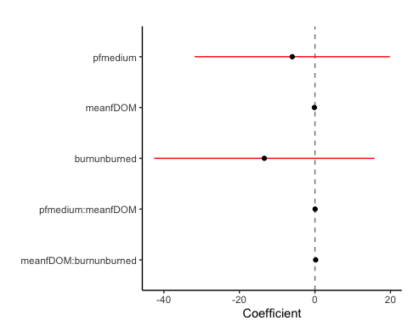

Turb

turb.CV %>% ggplot(aes(x = meanfDOM, y = CVbeta)) +   
 geom_hline(yintercept = 0, linetype = "dotted", size = 1) +  
 geom_point(aes(color = site.ID), size = 2) +  
 scale_color_manual(values = c("orange red", viridis::viridis(6)), "Catchment")+  
 theme_bw() +  
 geom_smooth(method = "lm", na.rm = TRUE, fullrange = TRUE, aes(group = 1)) +   
 stat_poly_eq(formula = y~x,  
 label.y = "top", label.x = "right",  
 aes(label = paste(..eq.label.., ..rr.label.., sep = "~~~")),   
 parse = TRUE) +   
 ylab("CV Beta Index") +  
 ggtitle("Beta vs. fDOM")

## `geom_smooth()` using formula 'y ~ x'

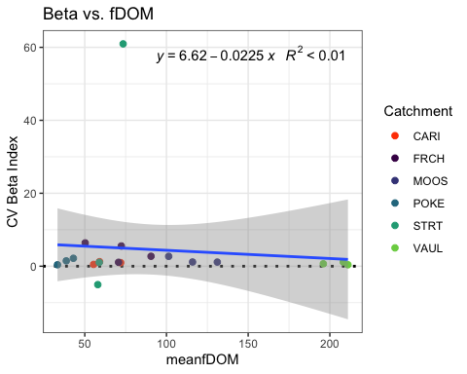

turb.CV %>% ggplot(aes(x = pf, y = CVbeta)) +   
 geom_hline(yintercept = 0, linetype = "dotted", size = 1) +  
 geom_point(aes(color = site.ID), size = 2) +  
 scale_color_manual(values = c("orange red", viridis::viridis(6)), "Catchment")+  
 theme_bw() +  
 geom_smooth(method = "lm", na.rm = TRUE, fullrange = TRUE, aes(group = 1)) +   
 stat_poly_eq(formula = y~x,  
 label.y = "top", label.x = "right",  
 aes(label = paste(..eq.label.., ..rr.label.., sep = "~~~")),   
 parse = TRUE) +   
 ylab("CV Beta Index") +  
 ggtitle("Beta vs. pf")

## `geom_smooth()` using formula 'y ~ x'

## Warning: Not enough data to perform fit for group 1; computing mean instead.

## Warning: Not enough data to perform fit for group 2; computing mean instead.

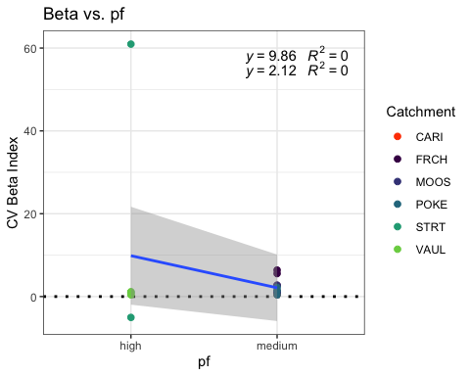

turb.CV %>% ggplot(aes(x = carbon, y = CVbeta)) +   
 geom_hline(yintercept = 0, linetype = "dotted", size = 1) +  
 geom_point(aes(color = site.ID), size = 2) +  
 scale_color_manual(values = c("orange red", viridis::viridis(6)), "Catchment")+  
 theme_bw() +  
 geom_smooth(method = "lm", na.rm = TRUE, fullrange = TRUE, aes(group = 1)) +   
 stat_poly_eq(formula = y~x,  
 label.y = "top", label.x = "right",  
 aes(label = paste(..eq.label.., ..rr.label.., sep = "~~~")),   
 parse = TRUE) +   
 ylab("CV Beta Index") +  
 ggtitle("Beta vs. carbon")

## `geom_smooth()` using formula 'y ~ x'

## Warning: Not enough data to perform fit for group 1; computing mean instead.  
  
## Warning: Not enough data to perform fit for group 2; computing mean instead.

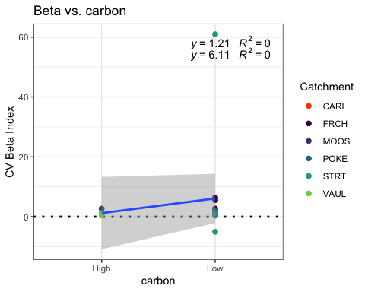

turb.CV %>% ggplot(aes(x = burn, y = CVbeta)) +   
 geom_hline(yintercept = 0, linetype = "dotted", size = 1) +  
 geom_point(aes(color = site.ID), size = 2) +  
 scale_color_manual(values = c("orange red", viridis::viridis(6)), "Catchment")+  
 theme_bw() +  
 geom_smooth(method = "lm", na.rm = TRUE, fullrange = TRUE, aes(group = 1)) +   
 stat_poly_eq(formula = y~x,  
 label.y = "top", label.x = "right",  
 aes(label = paste(..eq.label.., ..rr.label.., sep = "~~~")),   
 parse = TRUE) +   
 ylab("CV Beta Index") +  
 ggtitle("Beta vs. burn")

## `geom_smooth()` using formula 'y ~ x'

## Warning: Not enough data to perform fit for group 1; computing mean instead.

## Warning: Not enough data to perform fit for group 2; computing mean instead.

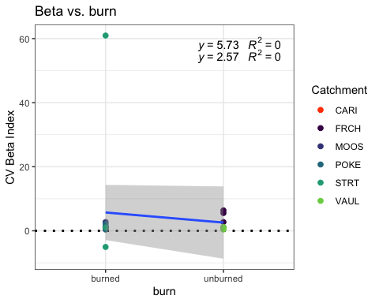

turb.CV <- turb.CV[-c(1,10),] # removing CARI 2018/MOOS 2019 due to it being an outlier   
  
fcvturb <- formula(CVbeta ~ pf*meanfDOM + burn*meanfDOM + (1|year))  
  
Mcvturb <- lmer(fcvturb, data = turb.CV)  
summary(Mcvturb)

## Linear mixed model fit by REML ['lmerMod']  
## Formula: CVbeta ~ pf * meanfDOM + burn * meanfDOM + (1 | year)  
## Data: turb.CV  
##   
## REML criterion at convergence: 121.4  
##   
## Scaled residuals:   
## Min 1Q Median 3Q Max   
## -1.25021 -0.24490 -0.06276 0.14822 2.44505   
##   
## Random effects:  
## Groups Name Variance Std.Dev.  
## year (Intercept) 22.64 4.758   
## Residual 190.89 13.816   
## Number of obs: 17, groups: year, 4  
##   
## Fixed effects:  
## Estimate Std. Error t value  
## (Intercept) -20.7876 30.8741 -0.673  
## pfmedium 20.9189 31.3381 0.668  
## meanfDOM 0.6155 0.4588 1.341  
## burnunburned 57.2161 34.8204 1.643  
## pfmedium:meanfDOM -0.5987 0.4519 -1.325  
## meanfDOM:burnunburned -0.7818 0.4752 -1.645  
##   
## Correlation of Fixed Effects:  
## (Intr) pfmedm mnfDOM brnnbr pf:DOM  
## pfmedium -0.923   
## meanfDOM -0.962 0.893   
## burnunburnd -0.849 0.744 0.912   
## pfmdm:mnDOM 0.907 -0.953 -0.945 -0.857   
## mnfDOM:brnn 0.908 -0.825 -0.976 -0.968 0.919

plot(Mcvturb)

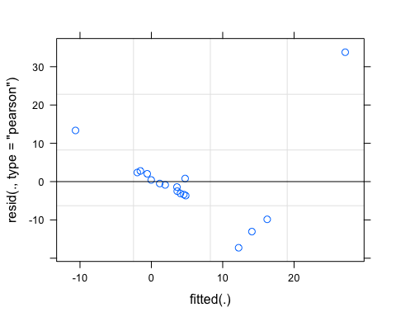

qqnorm(resid(Mcvturb))

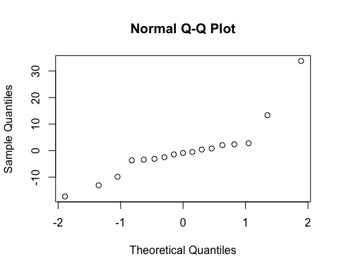

sjPlot::tab_model(Mcvturb)

## Warning: Argument 'df_method' is deprecated. Please use 'ci_method' instead.

CVbeta

Predictors

Estimates

CI

p

(Intercept)

-20.79

-90.63 – 49.05

0.518

pf [medium]

20.92

-49.97 – 91.81

0.521

meanfDOM

0.62

-0.42 – 1.65

0.213

burn [unburned]

57.22

-21.55 – 135.99

0.135

pf [medium] * meanfDOM

-0.60

-1.62 – 0.42

0.218

meanfDOM * burn[unburned]

-0.78

-1.86 – 0.29

0.134

Random Effects

σ2

190.89

τ00 year

22.64

ICC

0.11

N year

4

Observations

17

Marginal R2 / Conditional R2

0.260 / 0.338

r.squaredGLMM(Mcvturb)

## R2m R2c  
## [1,] 0.2596824 0.3381855

m1 <- lm(CVbeta ~ pf*meanfDOM + burn*meanfDOM, data = turb.CV)  
dwplot(m1,  
 dot_args = list(color = "black"), # color for the dot  
 whisker_args = list(color = "red"), # color for the whisker  
 vline = geom_vline(xintercept = 0, colour = "grey50", linetype = 2)) +  
 xlab("Coefficient") +   
 ggtitle("") +  
 theme_classic()

